DR. AMBEDKAR COLLEGE, DEEKSHABHOOMI, NAGPUR

DEPARTMENT OF LAW-

ACADEMIC SESSION- 2022-2023

- NAME OF THE PROGRAM: | AWARENESS TALK ON THE POCSO ACT AND CELEBRATION OF WORLD POPULATION DAY
DAY: | 11 JULY 2022
TIME: | 11.00 AM –1.30 PM

NAME OF CELL: LEGAL AID CLINIC PROGRAM COORDINATOR: DR. PRATIMA LOKHANDE

MEMBERS: Mrs. VAISHALI SUKHDEVE Miss. SARIKA KAMDI
STUDENTS: 60

Child sexual abuse is a major concern that is increasing day by day in India and to fight child sexual abuse, it is important that we all take responsibility in our own various ways to combat the menace. The country is experiencing frequent incidences of violations against children. In some incidents children are perpetrators and sometimes they are victimized by the people of their own surroundings. Protection of Children from sexual offences (POCSO) Act, 2012 in order to effectively address the heinous crimes of sexual abuse and sexual exploitation of children through less ambiguous and more stringent legal provisions.

The Legal Aid Clinic of Department of Law, Dr. Ambedkar College, Deekshabhoomi, Nagpur in collaboration with District Legal Services Authority organized the “AWARENESS TALK ON THE POCSO ACT”.
The main objective of the Legal Aid Clinic is to create awareness on ‘POCSO Act 2012’ to law students and teaching students to understand the special provisions of legislations and helping them to stand up for the safety of children. It was held on 11th July, 2022 at the College Seminar Hall.
The event began with ceremonial lighting of the candle and garlanding the portraits of Tathagat Guatam Buddha and Param poojya Dr. Babasaheb Ambedkar and the felicitation of the guests with sapling.
The welcome speech was given by Principal of College Dr. B. A. Mehere Thereafter Dr. Pratima Lokhande, coordinator of Legal Aid Clinic has given overview of activities of Legal Aid clinic.
Shree Jaydeep Pandey, secretary DLSA delivered a lecture among the students and sensitized the students on the very important topic of sexual abuse of children by citing live examples. He started with mentioning the offences given under IPC and then focussed on the detailed provisions of POCSO ACT. He mentioned about the lacunae in IPC like the problem of pornography is not mentioned in it and so the need to have new legislation which is Gender neutral in the form of POCSO. He discussed various kinds of offences mentioned in the Act regarding sexual abuse starting from sexual harassment, sexual assault and penetrative sexual assault and its aggravated form. He also discussed the penal provisions of such offences and made the students aware of the same.

CELEBRATION OF WORLD POPULATION DAY

Adv. Rajendra Rathi Sir very well explained the urgency and importance of population issues. He said there is a need to pay attention towards issues like importance of family planning towards the increasing population, gender equality, maternal and baby health, poverty, human rights, right to health, girl child education etc. He said there is a urgent need to make sure the easy access of reproductive health services everywhere as part the basic primary health for each couple.
that legal profession is a profession of service and not of business and encouraged the students to actively participate in dealing with the problems of over population and how a law student can contribute in problem solving.

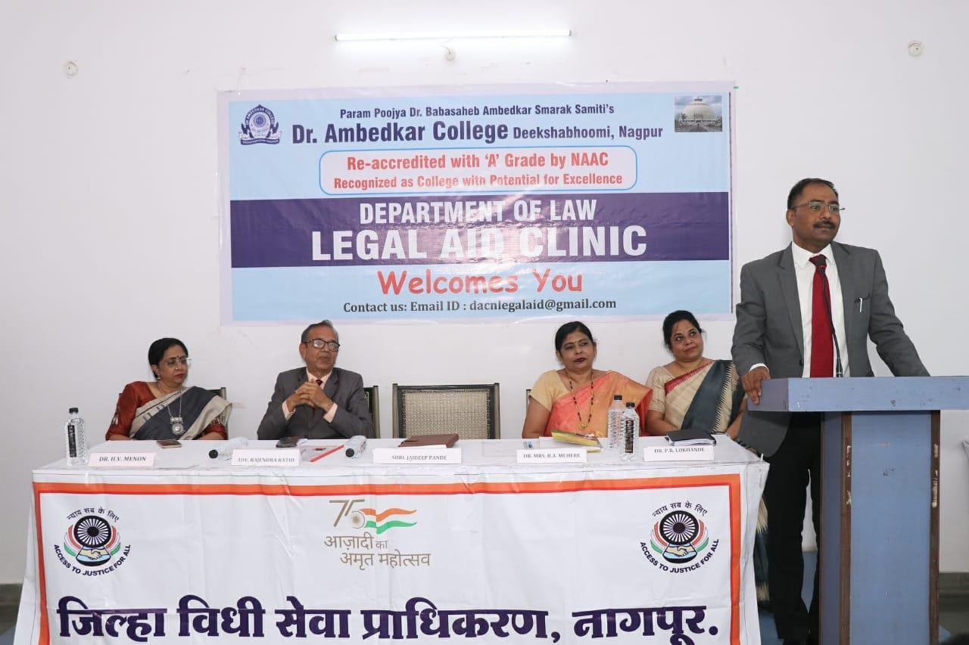
Dr. S.P. Kalamdhad, Ms. Shilpa Rathod, Ms. Sarkia Kamdi attended the program. Vaishali Sukhdeve, accorded the vote of gratitude at the end of this enlightening session.

Shree Jaydeep Pandey, secretary DLSA addressing the students
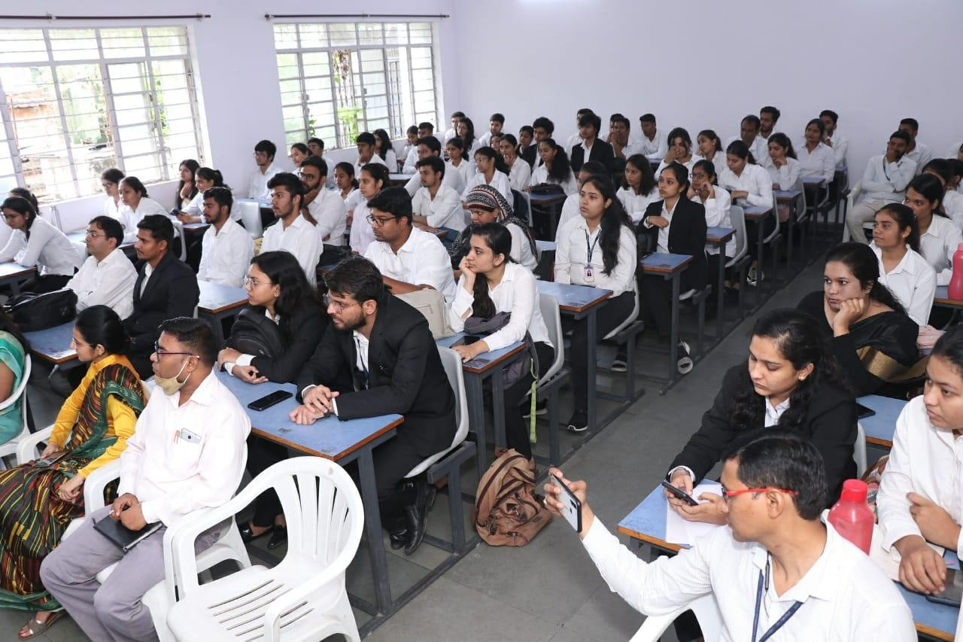

Glimpses of Visit To LEGAL AID CLINIC
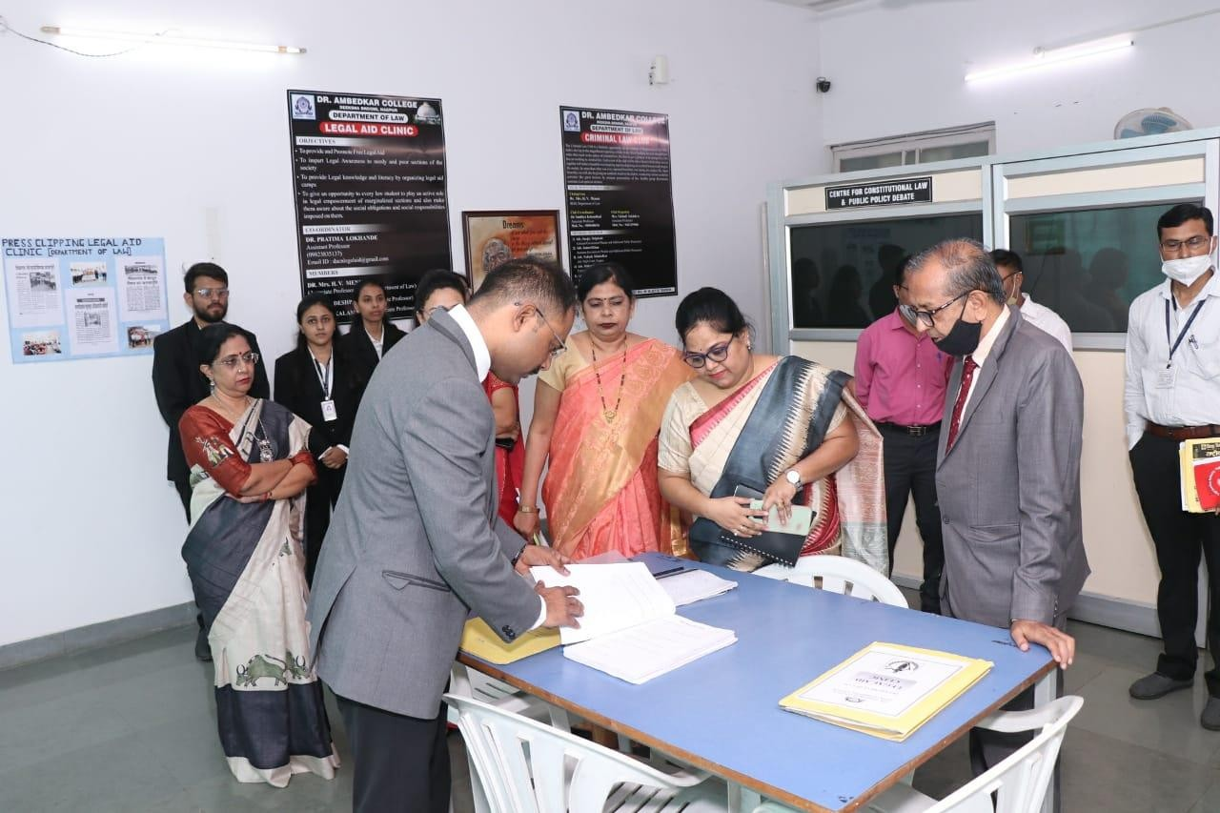
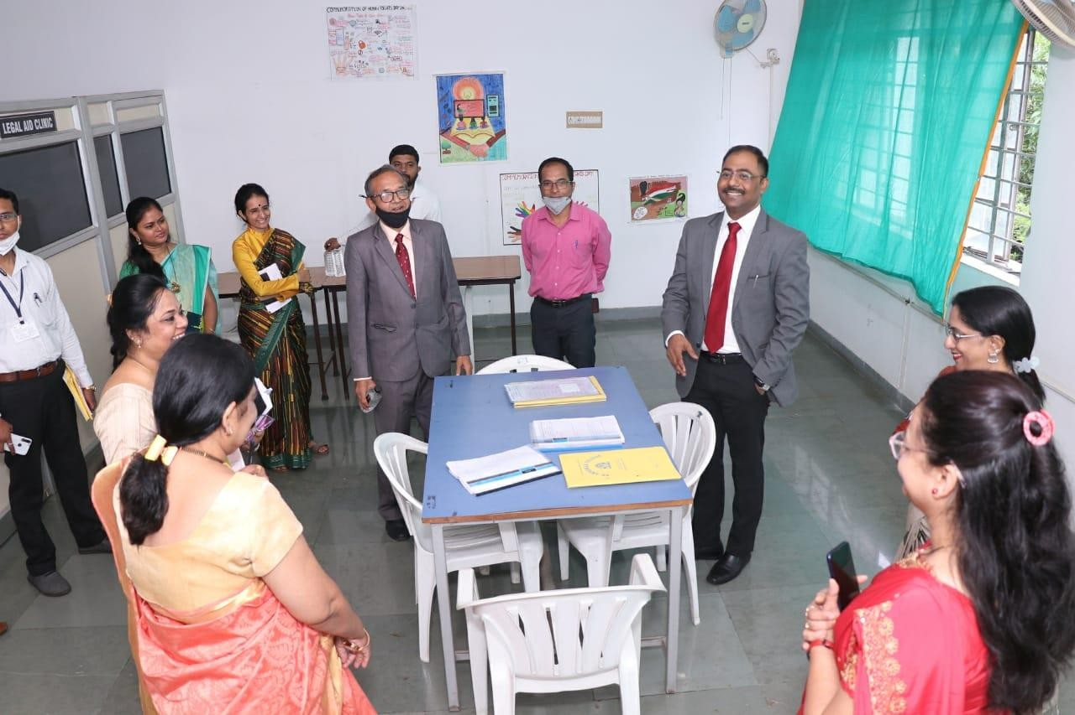

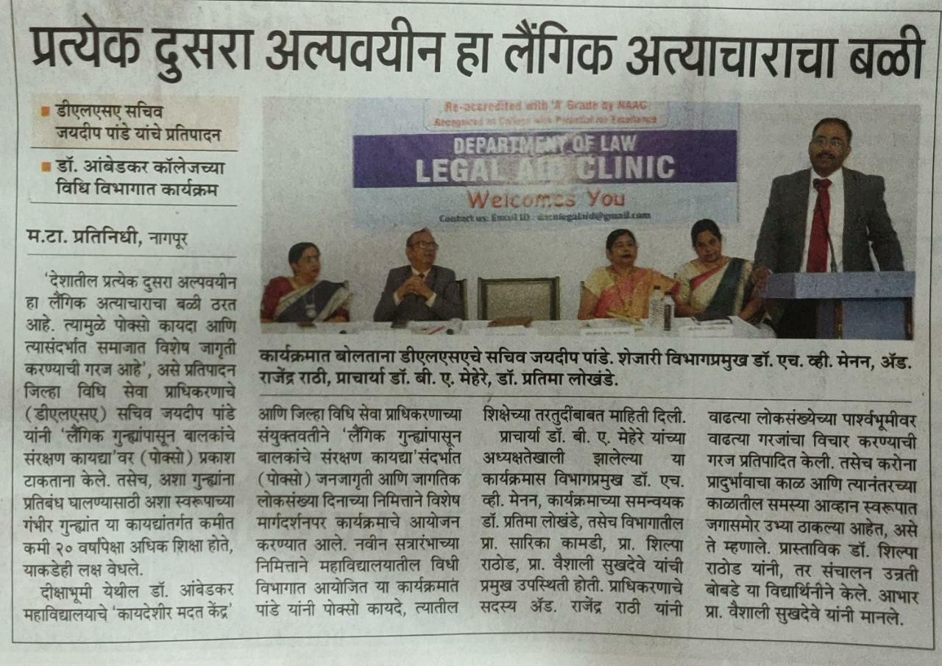

Newspaper Coverage

- “Felicitation of Meritorious Students of the College”: 25th July 2022

Dr. Ambedkar College, Deekshabhoomi, Nagpur, Department of Law felicitated the students for their excellent academic performance in the Summer 2021 examination, on 25th July 2022. The programme was presided by the principal of the college, Dr. B.A.Mehere.

The programme began by paying a floral tribute to the two torchbearers of humanity – Lord Gautam Buddha and Dr. B.R Ambedkar.

The welcome address was delivered by the principal of the college and culminated with a word of hope and belief that the results will get better each year by Dr. B.A. Mehere who firstly applauded the students for their outstanding academic accomplishment and the teaching and non-teaching fraternity for the indomitable endeavour in shaping the future of the young minds.

Head of the Department of Law, Dr. Mrs. H.V.Menon addressed the students
of college and encouraged them to never give up on their dreams. She further asked them to march ahead with strong conviction to pursue in what they believe firmly as the future awaits for those who endure hardships and challenges and blessed the awardees for their bright future.

This was followed by the felicitation of the meritorious students of LLB and LLM Course :

- First in Merit, Gold Medalist in Criminal Law and overall topper in LL.M Course – Ms. Priya Khanna
- First in Merit and Gold Medalist in Criminal Law – Ms. Asavari Kale
- First in Merit in Business Law – Ms. Tarang Shukla
- Third in Merit in Constitutional Law – Ms. Vasundhara Gawande
- First in Merit in LL.B (3 yrs. course) – Ms. Arefa Sheikh
- First in Merit in LL.B (5 yrs. course) – Ms. Kajal Gupta

The program was conducted by Ms. Anusha Patre, Assistant Professor and Vote of thanks was delivered by Ms. Shilpa Rathod, Assistant Professor, Department of Law. She expressed gratitude to the Principal, all faculty members and students for every possible support in making the program a great success. The program was beneficial to the students and their parents as they came to know more about academic ambience and several other opportunities provided by the college to the students.

Efforts taken by working committee and other non teaching staff made this program successful.

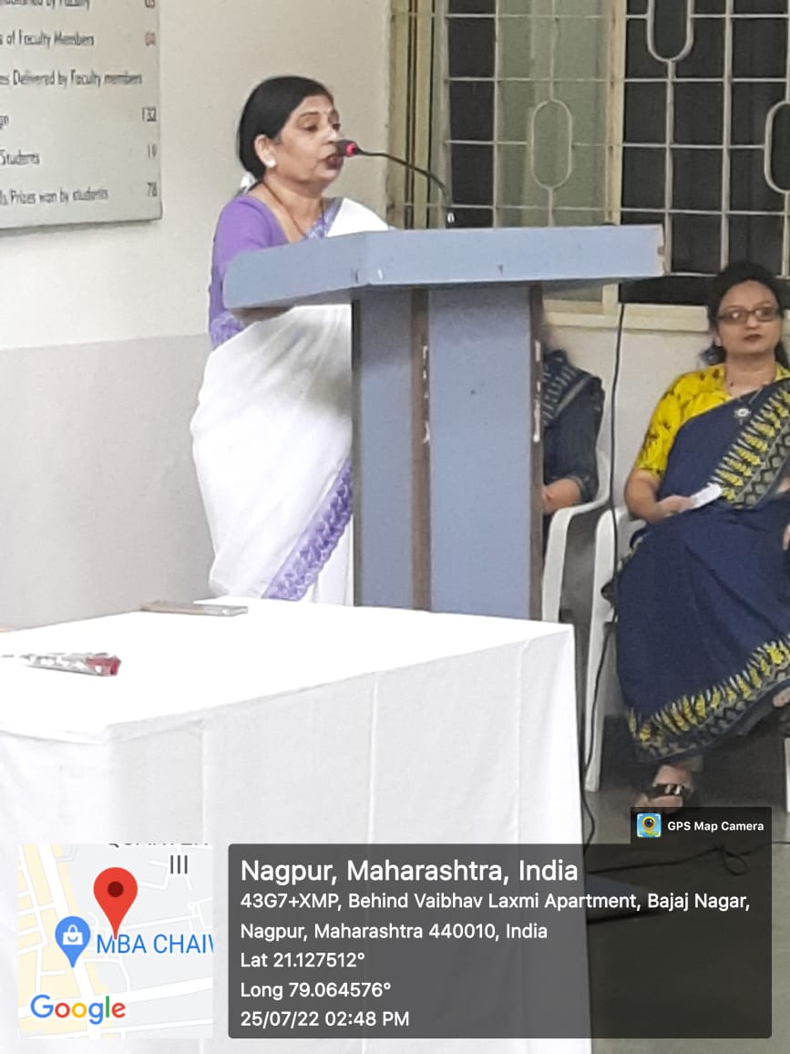
Principal Dr. B.A. Mehere addressing the students

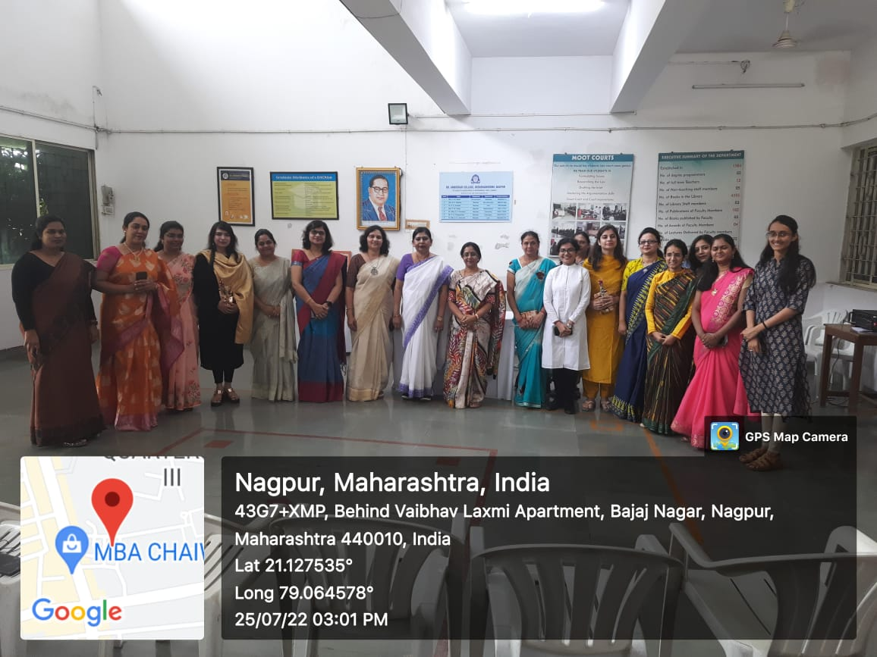

Faculty members with the merit holders
- In-house Moot Court Competition, 2022

NAME OF THE PROGRAMME: In-house Moot Court Competition, 2022
DATE AND DAY: 24th SEPTEMBER, 2022- Saturday
TIME: 11:00 AM
VENUE: Moot Court Hall A and B, Department of Law, Dr.Ambedkar College, Deekshabhoomi
PROGRAMME SUPERVISOR: Dr.Varsha Deshpande
PROGRAMME CO-COORDINATORS: Mrs.Vaishali A. Sukhdeve and Ms. Sarika Kamdi

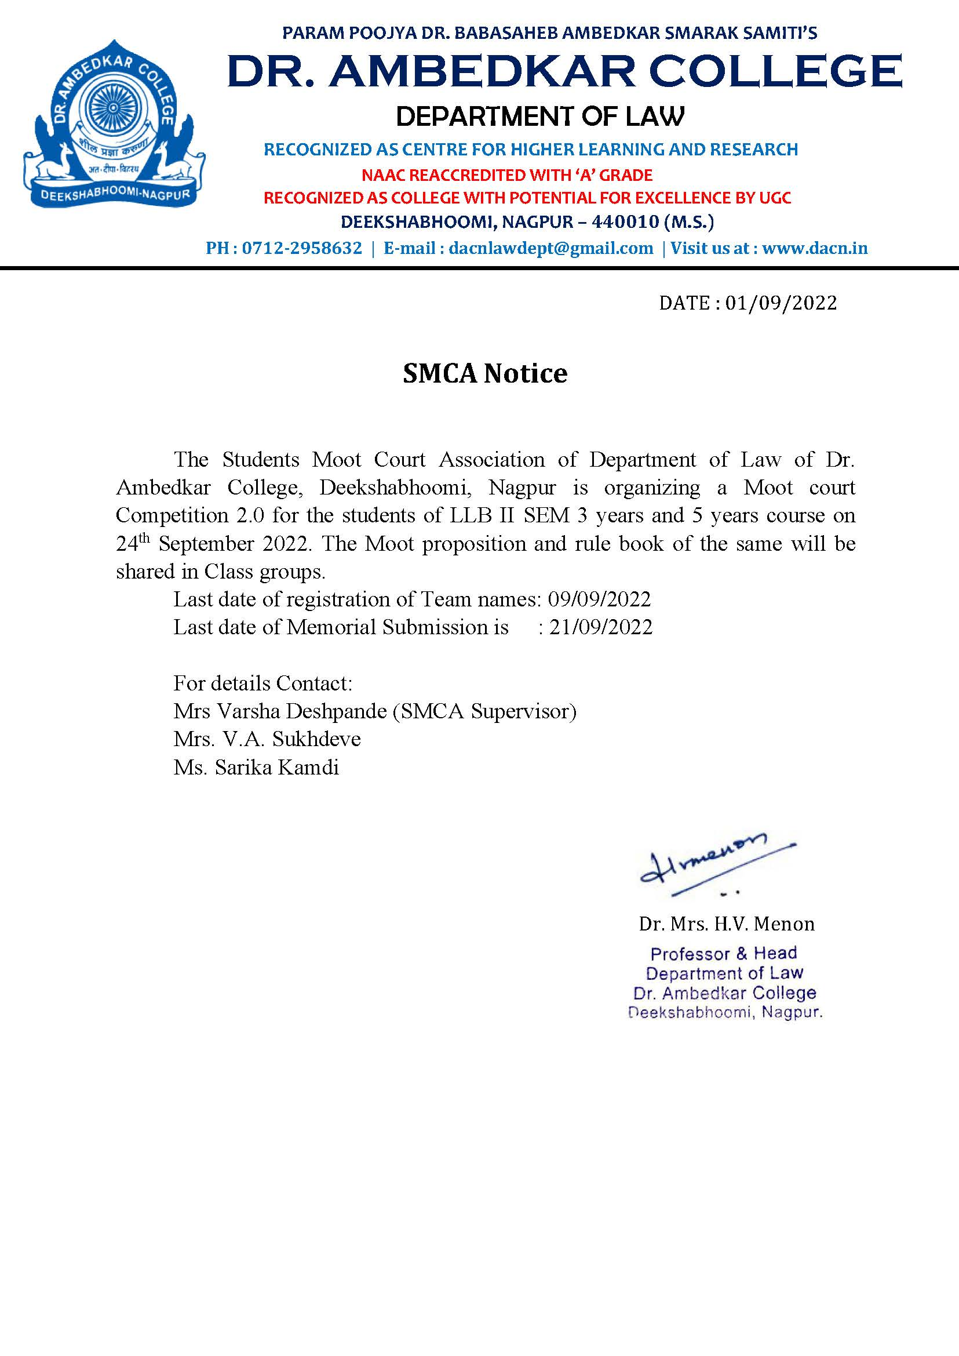
The significance of practical experience can never be overstated- be it in your profession or your life. Theoretical knowledge can get one far ahead in life but that, coupled with knowing of how things work can get one farther. With this in mind, the Department of Law, Dr. Ambedkar College, Nagpur organised its ‘In-house Moot Court Competition’ on 24/09/22.
The SMCA (Students’ Moot Court Association) organised its first event of the academic calendar 2022-23 since its installation. The students, after a break of two whole years due to the Covid-19 pandemic, were eager to participate. Needless to say, the participants, the organisers as well as the audience and faculty were very enthusiastic.
The students willing to participate got their moot problem upon registration, and seeing the performances, it is safe to say that they got to work straightaway. As the tradition goes, the moot problem is based on a real-life judicial precedent, so as to encourage reading and research among the students. And this year was no different. The problem chosen was based on the sensational and much-talked about topic of women’s right to entry in the Sabrimala temple. However, certain changes had been made and certain deviations were kept, so as to make it more challenging.
Speaking of challenges, the students did not back down from this one. The memorials were collected three days prior to the competition, i.e., on 21/09/22 following which the written submissions were concluded. One day prior to the Moot Court, the SMCA organised the ‘draw of lots’ and ‘memorial exchange’, wherein the teams got to know the side they would represent and the team they would argue against. To ensure that the participants would give their best, a small orientation program was also taken. It helped students understand the dos and don’ts that they needed to take care of, while before the Judges.
Finally the day of the competition arrived, and there was a tense feeling among all the participants. The college was honoured to have Adv. Aksahya Sudame, Adv. Nidhi Dayal, Adv. Kuldeep Mahalle and Adv. Vikrant Vishwarupe as the Hon’ble Judges for the competition. Undoubtedly, the students very delighted as well as nervous, in equal parts, to be arguing in front of such knowledgeable personalities.
The competition commenced in two rounds, with each round equally enthralling to view. At the end, the Judges departed the college with great satisfaction and words of affirmations for the participants. The participants had already won there, for they had left the judges impressed. The results of the same were anxiously awaited for, with each team hoping for the best. The faculties decided to not keep the results in dark for any longer, and on the week following the competition, the results were announced. Two teams, Team D and Team G qualified for the final round which is going to be held on 15TH October 2022. The introduction of another round for the Moots was a new addition. It has added more excitement and eagerness to the event.
It is appropriate to say that the SMCA left no stone unturned in co-ordinating the event. The student body showed excellent organizational skills under the guidance of the faculty in-charges of SMCA Mrs. Vaishali Sukhdeve and Ms. Sarika Kamdi. Lastly, and most importantly, the event was successful because of the constant support and supervision of Dr. Mrs. Varsha Deshpande and the Head of the Department, Prof. Dr. Mrs. H.V. Menon.
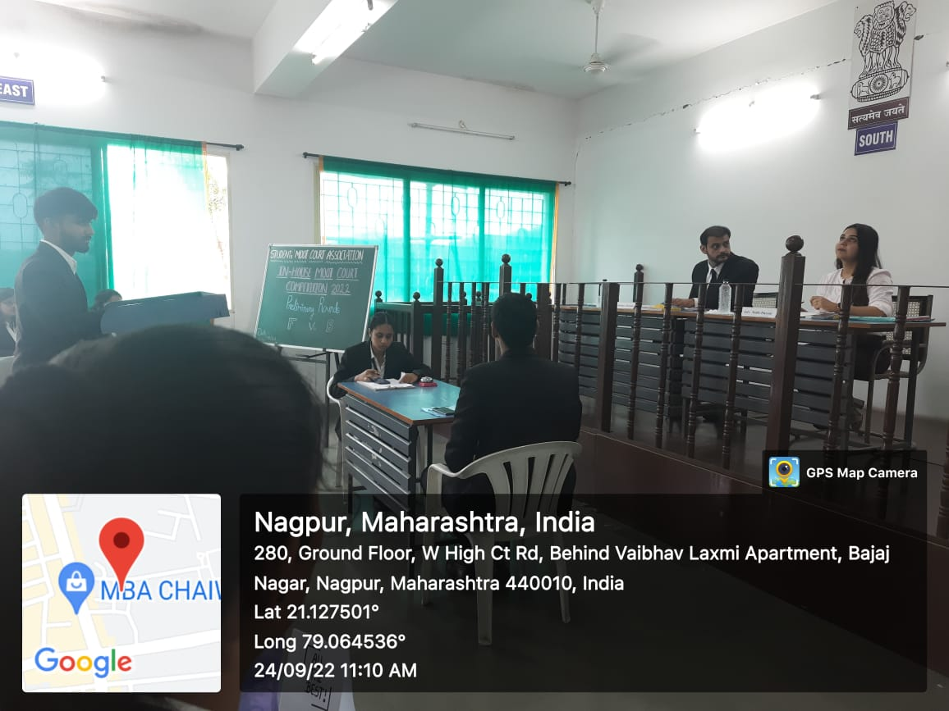 | 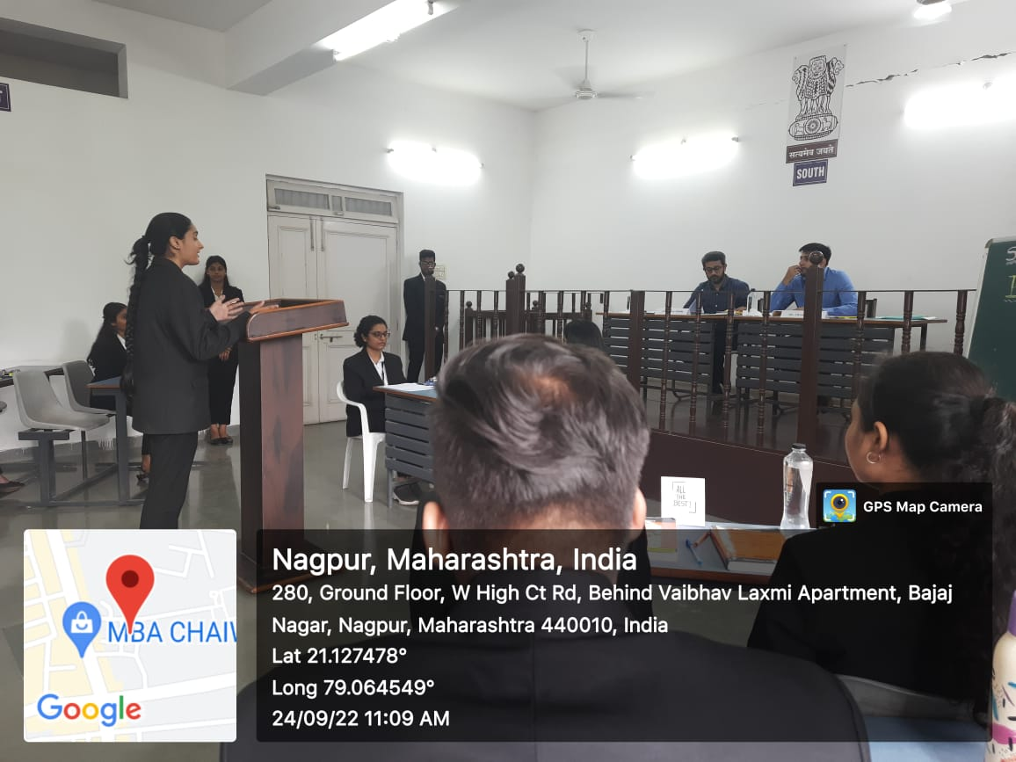
Students engaged in the Moot Court Competition as mooters in Moot Court Hall A and B
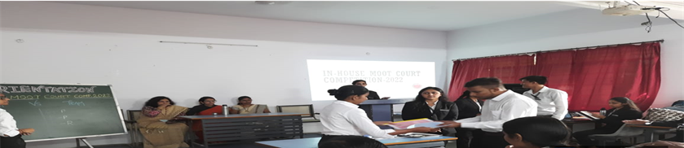
Students engaged in the memorial exchange program conducted during draw of lot
- REPORT OF AWARD CEREMONY- 2022

NAME OF THE PROGRAMME: Academic Excellence Award Ceremony- 2022
DATE AND DAY: 28TH September 2022, Wednesday
TIME: 11:30 AM
VENUE: Seminar room, Department of law, Dr.Ambedkar College, Deekshabhoomi
PROGRAMME SUPERVISOR: Dr. H.V. Menon
PROGRAMME CO-COORDINATOR: Mrs. Vaishali A. Sukhdeve

An Award ceremony to felicitate the toppers of the academic year 2021-2022 of LLB 3 years and 5 years course was organised by Department of Law, Dr. Ambedkar College Nagpur. The ceremony was graced by Chief guest, Adv. Sudhir Meshram, Dr. Sudhir S. Fulzele , Secretary, Param Pujya Dr. Babasaheb Ambedkar Smarak Samiti, Principal Dr. Mrs. B.A Mehre, Head of the department of law Dr. H.V. Menon and all the teaching staff. The ceremony began with the blessings of Lord Gautam Buddha and Dr. Babasaheb Ambedkar through traditional offering of devotion by garlanding of their portraits and lighting the candles by the chief guests and the dignitaries present on the dais. The welcome address was delivered by the Principal of the College, Dr. B.A. Mehere.
The Academic excellence Awards for this ceremony were sponsored and instituted by Adv. Sudhir Meshram in the memory of his father, Late, Adv. Shri. Sakharampant Meshram, former Mayor, Nagpur and first Chairperson of Param Pujya Dr. Babasaheb Ambedkar Smarak Samiti. Along with this, to commemorate the birth anniversary of Late, Adv. Shri. Sakharampant Meshram, a lecture series was also inaugurated on this occasion. The first lecture of the series was delivered by Adv. Meshram Sudhir Meshram who explained the importance of Law education and its significance for the society, where he advised the students to be well versed with Legal citations as well as application and interpretation of relevant legal provisions. Adv. Sudhir Meshram, also stated about the accomplishments and struggles of his father in whose remembrance the award is instituted. Presidential Address by Dr. Sudhir S. Fulzele, Secretary, PP Dr. Babasaheb Ambedkar Smarak Samiti was an inspiration to the law students, where he congratulated the students to be part of the prime institution and also emphasized on the importance of teacher’s role in an institution.
The awardees in the ceremony were Mr. Ved Gulaxe, highest sorcerer of LLB 3 years Course and Ms. Soniya Srinivasan, who secured highest aggregate marks in LLB 5 years course , batch of 2021-22. The vote of thanks was proposed by Prof. Dr. H.V. Menon, Head, Department of Law. The program was conducted by Mrs. Vaishali A. Sukhdeve, Assistant Professor. All the faculties of Department of Law were present and graced the ceremony and congratulated the awardees. The students of LLB 3 years and 5 years were also present to witness the ceremony.
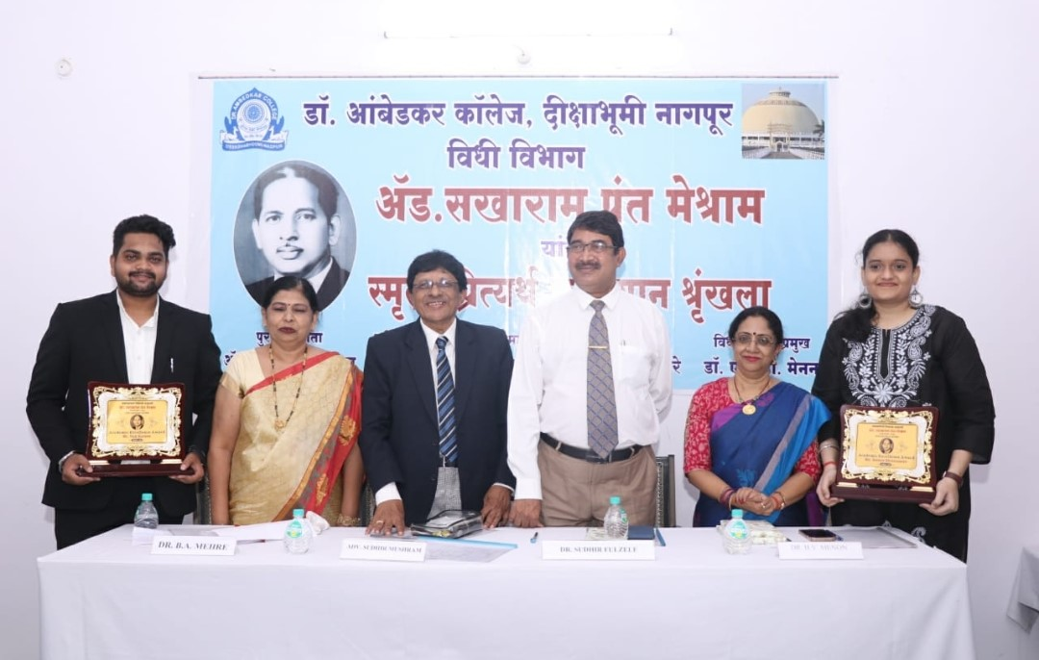
Adv. Sudhir Meshram, Dr. Sudhir Fulzele, Dr. B.A. Mehere, Prof. Dr. H.V. Menon along with the awardees Mr. Ved Gulaxe and Ms. Sonia Srinivasan.
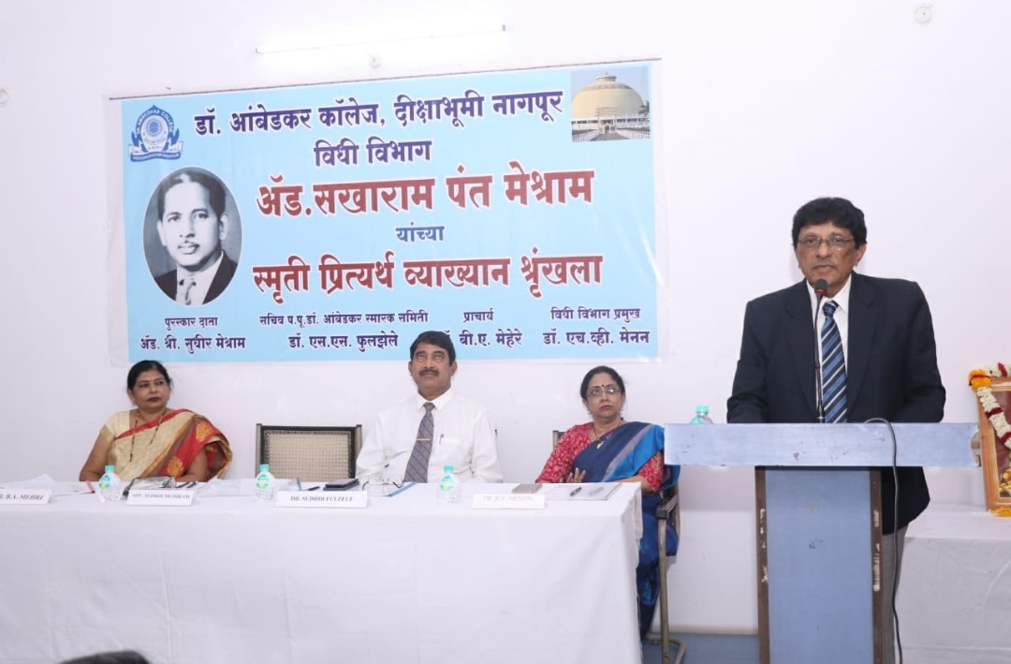
Adv. Sudhir Meshram, Chief guest and first speaker of the lecture series, commemorating the birth anniversary of Late, Adv. Shri. Sakharampant Meshram
- Guest Lecture on“Social Sensitization” : 14th September, 2022
NOTICE
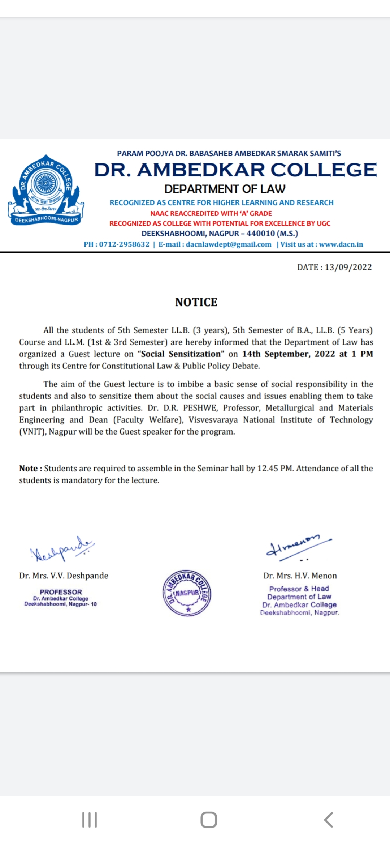
Report:
Dr. Ambedkar College, Department of Law, Deekshabhoomi, Nagpur, through the Centre for Constitutional Law and Public Policy Debate organized a Guest Lecture on the topic “Social Sensitization” on 14th September, 2022. The Speaker of the program was Dr. D.R. Peshwe, Professor, Metallurgical and Materials Engineering and Dean (Faculty Welfare), Visvesvaraya National Institute of Technology (VNIT), Nagpur. The aim of the Guest lecture was to imbibe a basic sense of social responsibility in the students and also to sensitize them about the social causes and issues enabling them to take part in philanthropic activities. The program commenced with a Welcome address by Dr. H.V. Menon, Professor & Head, Department of Law, Dr. Ambedkar College, Deekshabhoomi, Nagpur. The Introductory remarks were given by Dr. Varsha Deshpande, Professor and Co-ordinator, Centre for Constitutional Law and Public Policy Debate in which she highlighted various activities carried on by the Centre along with the importance of “Social Internship” along with “ Legal Internship” in the lives of law students.
In this program, the Guest Speaker discussed about the different NGOs working for different social causes. He gave insight about “Snehankur” which provides medical help in excellent hospitals for unwed mothers who relinquish their children. These women are then provided counselling and when required an opportunity to take professional employment or education free of cost. He also talked about “Snehalaya” which works towards developing the awareness and capability of individuals who have been deprived of their fundamental rights as a result of the inequalities that exist in our society and also towards offering a safe exit point to women and their children trapped in the crippling cycle of poverty and abuse. He also shed some light on the Charitable Trust, named “Mahan”, a 'Non-Profit' & 'Non-Government' organization providing preventive & curative medical facilities to tribal people in Melghat. He also gave valuable insight about another NGO named “Goonj” which envisions to grow as an idea across regions, economies and countries using urban discard as a tool to alleviate poverty and enhance the dignity of the underprivileged people of the world.
Dr. Peshwe also discussed about “Prayaas”, a social club of VNIT with a motto of “One can’t help many but everyone can help someone”. The members of this Club invest time, efforts and creativity for a better society. He also discussed in detail about the Anandvan project which was started by 'Baba Amte' who worked for the rehabilitation and empowerment of people suffering from leprosy.
The program was conducted by Dr. Varsha Deshpande, Professor and Co-ordinator, Centre for Constitutional Law and Public Policy Debate. Ms. Anusha Patre, Assistant Professor, Dr. Ambedkar College, Deekshabhoomi, Nagpur proposed the Vote of Thanks
The lecture was then followed by Question – Answer Session.
The Guest lecture was attended by 75 participants approximately comprising of the students from LL.B and LL.M. of the Department of Law and the Faculty members of the Department of Law. The feedback was also taken from the students.
Photos:
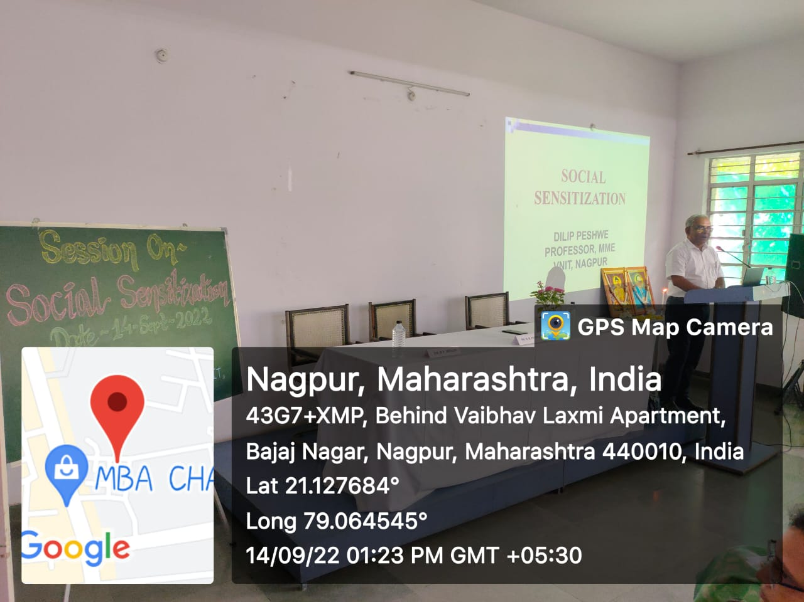
Dr. D.R. Peshwe, Professor, Metallurgical and Materials Engineering and Dean (Faculty Welfare), Visvesvaraya National Institute of Technology (VNIT), Nagpur addressing the students on “ Social Sensitization”

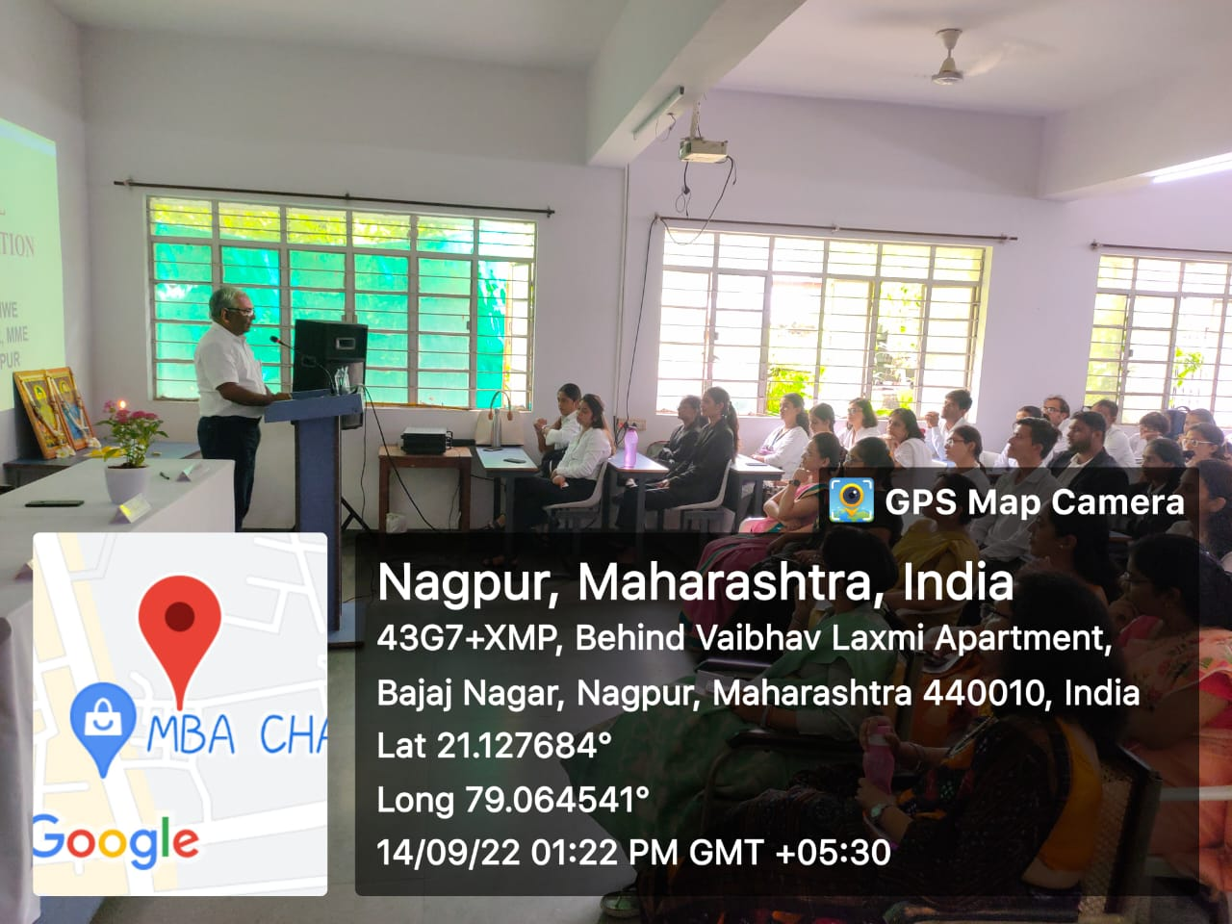

Feedback forms:
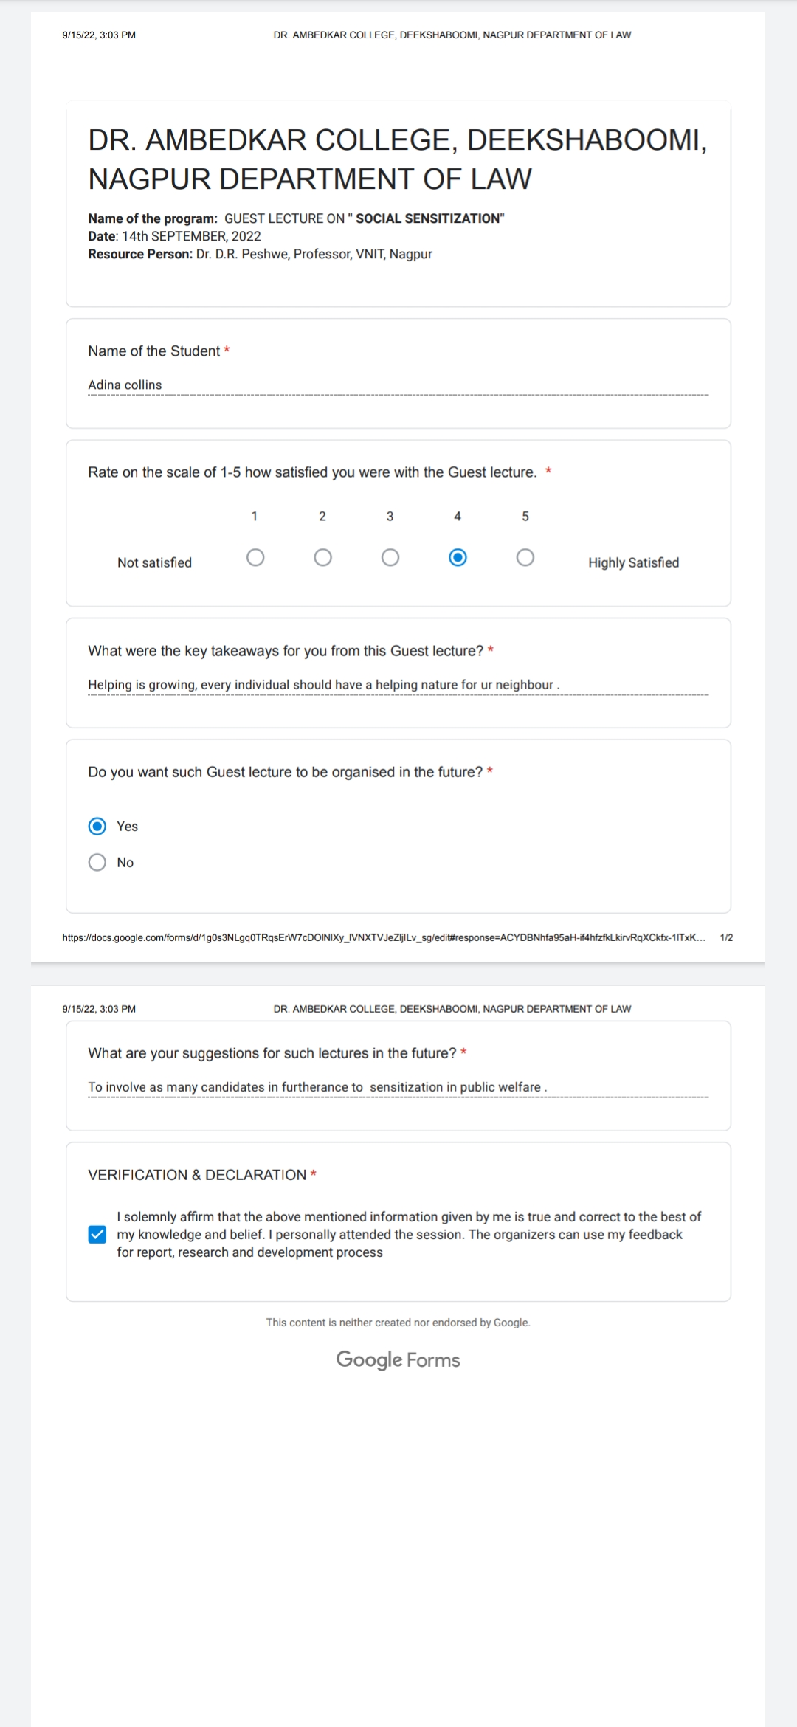

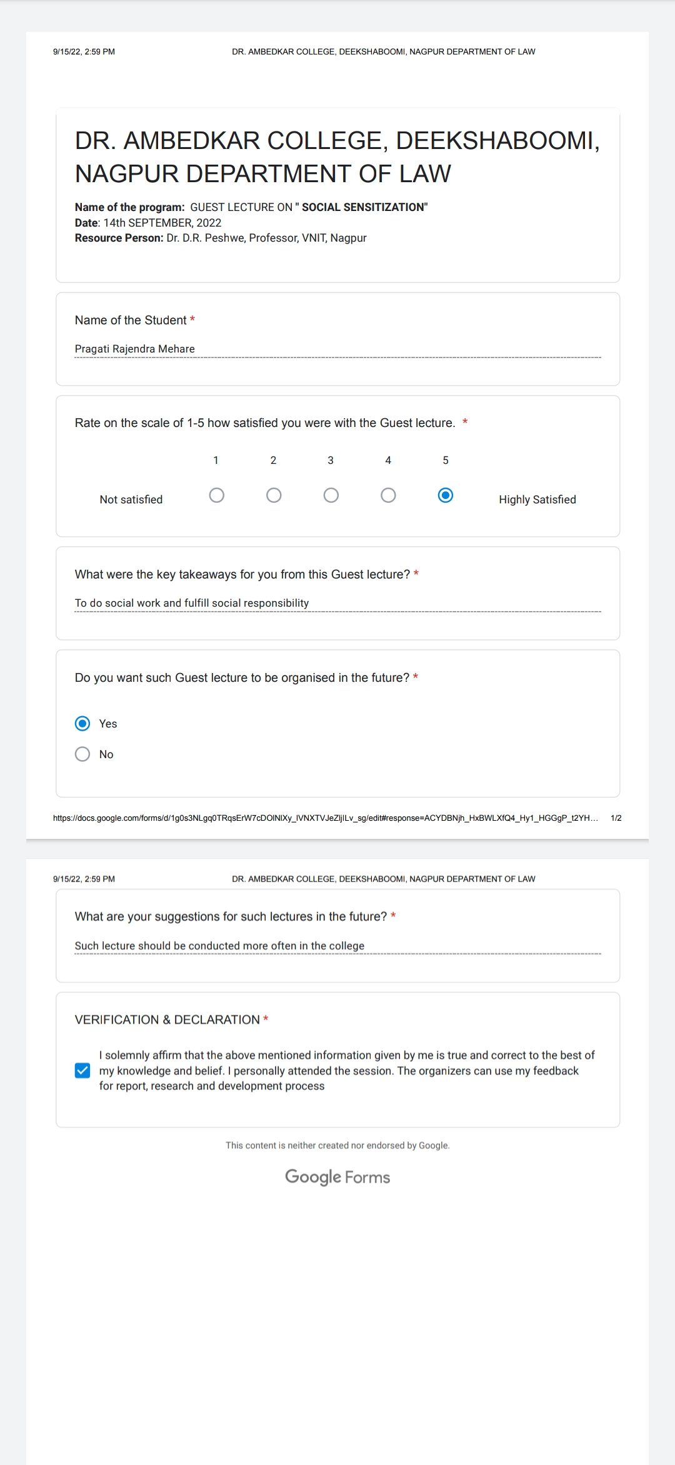

- REPORT ON “PROFESSIONAL ETHICS IN CONCILIATION AND ARBITRATION PROCEEDINGS” GUEST LECTURE 2022

NAME OF THE PROGRAMME: | “PROFESSIONAL ETHICS IN CONCILIATION AND ARBITRATION PROCEEDINGS” Guest lecture for final year students of LLB IXth SEM(5years) and Vth SEM (3 Years)
DATE AND DAY: | 3rd September, 2022, Saturday
TIME: | 12:00 P.M- 12.50 PM
GOOGLE MEET LINK:
PROGRAMME CO-ORDINATOR: | Asst.Prof. Sarika kamdi,
RESOURCE PERSON : Adv. Wilson Mathew

On 3rd September, 2022, Saturday, guest lecture was conducted by Dr. Ambedkar College, Department of Law, Deekshabhoomi, Nagpur for the final year students of LLB IXth Sem(5 yrs) and VI Semester (3 years course). Total 60 students attended the program. The Program was conducted under the guidance of Prof. Dr. H.V.Menon, Head of the Department of Law, and Associate Professor Dr. Pratima lokhande. in LLB VIth Semester (3years course) in Seminar Hall Room No.4 at 12.00 P.M.

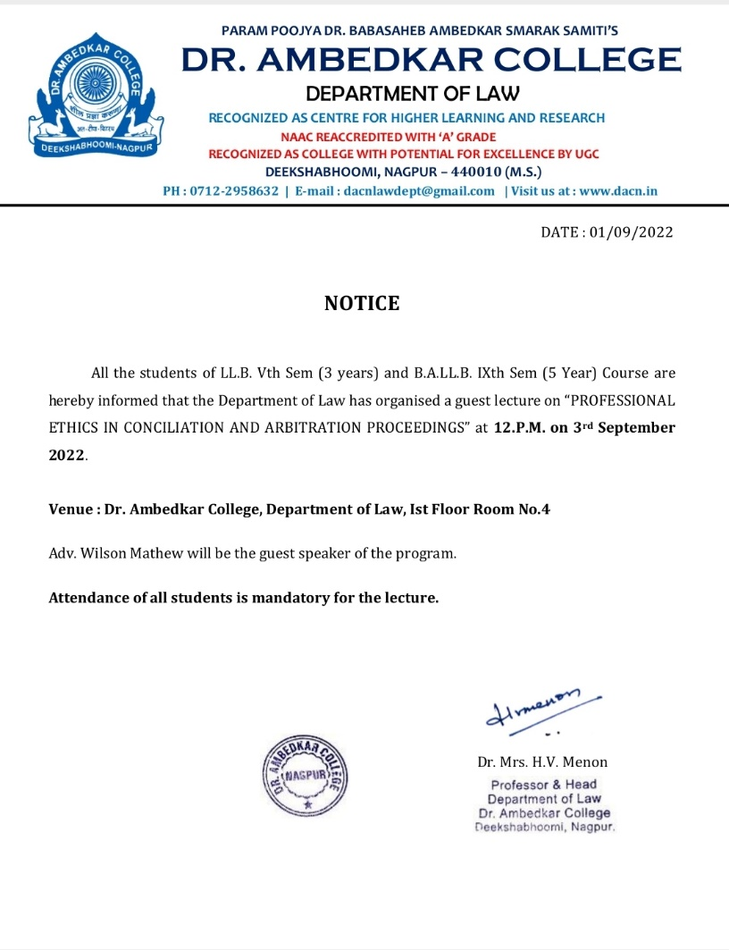
The course content delivered in the lecture is as follows
“PROFESSIONAL ETHICS IN CONCILIATION AND ARBITRATION PROCEEDINGS’’

The speaker of the session Adv. Wilson Mathew presented the keynote address on “PROFESSIONAL ETHICS IN CONCILIATION AND ARBITRATION PROCEEDINGS” and its importance in legal studies.
This lecture was arranged with the motive of sharing the knowledge and practical experience of Adv Wilson Mathew. He started his interaction with the students on a note by asking them how they follow ethics in their day today life. He discussed and analysed the relationship between ethics and law profession. Eventually moved towards the topic law profession and ethics focusing on different aspects of arbitration and conciliation. The relation between them he tried to explain students how ethics are important in noble profession like law. Covered different concept and aspect of social responsibility. He precisely covered conflict of interest in detail and guide the students how to take a call on situation where there is conflict of interest. He discussed the ethical grounds for refusing to accept a brief. Suggested the students to Give the client an informed choice. Then he discussed who can appointed as arbitrators. What is right way to be followed in arbitration and conciliation proceeding. Discussed how commercial laws operate in India, what is position in India and abroad. Shared his national and international arbitration and conciliation experience there by making the session more interactive and informative.

Adv. Wilson Mathew Interacting with students
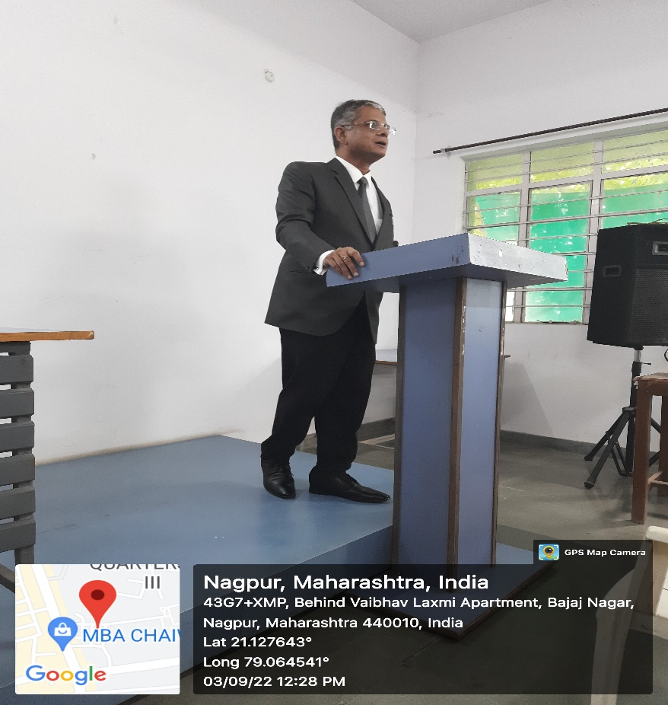

feedback responses obtained from through google form the participants
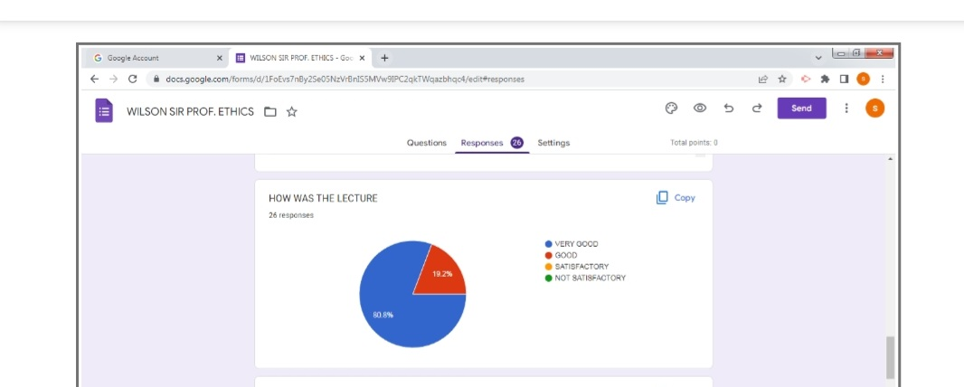

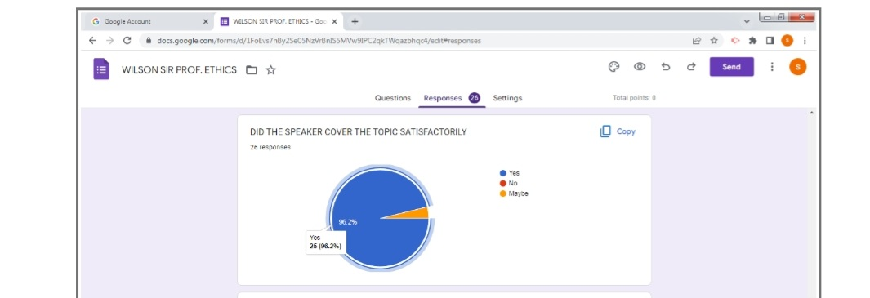
The objectives of the webinar were achieved. The overall session discussion benefitted the faculties and the students. This online lecture would help the participants in their academic studies and also in their future professional career.

- Debate Competition:
Date: 7th Sept 2022
Name of the Programme: Debate Competition
Name of the Judges: 1. Adv. Piyush Kadam
2. Adv. Rohan Chabra
Name of Program Co-ordinators: 1. Mrs Sandhya Kalamdhad
2. Ms. Shilpa Rathod
3. Mrs. Vaishali Sukhdeve
4. Ms. Sarika Kamdi
Number of Attendees: 73
Number of Participants: 14
Name of Venue: Seminar Hall of Department of Law, under the aegis of Criminal Law Club, Dr. Ambedkar College Deeksha Bhoomi, Nagpur

NOTICE
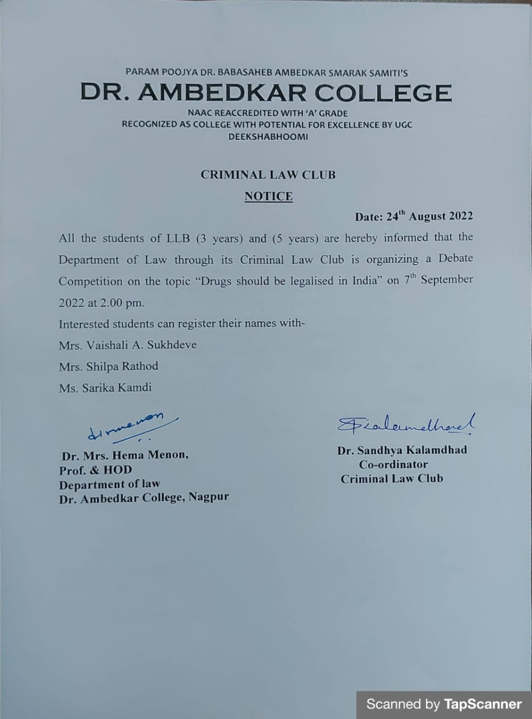

REPORT ON DEBATE COMPETITION

The Criminal Law Club of the Department of Law, Dr. Ambedkar College, Deekshabhoomi Nagpur, has conducted the Intra-college Debate Competition on 7th Sept 2022 for the students of LL. B 3 years and 5 years course. The topic of the debate was “DRUGS SHOULD BE LEGALISED IN INDIA?”
Total 73 attendees were present in the programme, out of which 14 participants had competed in the competition. Each participant had to speak either for or against the motion under the time duration of 5 minutes. The competition was ably judged by Adv. Piyush Kadam, Advocate practicing in District Court and High Court, Nagpur and Adv. Rohan Chabbra, Advocate practicing in District Court and High Court, Nagpur.
The program commenced with the welcome address by Dr. H.V. Menon, Head Department of Law to the well acclaimed Judges, the faculty members of the departments, treasured invitees and the participants. The rules of the competition were read out before commencing the competition. All the participants were invited individually to express their views on the topic of the competition. There were so many notable points presented by each participant and brought out their hidden intellect. At the end 2 minutes time allowed to the first speakers favouring the motion and against the motion for rebuttal.
At the end both the judges have enlightened with the words of inspiration and motivation to the participants and students and provided few encouraging tips in the student’s interest.
The first prize bagged by Ms. Nishtha Singh, Ms. Sneha Badhiye secured the second prized and Ms. Apurva Pittalwar is the third recipient of prize. The special recognition has been given to all the Participants for their excellent performance.
The Programme was compared by Ms. Shilpa Rathod under the guidance & supervision of Dr. Mrs. Sandhya Kalamdhad, Associate Professor and Organising secretary of Criminal Law Club of Department of law.
The event concluded with vote of thanks proposed by Ms Vaishali Sukhdeve to the jury members and also to everyone who was present to witness the event.

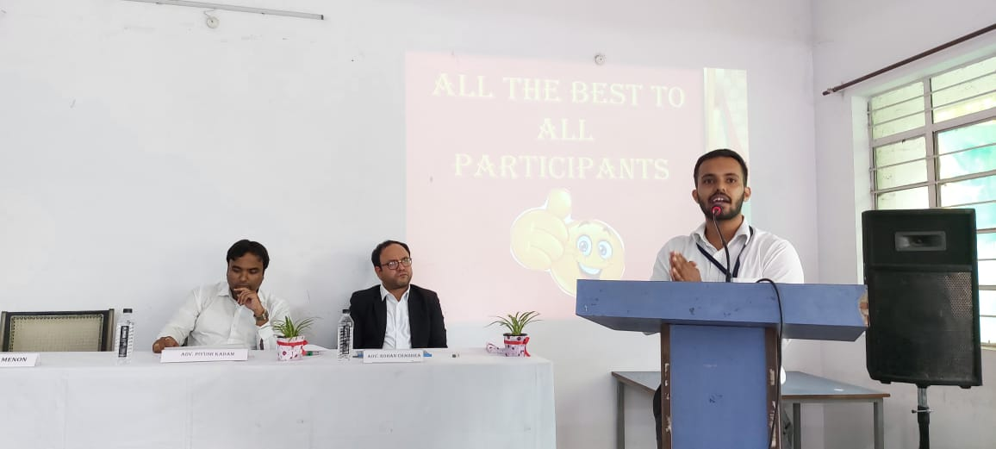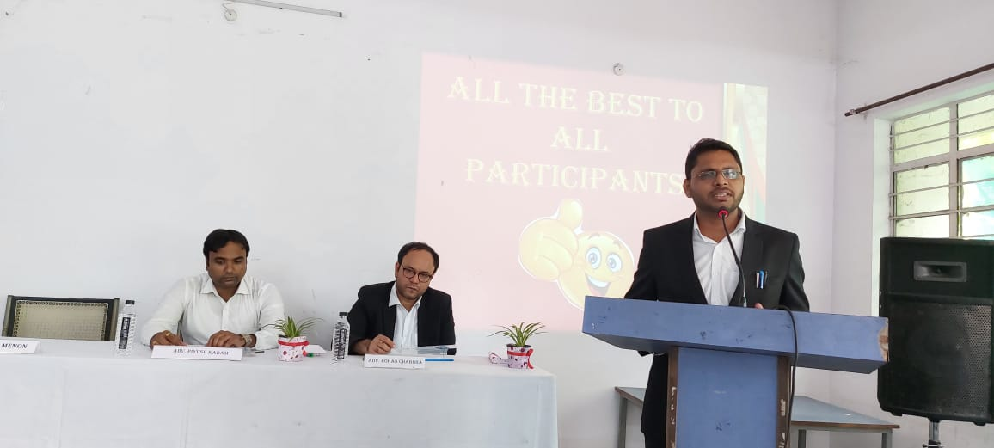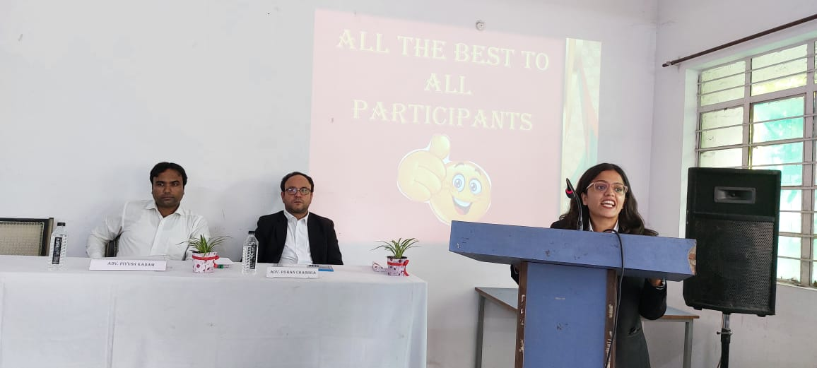
(The Participants presenting their views for and against the motion in the competition)

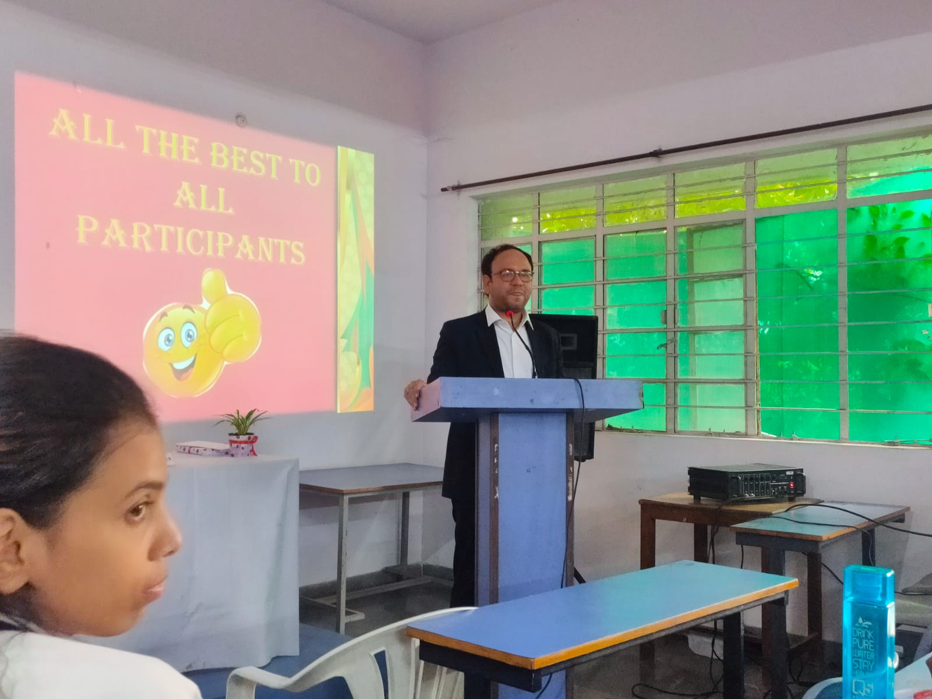
- SMCA INSTALLATION CEREMONY

NAME OF THE PROGRAMME: SMCA INSTALLATION CEREMONY
DATE AND DAY: 17th SEPTEMBER, 2022- Saturday
TIME: 11:30 AM
VENUE: Auditorium, Dr.Ambedkar College, Deekshabhoomi
PROGRAMME SUPERVISOR: Dr.Varsha Deshpande
PROGRAMME CO-COORDINATORS: Mrs.Vaishali A. Sukhdeve and Ms. Sarika Kamdi

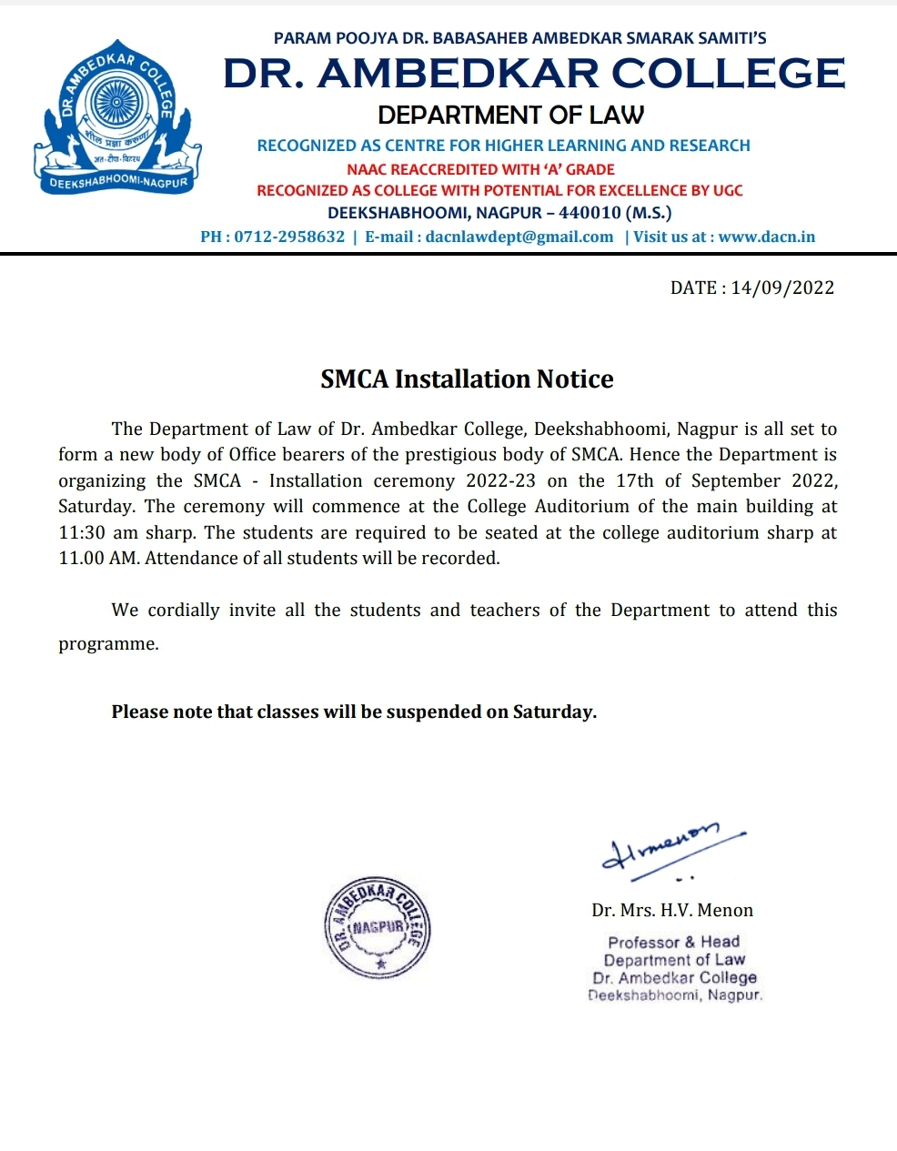

A new team of office bearers of the Student’s Moot Court Association (SMCA) for the academic year 2022-2023 of Dr. Ambedkar College Nagpur was inducted on 17th Septembe 2022. We had on the dias our esteemed Chief guest Adv. Nahush Khubalkar, Principal Dr. Mrs.B.A Mehre, Head of the department of law Dr.H.V.Menon and the Supervisor of SMCA Dr.V.V.Deshpande. The ceremony began with a traditional offering of devotion to Lord Gautam Buddha and Dr. Babasaheb Ambedkar with garlanding of their portraits and lighting the candles by the chief guests and the dignitaries present on the dais.
Further, the chief guest of the ceremony Adv. Nahush Khubalkar was offered an eco-friendly welcome with a sapling by the incoming President Unnati Bobde. The Principal Dr. Mrs.B.A Mehre was welcomed with a sapling by the incoming Vice President Atik Pansare. The principal Dr. Mrs.B.A Mehre then addressed the audience and welcomed the chief guest. Her speech made an enthusiastic start to the ceremony. She encouraged the students and also wished all the good luck to the new body of SMCA.
The Supervisor of SMCA, Dr.V.V.Deshpande then presented the introductory remarks. She introduced to the audience the aims and objectives of the SMCA. She clearly pronounced the workings of the body of SMCA and its importance for the development of students. Through her words, she firmly made the students believe that not only the SMCA conducts events, but also develops the qualities of team work, discipline, perseverance and punctuality.
Thereafter, the formal installation of the new team of office bearers took place. Ms.Unnati Bobde was pinned as the President of the SMCA by the chief guest. Incoming president Ms.Unnati Bobde then exchanged the chair with the outgoing President Ms. Sonia Shrinivasan. The entire team of SMCA was then installed by the President. Ms.Mugdha Mundle took charge as the Secretary of the SMCA and then exchanged the chair with the outgoing Secretary Mr.Vedant Vyawahare. A total of 11 Core-Committee members and 22 Executive Committee members were installed.

The core committee consists of :
PRESIDENT - Unnati Bobde
VICE PRESIDENT- Atik Pansare
SECRETARY -Mugdha Mundle
JOINT SECRETARY-Tanmay Makkad
TREASURER- Rushabh Bangre
DIRECTOR I- MOOT COURT WORKSHOP - Sneha Badhiye
DIRECTOR II- MOOT COURT COMPETITION – Kshipra Ektare
STUDENT COORDINATOR MOOT COURT WORKSHOP- Gayatri Khaire
STUDENT COORDINATOR MOOT COURT COMPETITION - Dnyaneshwar Neherkar
EXECUTIVE HEAD(3YRC) - Kartiki Gowardipe
EXECUTIVE HEAD(5YRC) - Saloni Gupta

The executive committee members are:
Ms.Shriya Fadnavis, Mr.Vaibhav Gajbhiye, Mr.Praful Askar, Ms.Mansi Bali, Ms.Shruti Tighare, Mr.Surendra Gondane, Mr.Shreyansh Srivas, Ms.Surabhi Sayankar, Mr.Pranjal Jagdale, Ms.Radha Pachpor, Mr.Ritvick Naidu, Ms.Sumiti Oza, Mr.Soham Kathane, Ms.Yashika Nihalani, Ms.Aditi Anshu, Mr.Kuldeep Patil, Ms.Bushra Khan, Ms.Priyanka Kodwani, Ms.Ananya Tandaiyya, Ms.Shatakshi Dorle, Ms.Shivani Chintakuntalwar, Mr.Saad Khan.

The new office bearers of SMCA then sworn the oath. The oath was administered to the new body of SMCA by the principal Dr. Mrs.B.A.Mehre, followed by the group photograph of the newly elected body of SMCA.
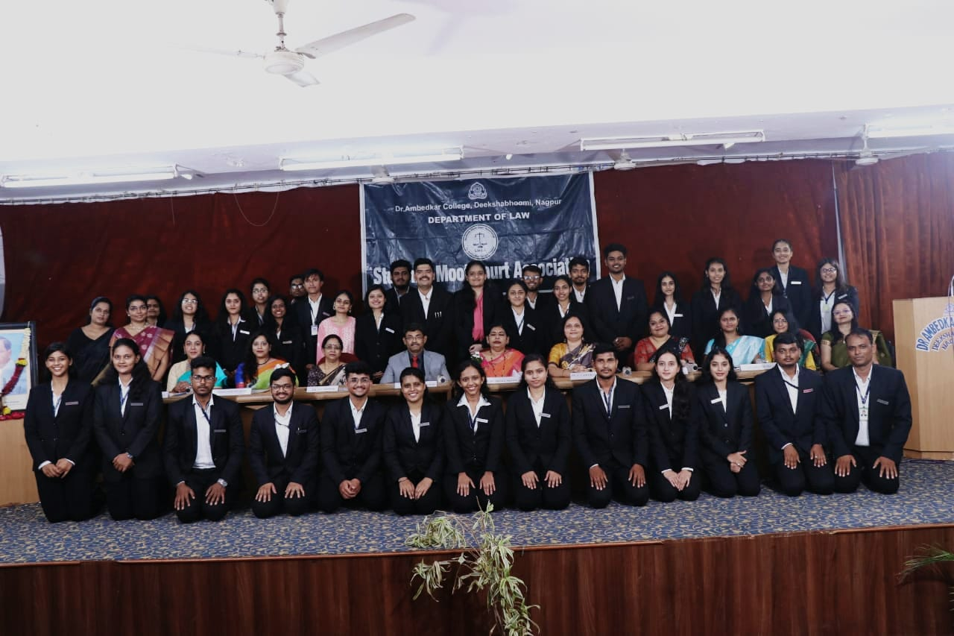
The President, Ms.Unnati Bobde then delivered an impressive acceptance speech which was a fine amalgamation of both, gratitude and confidence.
The esteemed ChieF Guest Adv.Nahush Khubalkar then addressed the audience. He has been a practicing Advocate since last 30 years. He has handled many cases in the areas of civil law, criminal law and constitutional law. He has a Master’s degree in the International law from Nagpur University. He has also judged various moot court competitions held in university college of law Nagpur. He was also appointed and functioned as assistant government pleader and additional public prosecutor for the government of Maharashtra. He is now practicing as a private advocate before the Nagpur Bench of Bombay High court in Nagpur. In his address, he congratulated the students on becoming members of the SMCA. He also stressed upon the importance of moot court workshops, competitions and other activities conducted by the SMCA for the development of the budding lawyers.

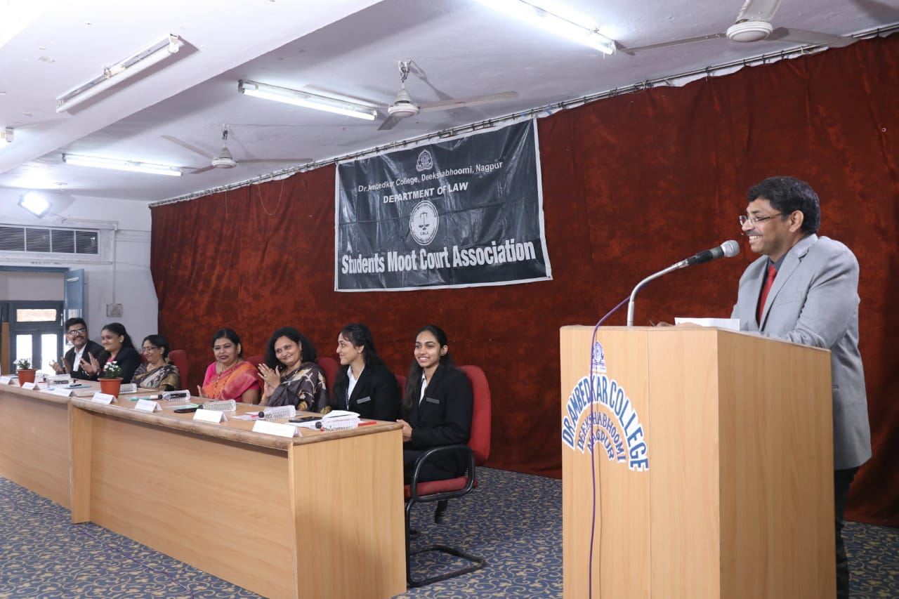

The Head of the Department of Law, Dr. H.V. Menon then addressed the audience. She admired how the Chief Guest convinced the students about the importance of moot court competitions. She encouraged the students to actively participate in the activities conducted by the SMCA.

The Secretary, SMCA, Ms.Mugdha Mundle presented the Chief guest, Adv.Nahush Kubhalkar with a memento.

The vote of thanks was delivered by Secretary Ms. Mugdha Mundle. She whole heartedly, extended her sincere thanks to everyone present in the auditorium.
The programme was concluded with the singing of the National Anthem. The proceedings of the SMCA Installation ceremony 2022-23 were carried on by Ms.Sanika Duragkar and Ms.Subhusha Agrawal.

All faculty members of the Department and students of LLB 3 years and 5 years were present in large numbers.

- Teachers Day Report:
Name of the Programme: Teachers Day Celebration
Day & Date : Tuesday, 6th September’2022
Time & Venue : 12pm, Dr. Ambedkar College
Department of Law, Nagpur

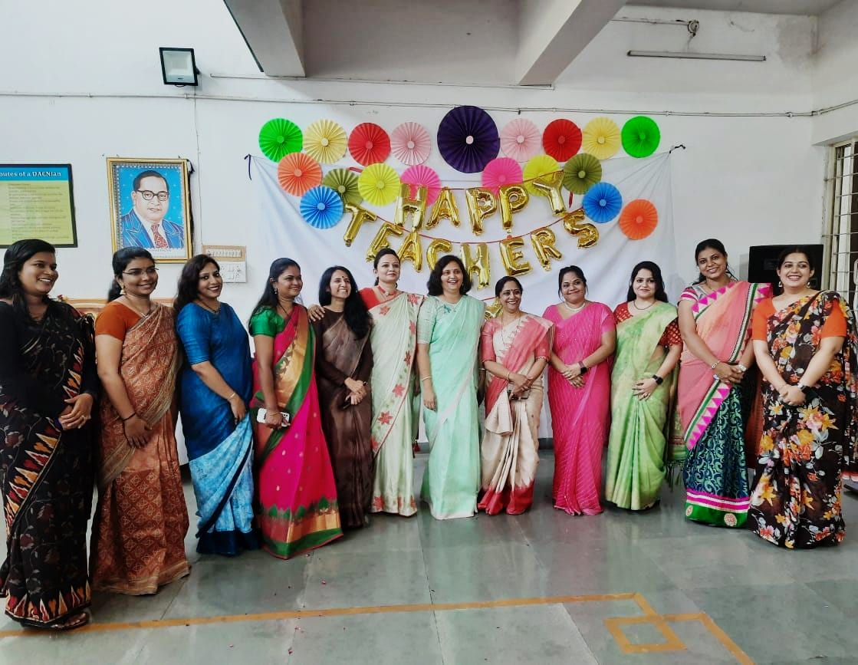
"Teachers are the torch bearers of the Gen-next"
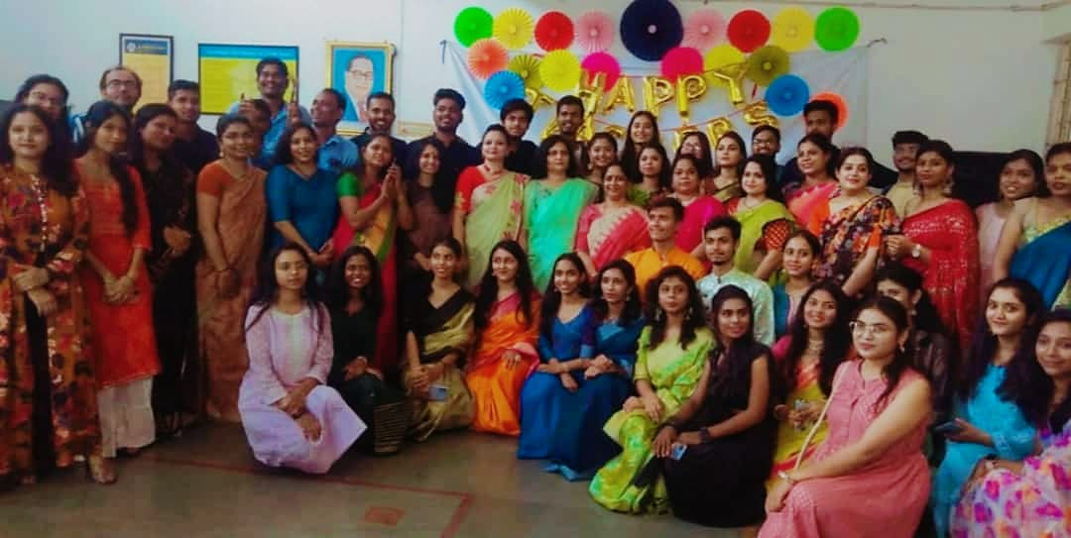
In India, 5th September is celebrated as Teachers Day as a mark of tribute to the contribution made by teachers to the society. 5th September is the birthday of a great teacher Dr. Sarvapalli Radhakrishnan, a staunch believer of education and a well-known diplomat, visionary, statesman, scholar, President of India and above all a perfect Teacher.
Teacher's day was celebrated by the students of Law Department on 6th September to express their gratitude for the immense contribution put forth by their teachers towards their development. Students decorated the college campus and welcomed the faculties warmly.
The celebration began with a traditional offering of devotion to Lord Buddha and Dr. Babasaheb Ambedkar with garlanding of their portraits and lighting the candles by the Head of the Department, Mrs. H.V. Menon and all other faculties. Further, each of the faculties were given a token of gratitude to show the acknowledgement and recognition of the hard work put by the teachers, wishing them a Happy Teachers Day.
A student of 3rd Year from the 3 Years course then delivered a speech on the importance of teachers in one’s life and the concept behind the celebration of Teachers Day. Her speech gave an enthusiastic start to the celebration. Then the students conducted games like Dumb charades & Quizzes and other recreational activities among the teachers to engage them and showcase a great deal of bond which goes beyond work colleagues. Unlike any other monotonous workday, the students wanted the day to be very free flowing and relaxing for the teachers. So, students and the teachers participated in singing beautiful melodies for a change.
The Head of the Department, Dr. H.V. Menon then addressed the audience by admiring all the hardwork and the wonderful collaborations by the students throughout. She also acknowledged all the contribution made by everybody for the collective upliftment of the department.
After all the hush & bush from the recreational activities, the enthusiasm in the room was still there. So, we finally settled down to celebrate this auspicious day by cutting the cake by the teachers & a session of photography commenced thereafter.
The vote of thanks was delivered by Ms. Unnati Bobde a student of final year. She whole heartedly extended her sincere wishes to all the teachers and thanked everybody for their presence. Teachers Day was celebrated with a lot of anticipation, for the sheer spirit of the occasion. The event was concluded by the reviews of the Department and all the faculties.
- Fun Activity : DAY:19TH SEPTEMBER 2022

ORGANISING DEPARTMENT: THE NOUVEAU CORPORATES CLUB OF DEPARTMENT OF LAW

PROGRAM CO-ORDINATORS: DR. PRATIMA LOKHANDE
MS. ANUSHA PATRE

NUMBER OF STUDENTS: 30

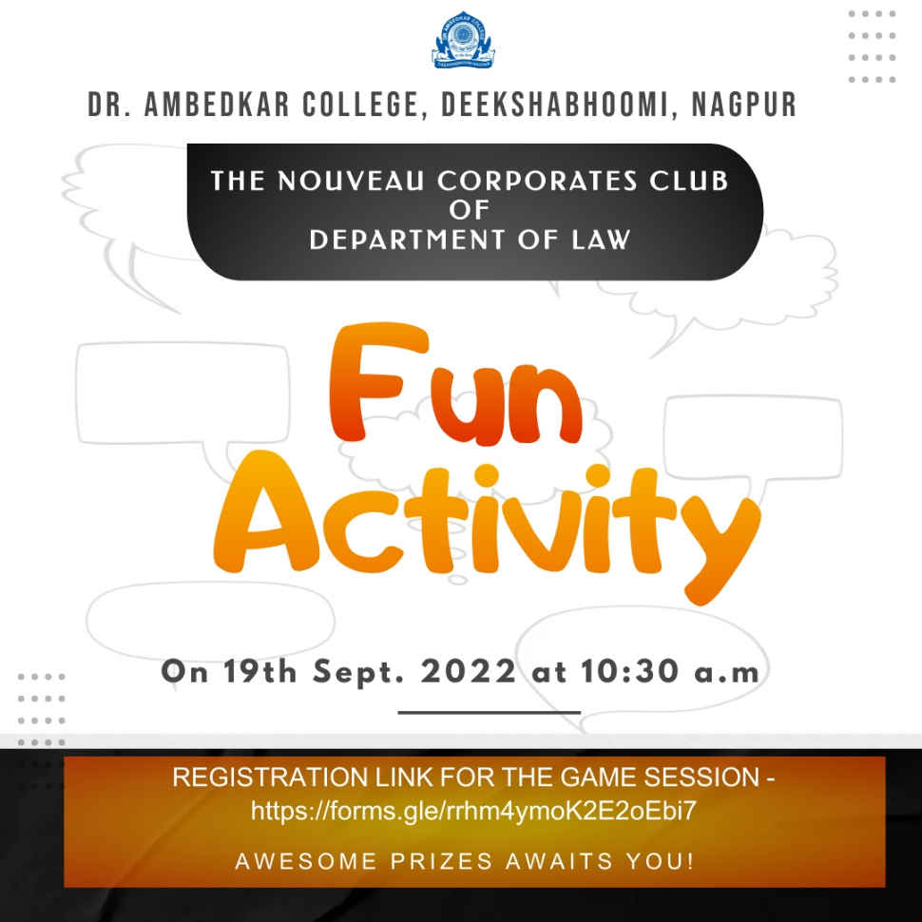

A fun activity mainly aimed at Team building and fostering ties between the members of The Nouveau Corporates Club was conducted on 19th September 2022 at 10:30 a.m.
All the registered members of the club assembled in seminar room and the activity started with a welcome address by Dr. Pratima Lokhande, Vice Chair of The Nouveau Corporates Club.

The activities were planned with time limit. All the activities planned for students will be helpful in Team bonding and also these activities improve workplace projects that involve teamwork.

This will help members understand each other's strengths, weaknesses, and interests and this understanding will help them even better together on future progress.

The First activity was designed to improve communication and how
collaboration within a group can help solve difficult problems. By working together, teams can find the solutions that work best.

The Second activity was 'Pass the message game'. It demonstrates how the meaning of a message becomes distorted as it is told and moved on from one person to another as different interpretations are applied according to beliefs, preferences, knowledge and experience.

The activity was conducted by Dr. Pratime Lokhande, Vice Chair of The Nouveau Corporates Club and Ms. Anusha Patre, Acting Chair of The Nouveau Corporates Club. Students enjoyed a lot and participated enthusiastically. They learnt about creative thinking, decision making, coordination and team management.

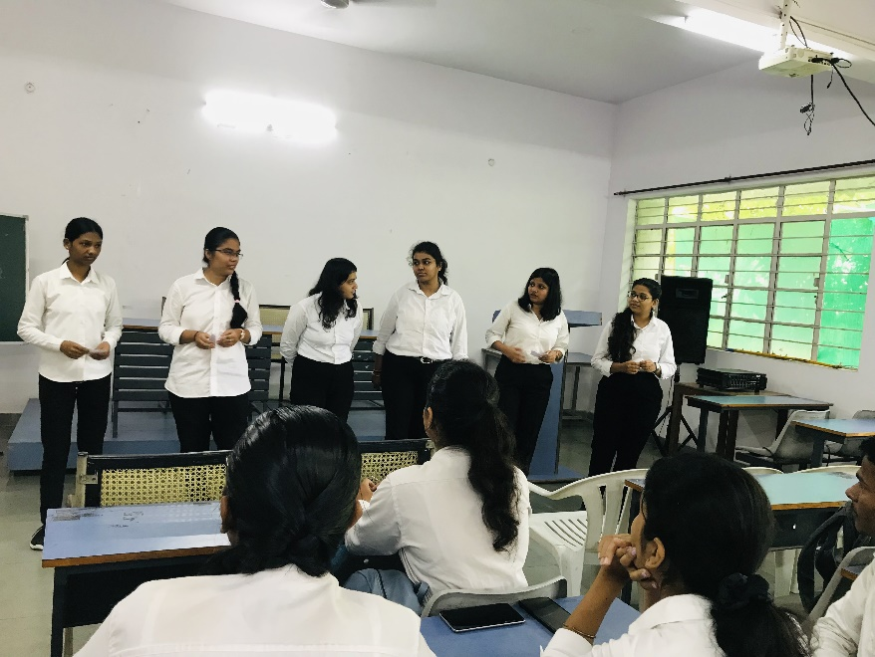

Participants during the session

- GUEST LECTURE ON HIGHER EDICATION AND CAREER PROSPECTS ABROAD

Date: 15th September 2022
Name of the Programme: GUEST LECTURE ON HIGHER EDICATION
AND CAREER PROSPECTS ABROAD

Resource Persons: Mr. Abhishek Nath

Organised by: Legal Aid Clinic

Name of Program Co-ordinator: Dr. Pratima Lokhande

Name of Members: 1. Ms. Shilpa Rathod
2. Mrs. Vaishali Sukhdeve
3. Ms. Sarika Kamdi

Number of Attendees: 59 Participants
Name of Venue: Seminar Room, Department of Law
Dr. Ambedkar College Deeksha Bhoomi, Nagpur

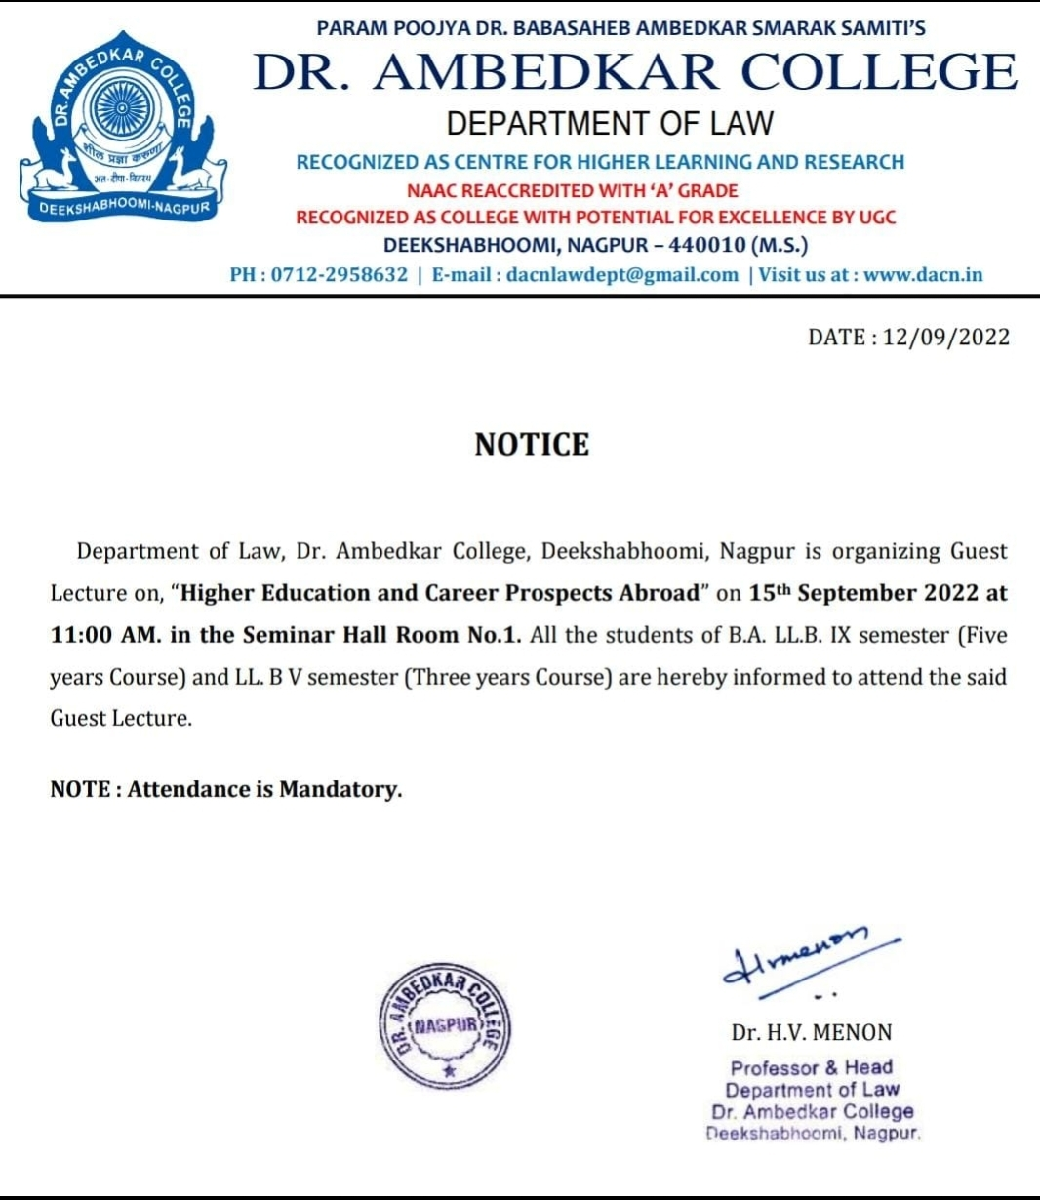

A Guest Lecture in Department of Law, Dr. Ambedkar College was held on 15th September 2022 by Mr. Abhishek Nath, Senior Counsellor at Global Reach Institute and educational consultant in Seminar Hall. He emphasized on how to prepare for studying abroad like Europe, America and Australia. If students are applying for a graduate-level degree, especially a master’s programs, doctoral programs, awarding fellowship etc.
Mr. Abhishek Nath explained various global career opportunities and talked about quality of education abroad. He pointed out that university abroad helps to acquire new skills. He also talked about Student Life Abroad and gave an overview of Scholarships. He mentioned that based on merit; scholarships are given by universities abroad to the foreign students grading. He has highlighted the requirements of admissions of different universities of different countries like USA, Canada, Australia, UK, Singapore, New Zealand etc.
Students asked questions regarding scholarships that were explained by Mr. Abhishek Nath. Students of LL.B. V semester Three years course and B.A.LL.B. IX semester Five years course were benefited by the interaction.
Event was coordinated by Dr. Pratima Lokhande (Associate Professor) and Vote of thanks was given by Mrs. Vaishali Sukhdeve (Assistant Professor)

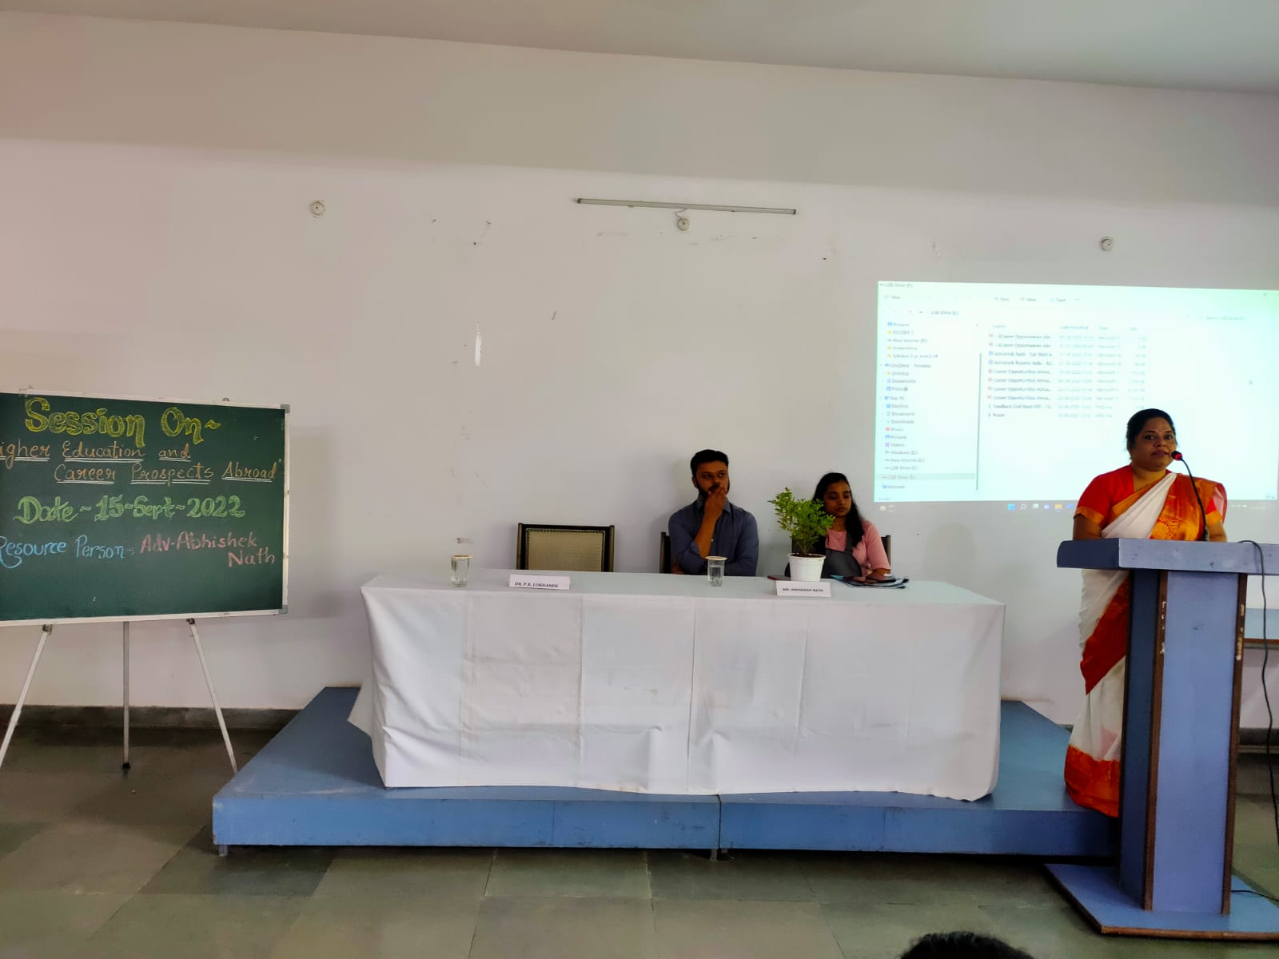
Introductory Remarks by Dr. Pratima Lokhande, Associate Professor

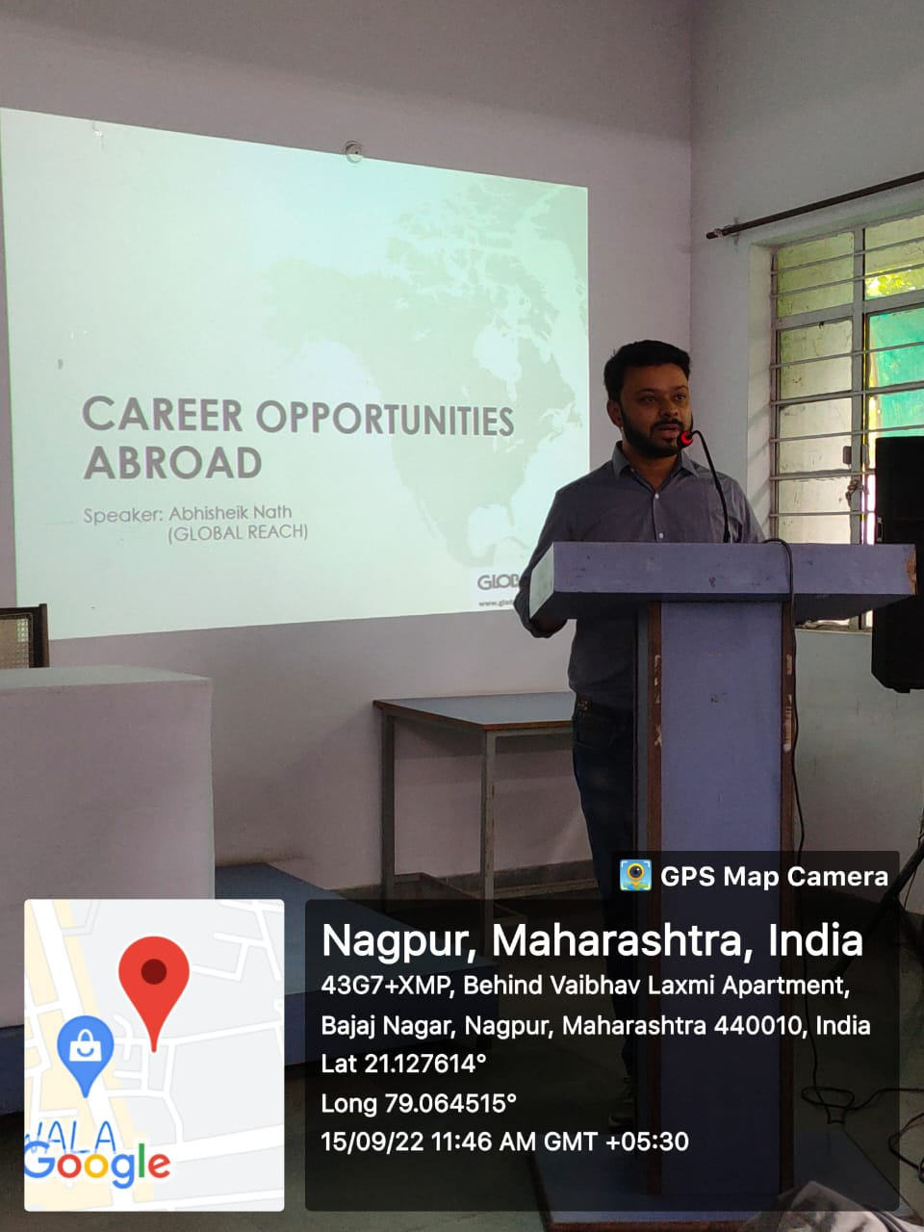
MR. Abhishek Nath Addressing the Students, Senior counsellor
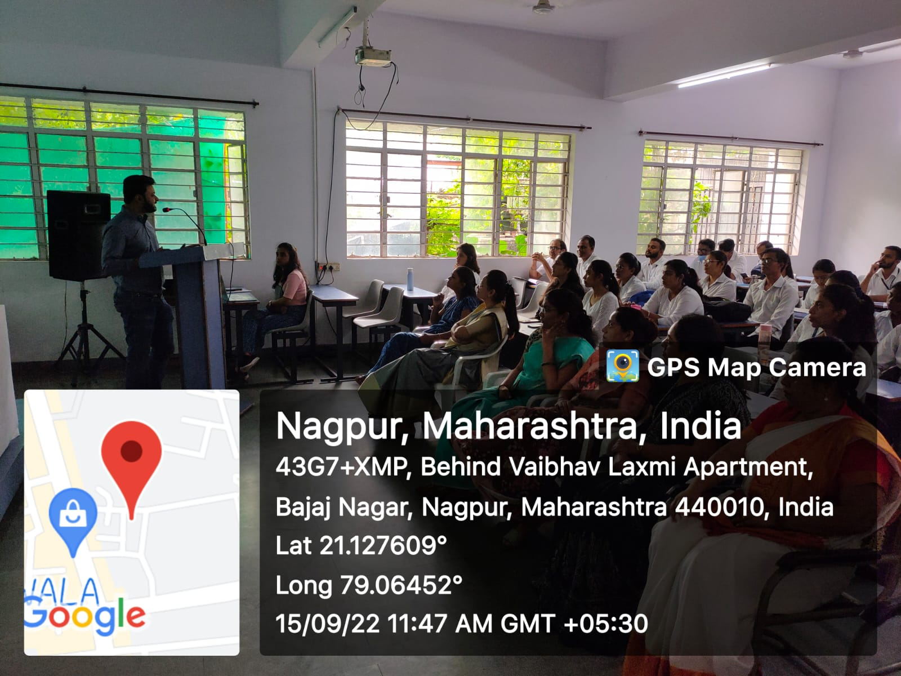

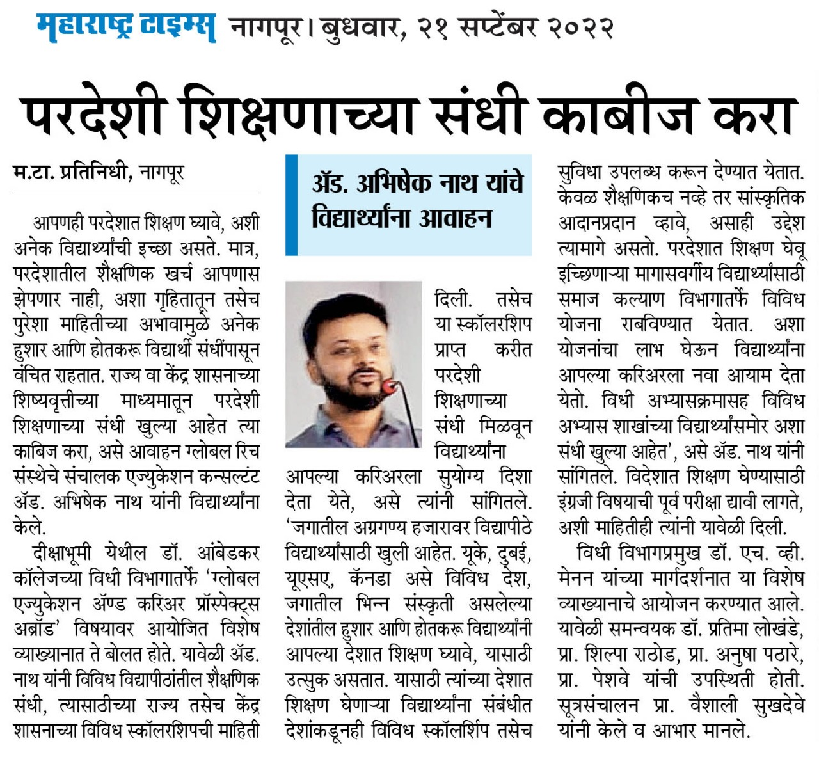
Newspaper Coverage

- Anti- Ragging Awareness Program & Awareness Programme on “Victims of Drug abuse: An eradication of Drug Menace”

Date: 16th September 2022
Name of the Programme: Anti- Ragging Awareness Program & Awareness
Programme on “Victims of Drug abuse: An eradication of Drug Menace”
Resource Persons: Hon’ble Shri Anilkumar Sharma
Adv. Smita Deshpande
Organised by: Legal Aid Clinic
Anti-ragging Cell
Name of Program Co-ordinators: 1. Dr. Pratima Lokhande
2. Dr. Sandhya Kalamdhad
Name of Members : 1. Dr. Priti Singh
2. Ms. Shilpa Rathod
3. Mrs. Vaishali Sukhdeve
4. Ms. Sarika Kamdi
Number of Attendees: Around 223
Name of Venue: College Auditorium Dr. Ambedkar College Deeksha Bhoomi, Nagpur
NOTICE
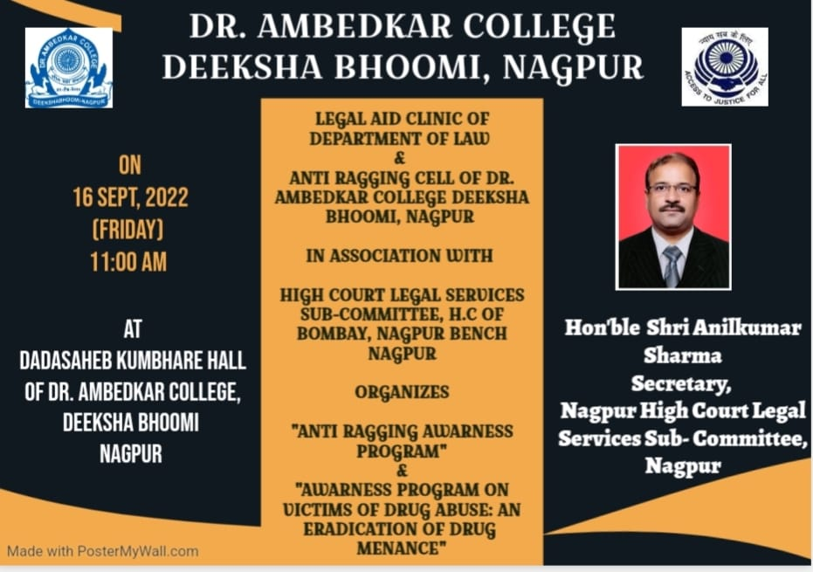

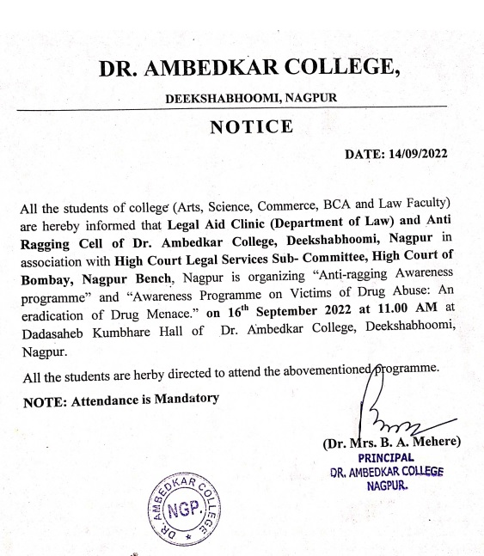

The Legal Aid Clinic of the Department of Law and Anti Ragging Cell of Dr. Ambedkar College, Deeksha bhoomi Nagpur, in collaboration with Nagpur High Court Legal Services Subcommittee, Nagpur has organised an awareness Program on 7th Sept 2022 for the students of various disciplines Art, Science, Commerce, and Law.
Around 200 attendees were present in the program. Hon’ble Shri Anilkumar Sharma, District Session Judge and Secretory of Nagpur High Court Legal Services Subcommittee, Nagpur and Adv. Mrs Smita Deshpande Practicing Advocate in District Court and High Court invited as Chief guest and Guest of Honour.
The program commenced with the lamp lighting ceremony by the hand of hon’ble guests of the Programme which was followed by the welcome address by Dr. Bhoomi Mehere Principal of the college to the well acclaimed Judges, the faculty members of the departments, treasured invitees and the participants. Dr. Hema Menon gave brief information regarding department of law. Dr. Pratima Lokhande gave the overview of the Legal Aid Clinic of Department of law. Dr. Priti Singh has briefed about the Anti-Ragging cell of the College.

Adv. Smita Deshpande enlightened the audience on the topic of Anti-ragging laws. She has provided the statistical record with the courts dealing with Anti-ragging cases. Further she elaborative discussed regarding the provision of the law on Anti-Ragging. She empathetically mentioned that there is a psychological element involved in the cases of ragging.
Hon’ble Shri Anilkumar Sharma delivered the Presidential remark and shared the information regarding the provisions of anti-ragging laws. He elaborately convenience the students regarding the repercussion of the ragging in college. He further dealt with the topic on “Victims of Drug Abuse: Eradication of the Drug menace”. He has shared the statistical record of the Drug abuser and briefed regarding the various terminology of Drug abuse, drug victim and drug pedlars. He enlightened the audience with the different laws in the domain of Drug abuse.
The hon’ble guests overwhelmed by knowing that our college has no case of Ragging till present date and for that they have congratulated the college.
The Programme was conducted by Ms. Shilpa Rathod under the guidance & supervision of Dr. Pratima Lokhande, Associate Professor and Co-ordinator of Legal Aid Clinic, Department of law.
The event concluded with vote of thanks proposed by Mrs. Vaishali Sukhdeve to the jury members and also to everyone who was present to witness the event.

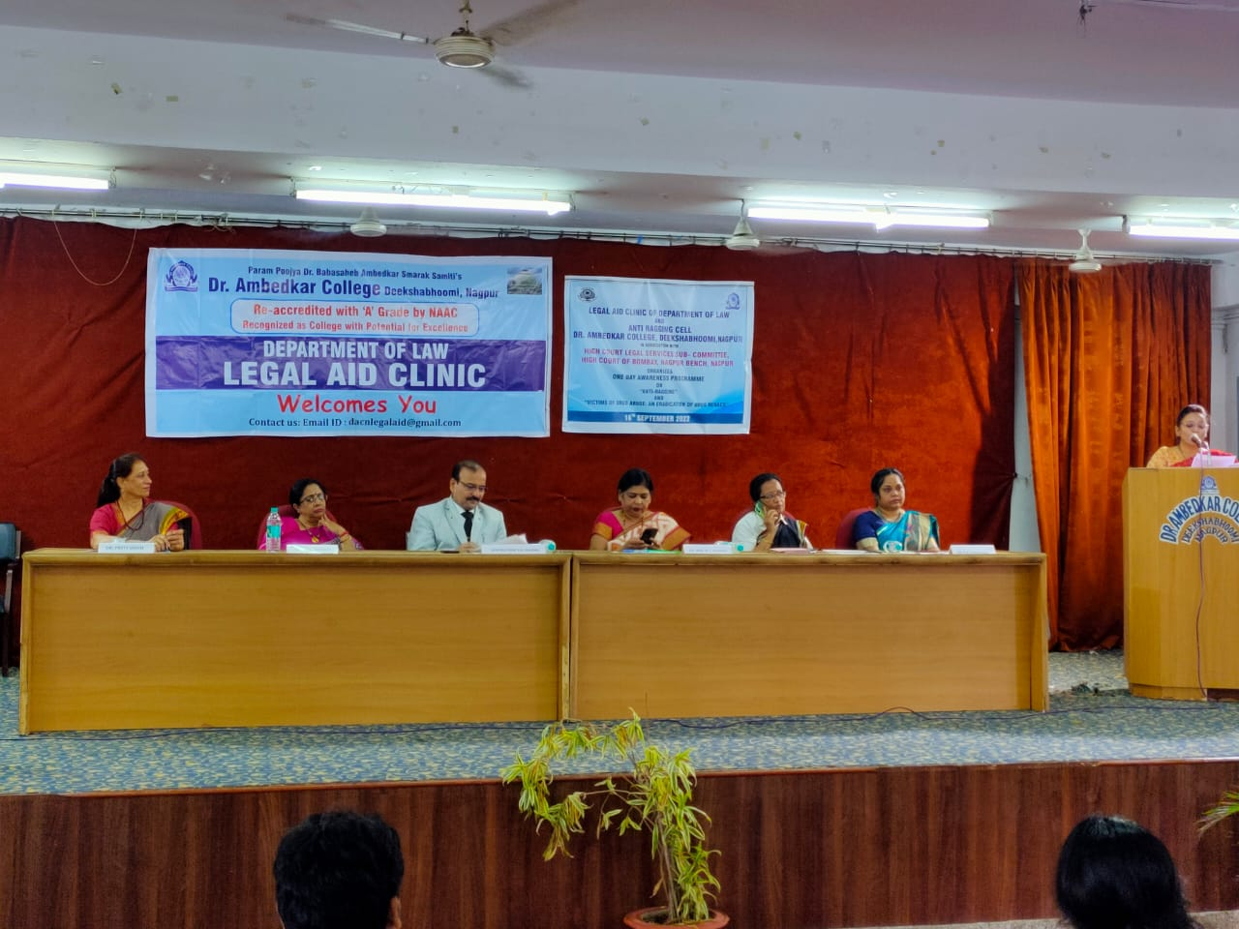
(Dignitaries on the Dias) 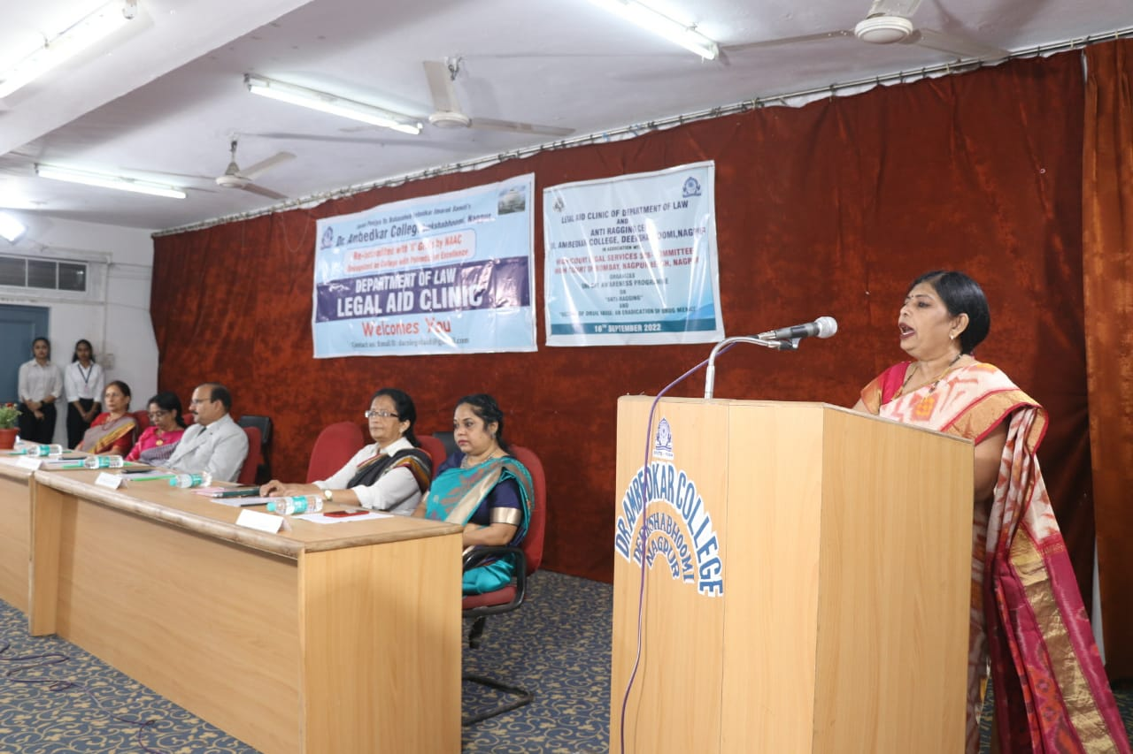
(Dr. Bhoomi Mehre, Principal of the College giving the welcome address)

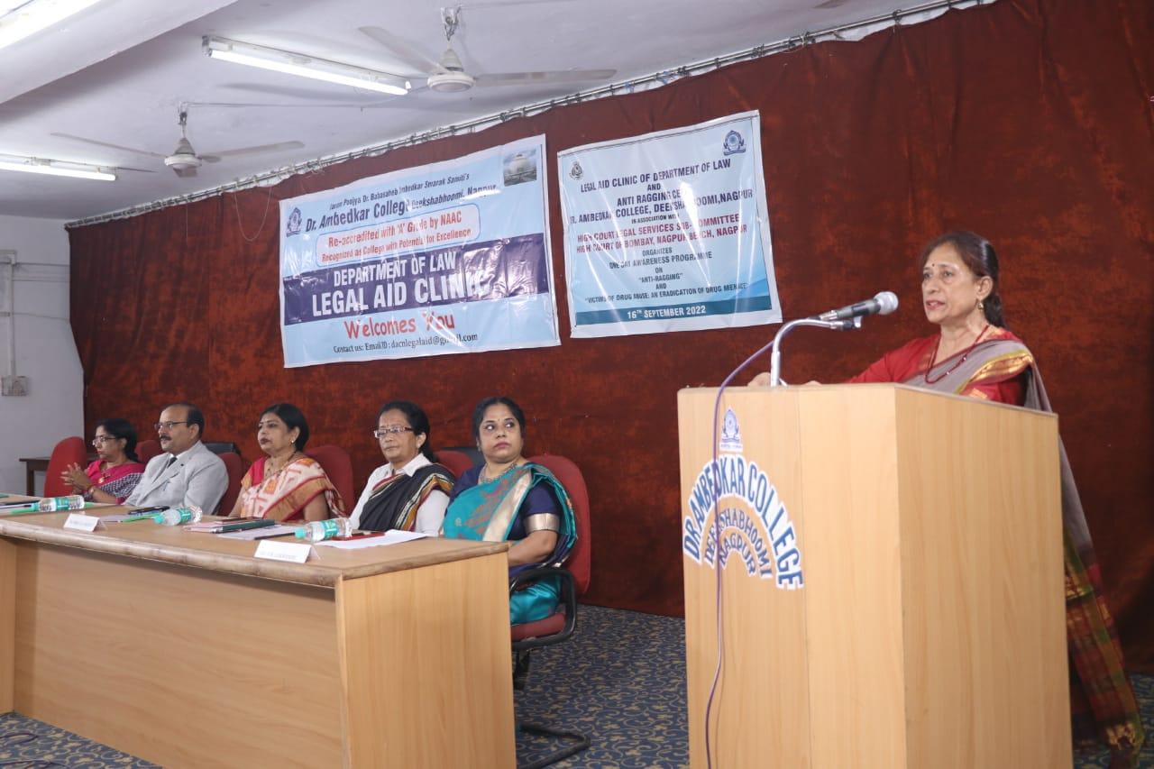
(Dr. Priti Sing Member of Anti Ragging Cell briefing about the work of Anti Ragging Cell)

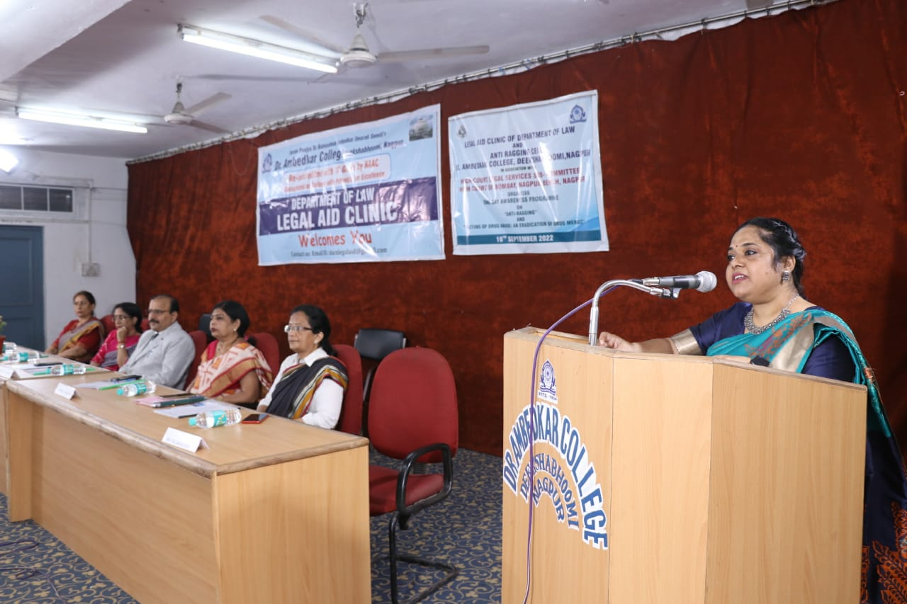
(Dr. P.R. Lokhande giving an overview of Legal Aid Clinic of Department of Law)
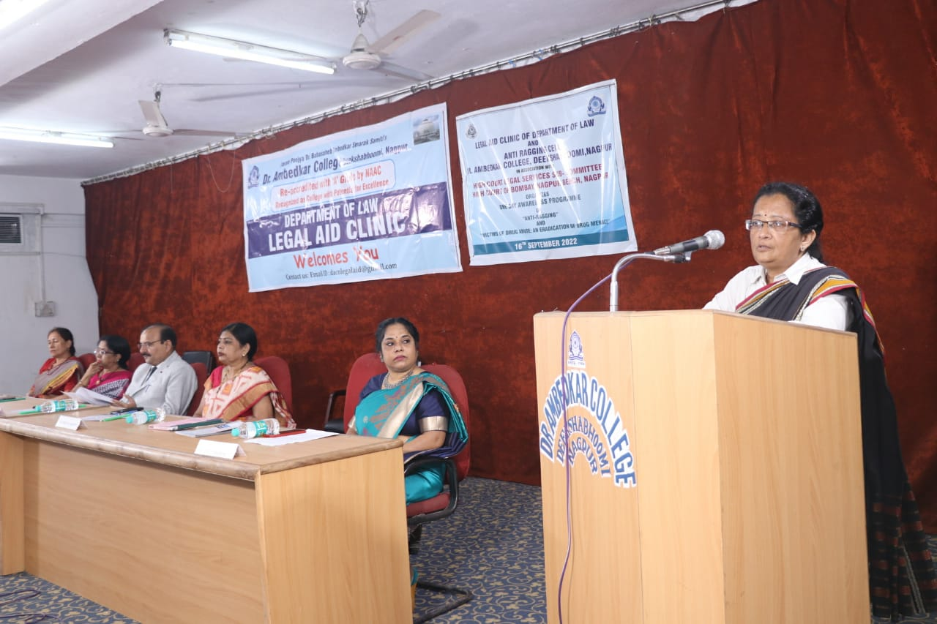
(Adv. Smita Deshpande delivering the brief provisions of the Ant-Ragging Law)

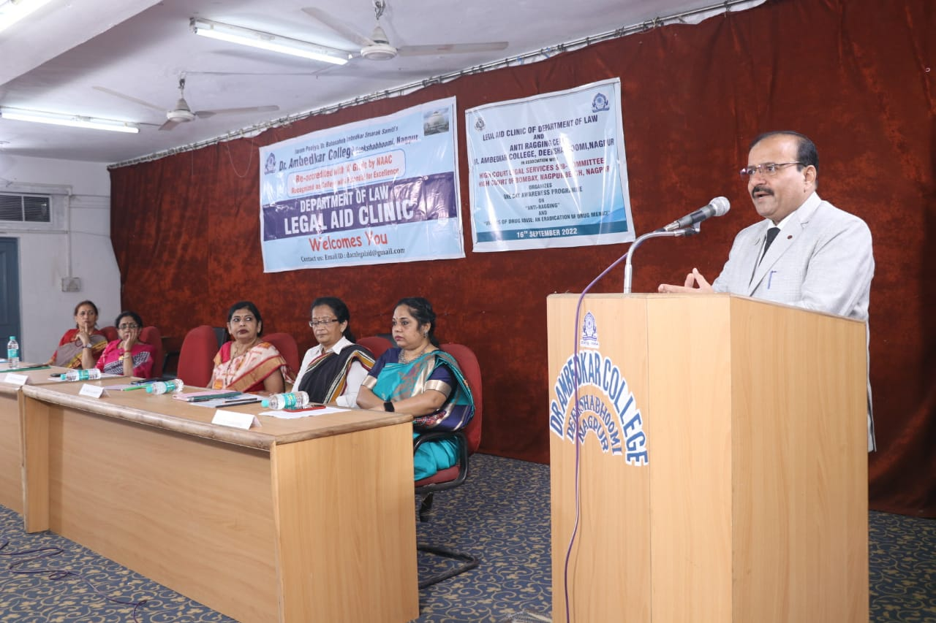
(Hon’ble Shri Anil Kumar Sharma giving the Presidential Remark)

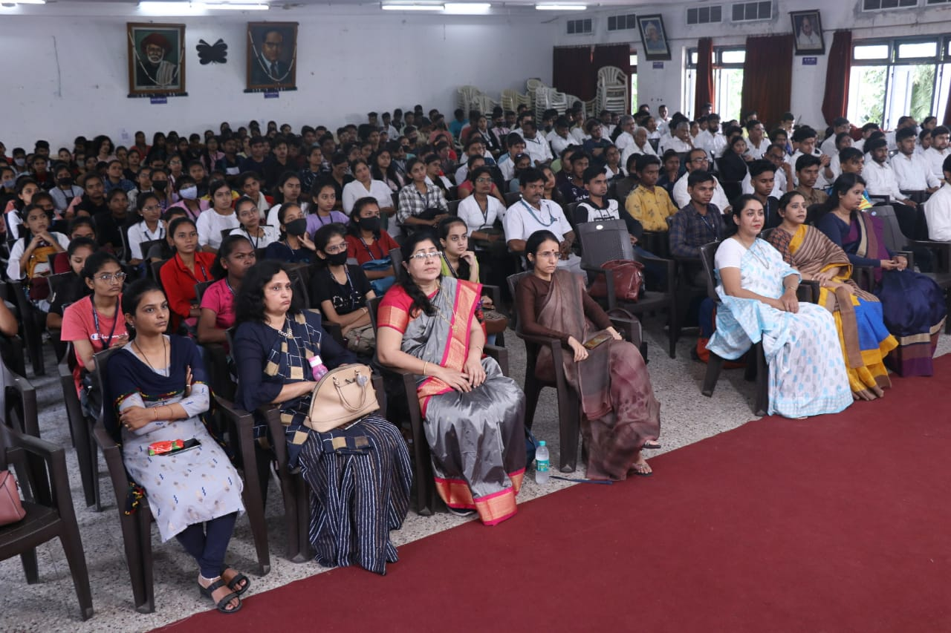
(Audience Present at the Awareness Programme)

- THREE DAYS FREE LEGAL AID AND LEGAL LITERACY PROGRAMME
Date: 3RD, 4TH & 5TH October 2022
Name of the Programme: FREE LEGAL AID AND LEGAL LITERACY PROGRAMME
Chief Guest: Hon’ble Shri S. B. Gawande
District Judge, District Court, Nagpur
Guest of Honour: Shri Jaideep Pandey
Organised by: Legal Aid Clinic of Department of Law
Co-ordinator of Legal Aid Clinic: Dr. Pratima Lokhande
Members of legal Aid Clinic: 1. Ms. Shilpa Rathod
2. Mrs. Vaishali Sukhdeve
3. Ms. Sarika Kamdi
Number of Volunteers: 124
Name of Venue: Department of Law, Dr. Ambedkar College Deeksha Bhoomi, Nagpur

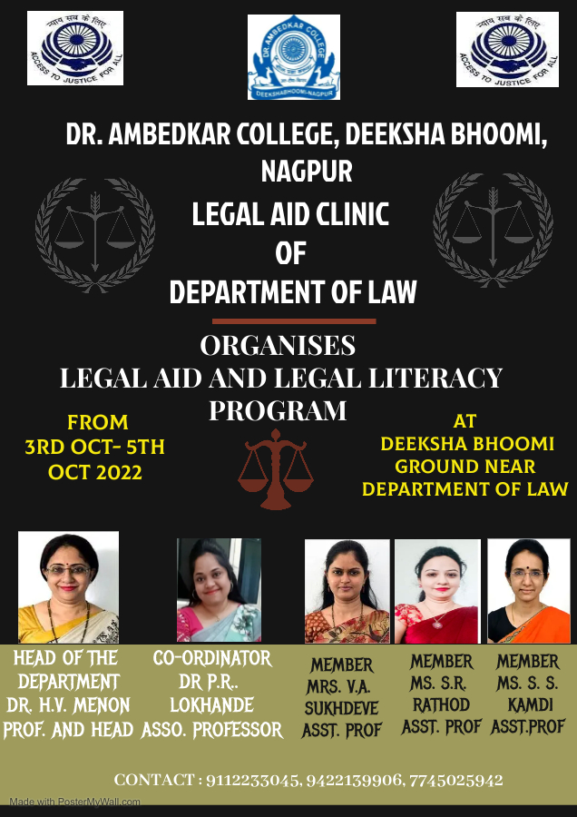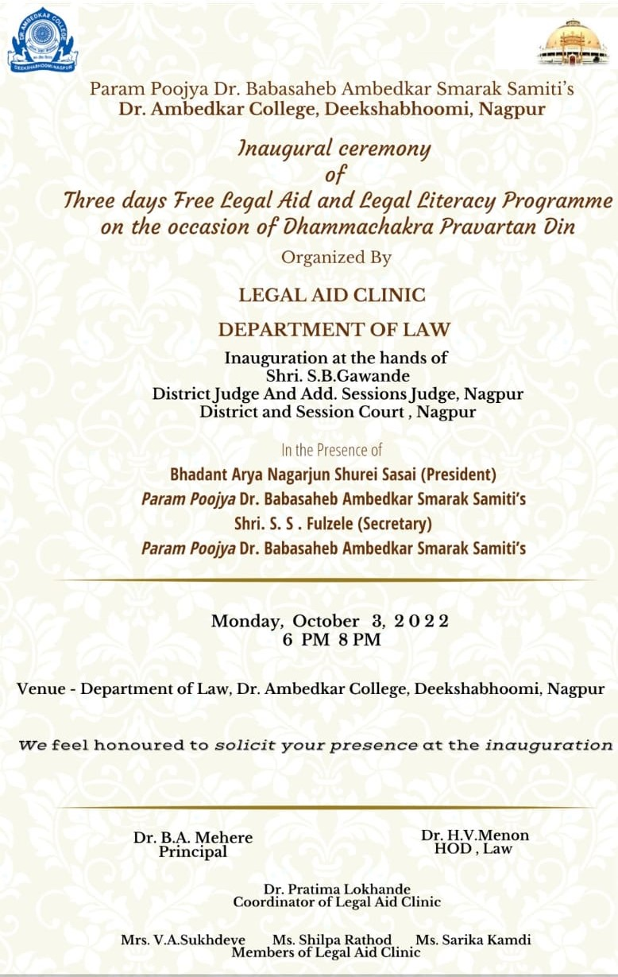
Three days Free Legal Aid and Literacy Programme was inaugurated on 3rd October, 2022 at the hands of Chief Guest Hon’ble Shri S.B. Gawande District Judge & Additional Session Judge, District Court Nagpur in presence of Guest of Honour Shri Jaideep Pandye Secretary, DLSA Nagpur and Members of Param Poojya Dr Ambedkar Smarak Samiti Adv. Shri Anand Fulzele, Shri N. R Sute and Shri Pradeep Aglawe to mark the 66th Dhammachakra Pravartan Din in the Deeksha Bhoomi organized by the Legal Aid Clinic of Department of Law, Dr. Ambedkar College, Deeksha Bhoomi, Nagpur. Free Legal Aid and Literacy Programme is regularly organized since last 18 years by the Department of Law. This year, Department of Law has undertaken an initiative of conducting a survey and reporting the same in the complaint register by the Students of Department for further redressal. A special issue of Information brochure (Booklet) has been prepared by the members of Legal Aid Clinic and same has been unveiled at the hands of the Chief guest. Information Brochure released with an intent to spread an awareness amongst masses about various laws pertaining to issues like health, free and compulsory education, welfare of women, age old person laws, Cyber offences and sexual offences against children. In addition to this, the Legal Aid clinic has also organised the Poster Making Competition which was based on 10 different themes. This competition received the overwhelming response from the students of LLB and LLM Course. Around 30 students have prepared the unique posters based on the given themes which has displayed and inaugurated on the first day of Free Legal Aid and Literacy Programme at the hands of Chief Guest and in presence of other invitees.
The program commenced with the lamp lighting ceremony by the hand of hon’ble guests of the Programme which was followed by the welcome address by Dr. Bhoomi Mehere Principal of the college to the well acclaimed Judges, the faculty members of the departments, treasured invitees and the participants. Dr. Hema Menon gave brief information regarding department of law. Dr. Pratima Lokhande gave the overview of the Legal Aid Clinic of Department of law.
Shri Jaideep Pandey Secretory of DLSA, Nagpur emphasized on making legal remedy more accessible to all so as to create a society as envisioned by the Constitution makers. He explained the role of DLSA in providing the free access to get the justice among the common masses who can not afford the lawyers to get relief.
The Chief Guest Hon’ble Shri S.B. Gawande highlighted the importance of legal aid as an instrument to impart justice to poor masses. He informed the audience about Hussena Khatun v. State of Bihar case as a landmark case of fast-track trial. He further emphasised on the provisions of Legal Aid under Section 303 of the Code of Criminal Procedure (CrPC) and Sections 3 and 7 of the Code of Civil Procedure (CPC). He empathetically mentioned that while appealing to raise their voice for their just rights in the changing times, he also expressed hope that the law students should develop the quality of social service and strive to bring justice to the deprived and marginalized sections. He appreciated the efforts taken by the Department of Law and appealed law students and budding lawyers to pay back their Social Debt as a member of this society. He also emphasized on Reversal Parental Responsibility and remaining connected to one’s roots and culture.
One of the remarkable moments of the program was the skit presented by the Students of the Department of Law depicting how the present society still faces the offences of sexual abuse, domestic violence, unequal wages, denial of woman right in the property and the problems of age-old people in the society.
The Programme was conducted by Miss Anmol Shau a student from LLB III Sem 5 Years Course under the guidance & supervision of Co-ordinator and members of Legal Aid Clinic, Department of law.
The event concluded with vote of thanks proposed by Dr. Pratima Lokhande Co-ordinator of Legal Aid Clinic to the jury members and also to everyone who was present to witness the event.
Faculty members Dr. Varsha Deshpande, Dr. Mrs. Sandhya Kalamdhad, Ms. Shazia Bari, Mrs. Aishwarya Peshwe, Ms Anusha Patre and other staff members were prominently present. 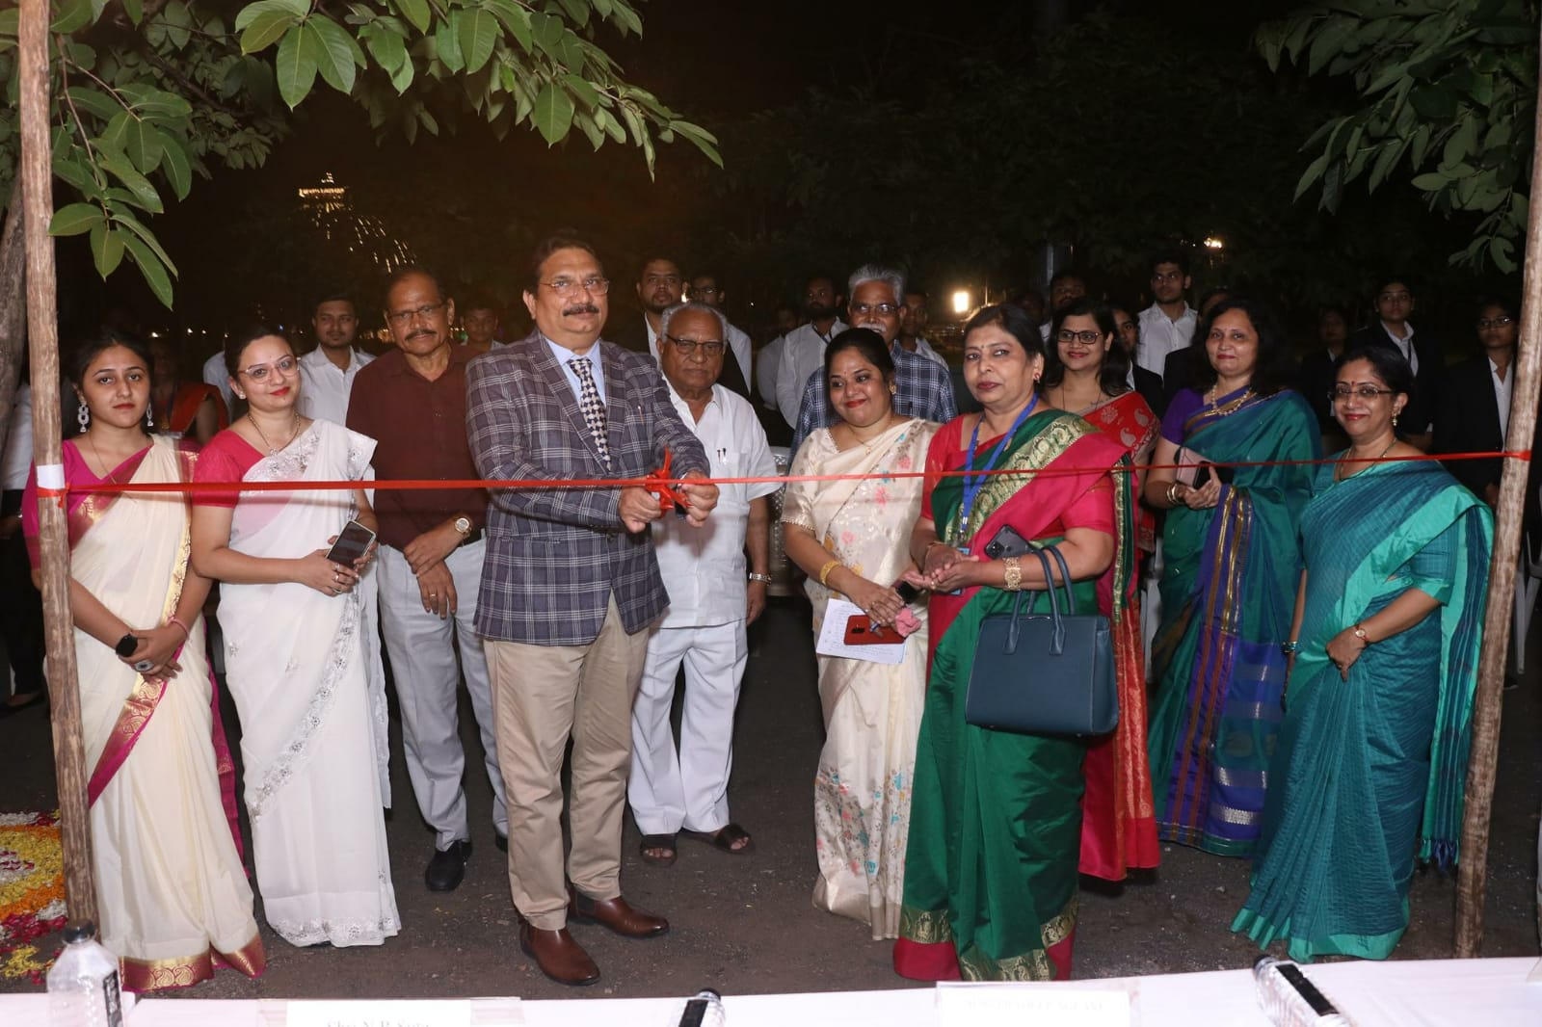
(Inauguration of Three days Free Legal Aid and legal Literacy Programme at the hands of Hon’ble District Judge Shri S.B. Gawande)
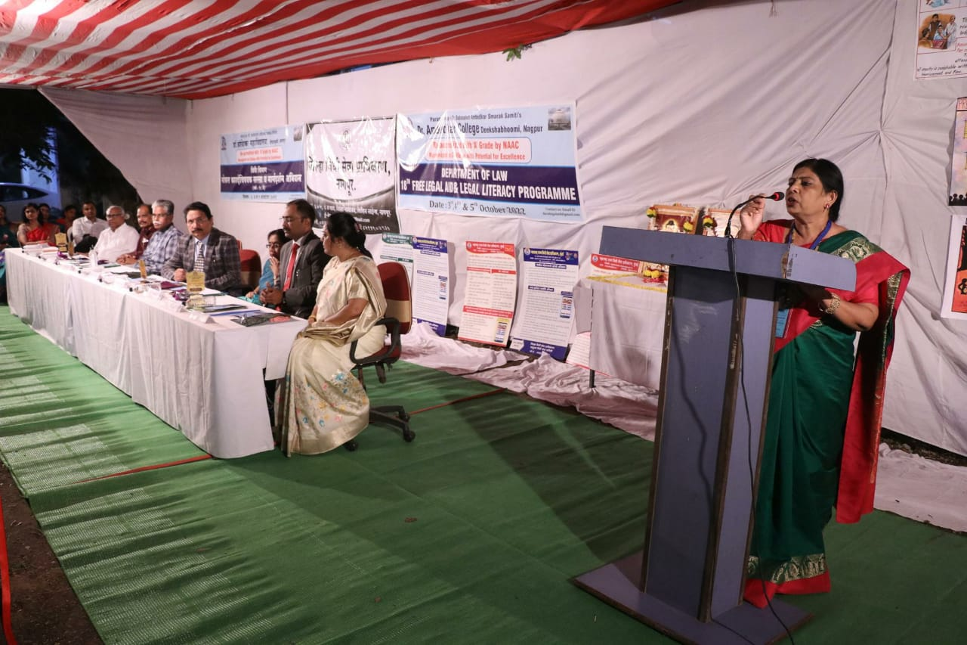
(Welcome Address by Dr. B. A. Mehere Principal of the college)
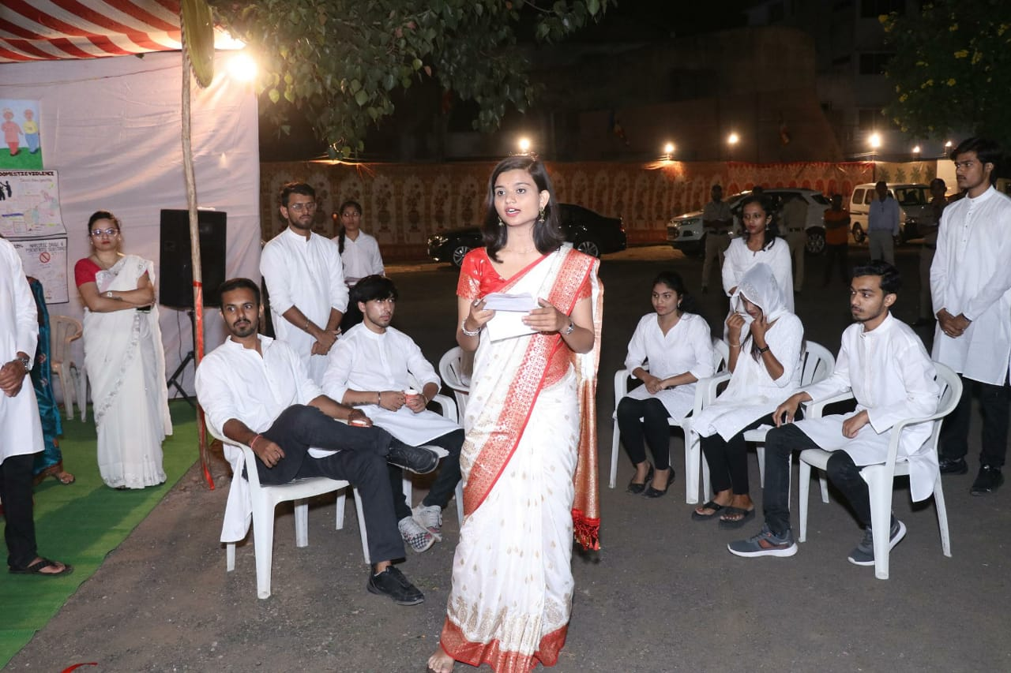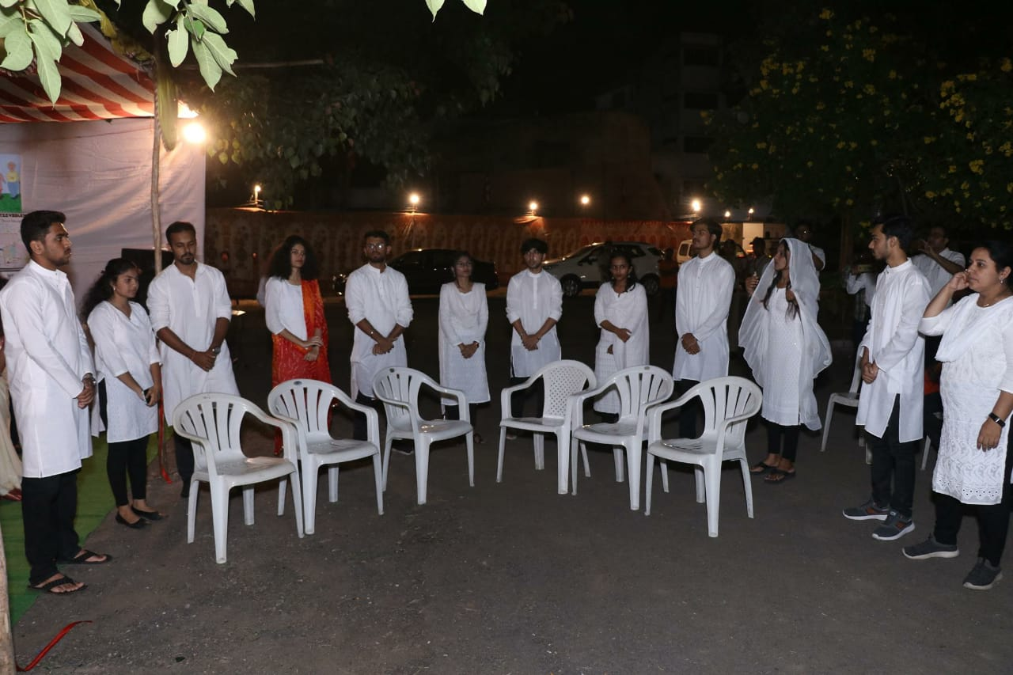
(Skit played by the Students of Department)

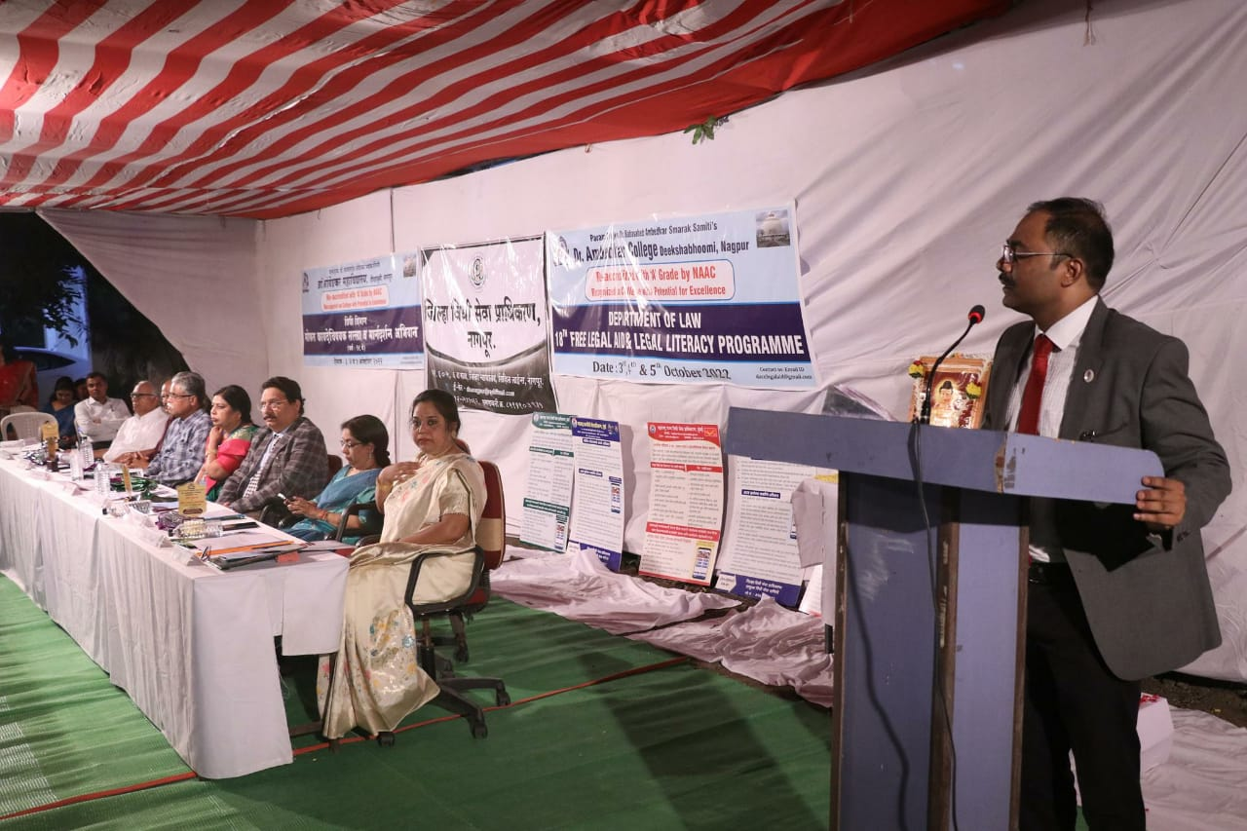
(Shri Jaideep Pandye introducing the role of District Legal Services Authority, Nagpur)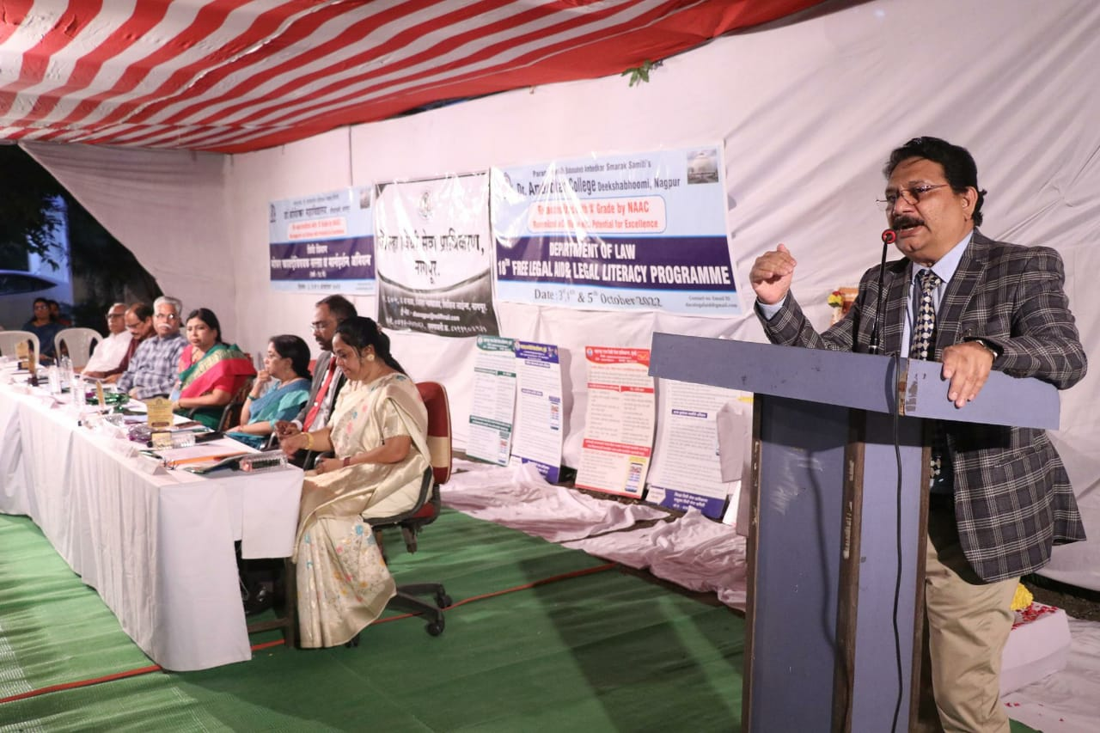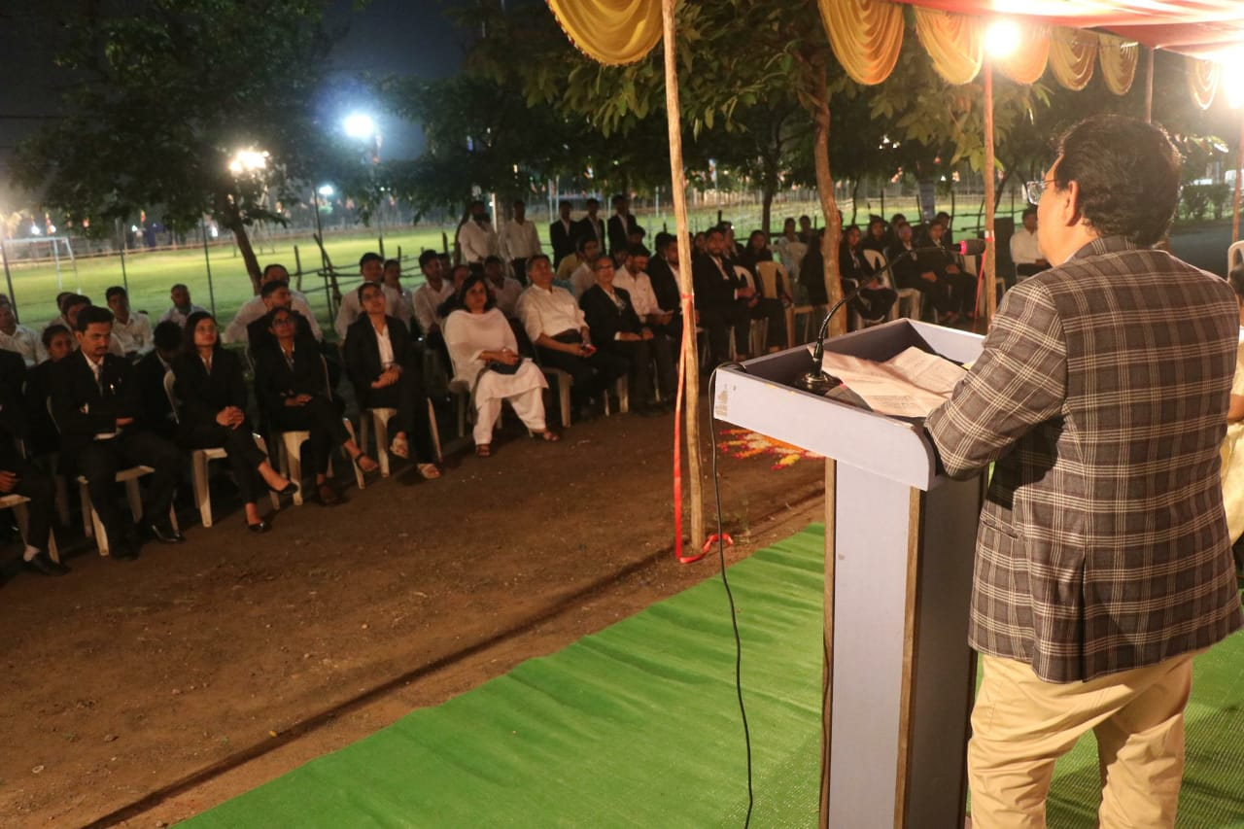(Hon’ble District Judge Shri S.B. Gawande giving the presidential remark to the audience present in the programme)
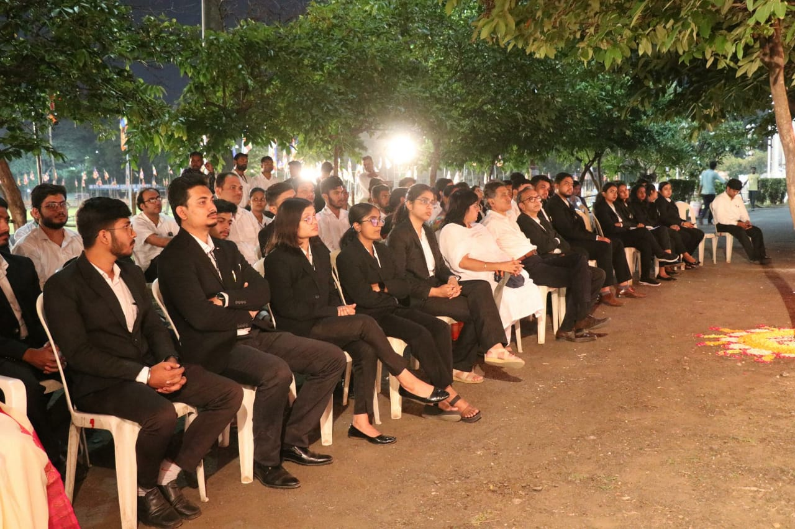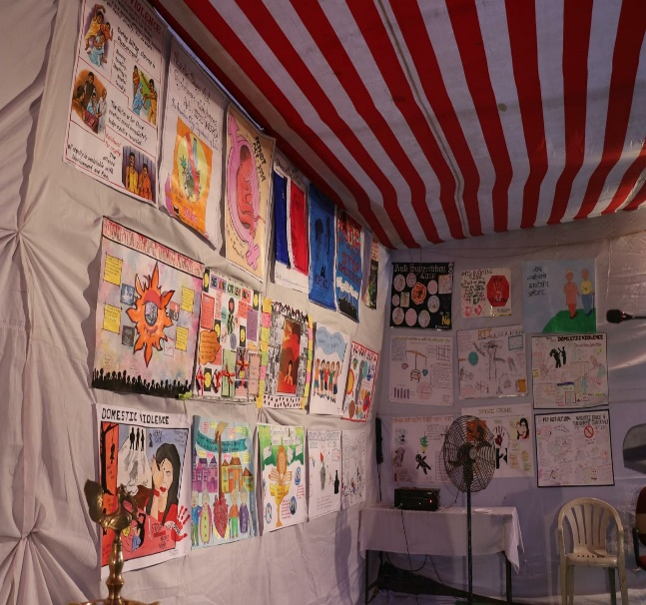
(Audience present in the programme and the poster display of all the participants)

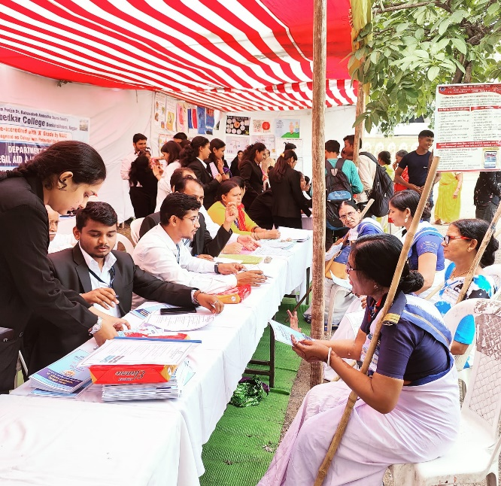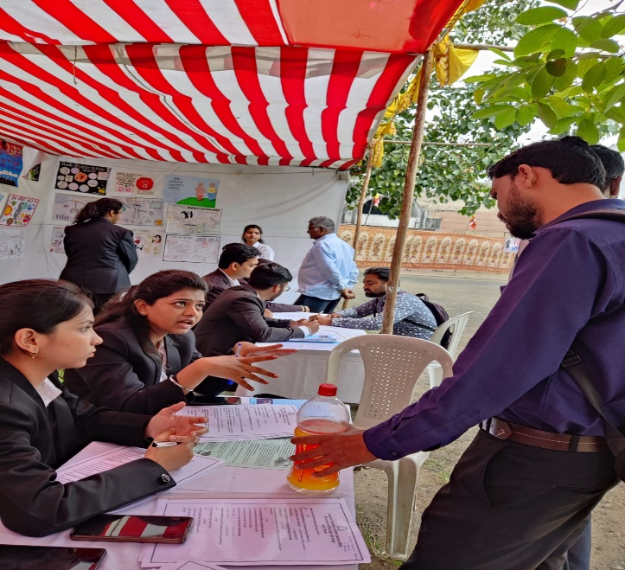
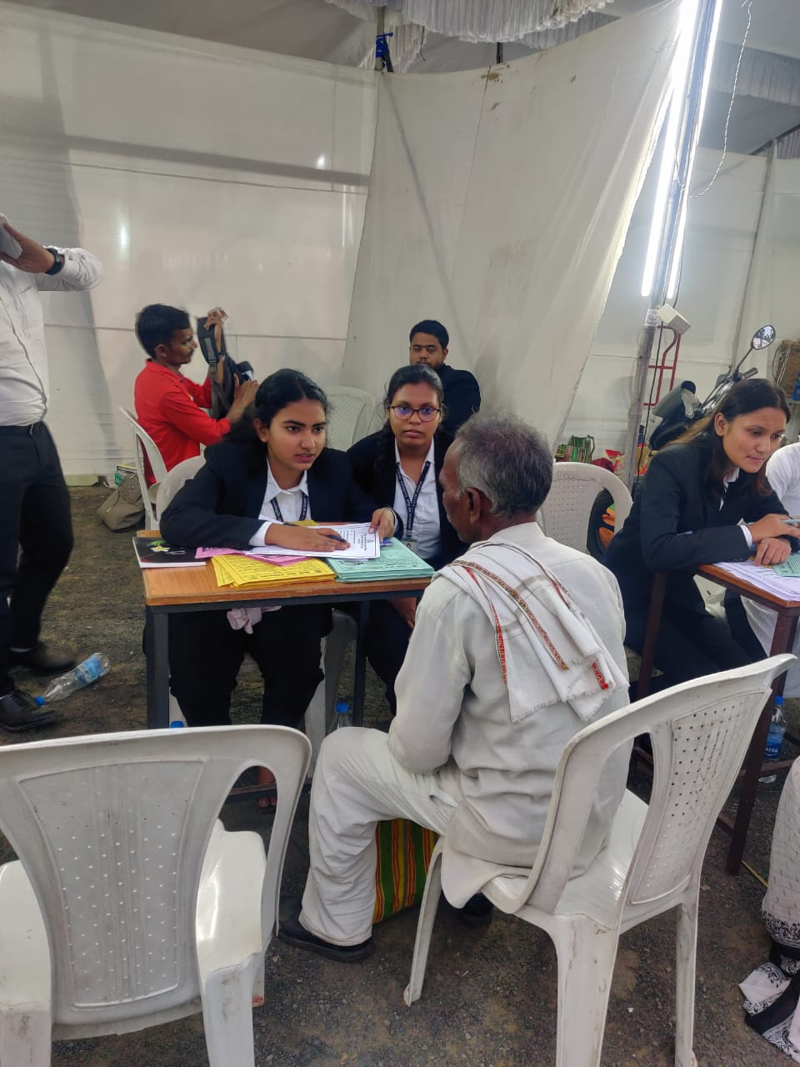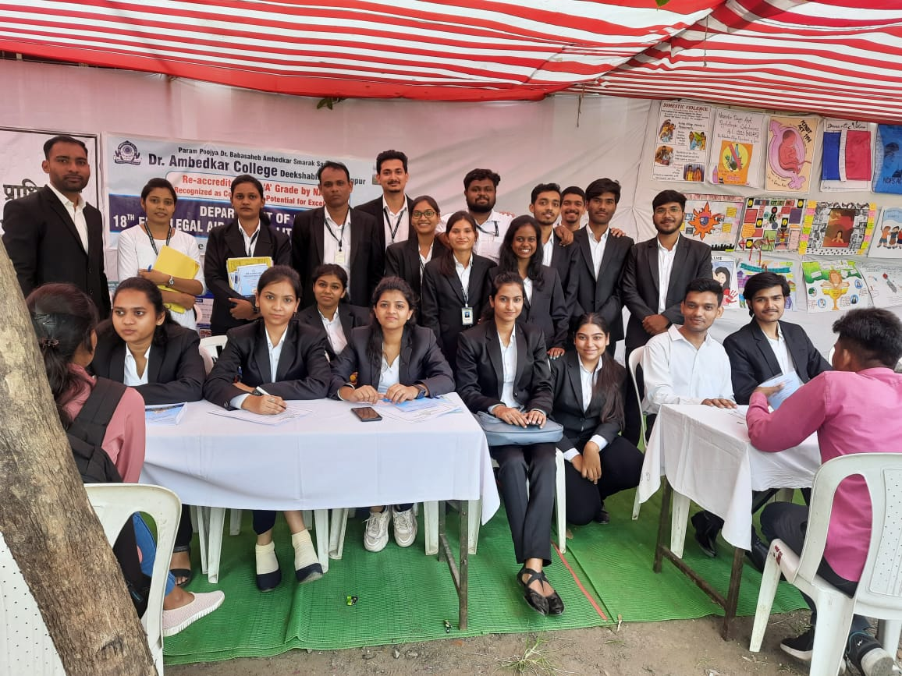

(Students and Faculty of the Department of Law providing Free Legal Aid to the Pilgrims and Distributing Information Booklet)
List of Volunteers for Three Days Legal Aid and Legal Literacy Programme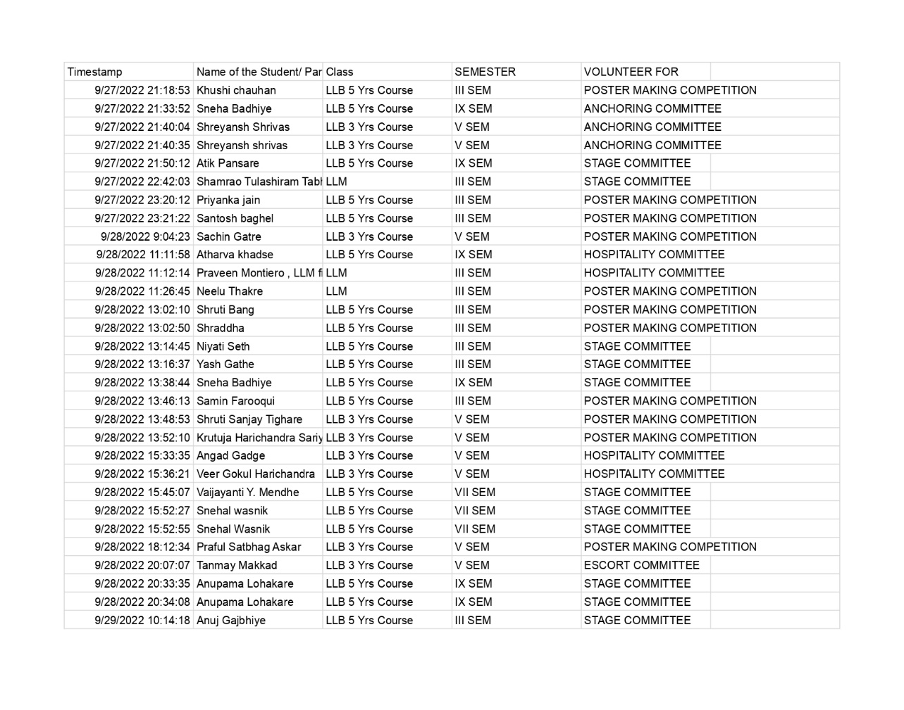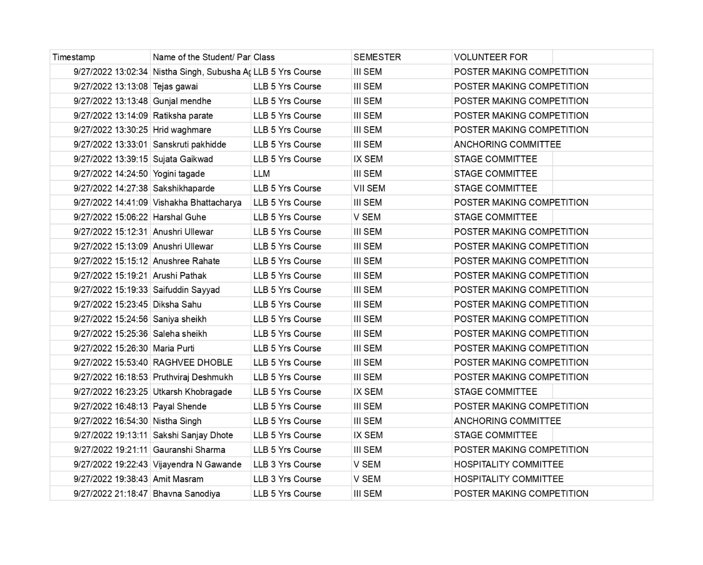
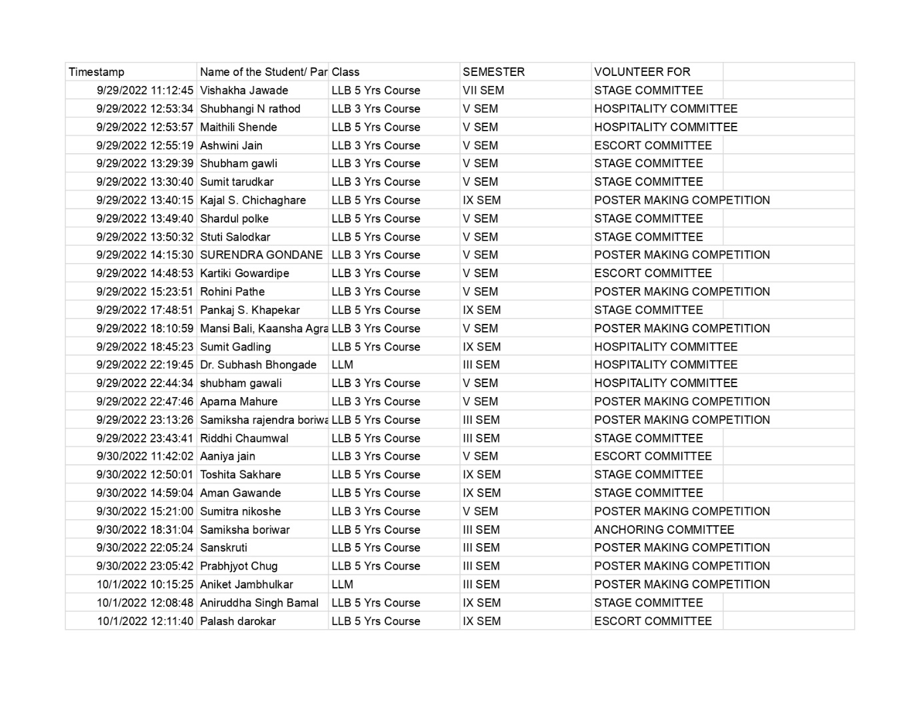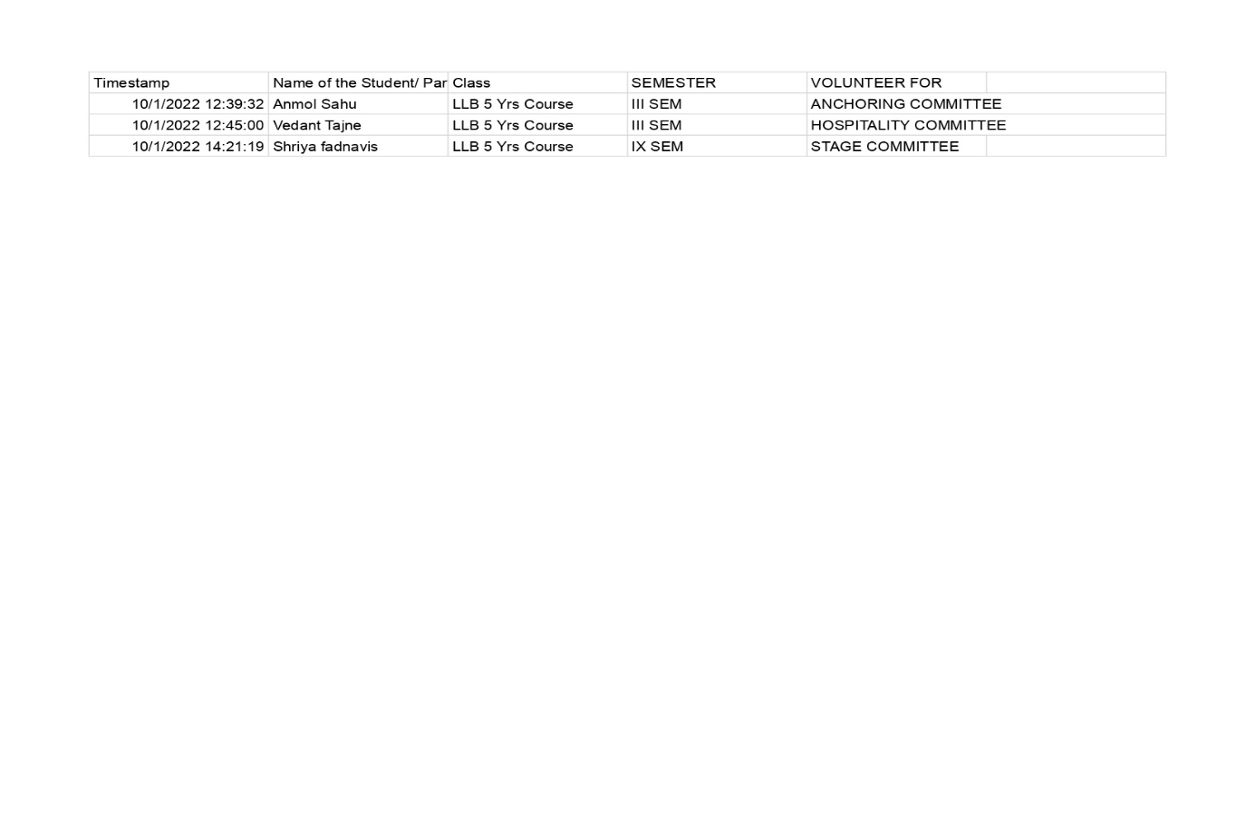
- GUEST LECTURE ON ADULTERY AND ITS DECRIMINALIZATION: 18-08-2022
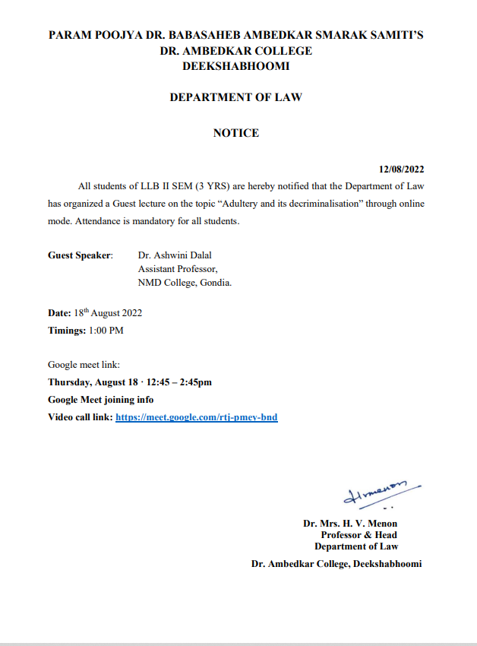

NAME OF THE PROGRAMME | Guest Lecture on the topic “Adultery and its decriminalisation”
DATE AND DAY: | 18th August 2022
TIME: | 1.00 pm to 2.30 pm
VENUE: | Virtual
ZOOM MEETING LINK: | https://meet.google.com/rtj-pmey-bnd
PROGRAMME SUPERVISOR: | Dr. Sandhya P. Kalamdhad

On 18th August 2022, Criminal Law Club of Department of Law organized a guest lecture on the topic “Adultery & It’s Decriminalisation”. Approximately 45 students of LLB ( 3 years course) joined the programme. Prof. Dr. H.V.Menon, Head of the Department of Law joined the online Program through Zoom Meeting. The Welcome address was given by Prof. Dr. H.V. Menon, Head of the Department of Law where she expressed the gratitude to the Resource person for sharing his knowledge and also emphasised the Importance of organizing such programs.
The speaker Adv. Priyanka Mardikar started her topic by stating the importance of the topic. She elaborated all the provisions under Indian Penal Code. Then she went through some important incidences and case laws on the topic. Students are greatly benefited out of this. Dr. Sandhya Kalamdhad proposed the vote of thanks.
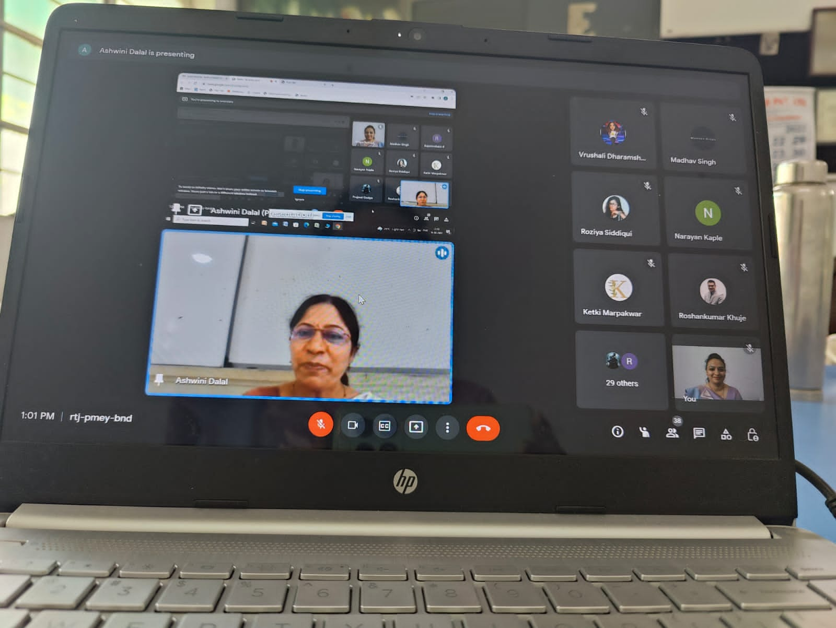
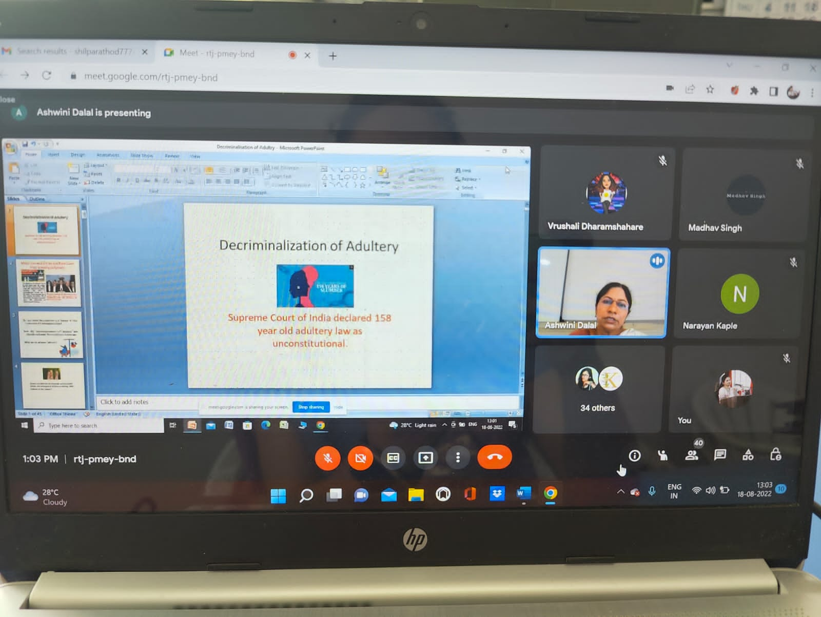

- GUEST LECTURE ON TRANSGENDER RIGHTS AND STRUGGLES: 31-07-2022
Notice:
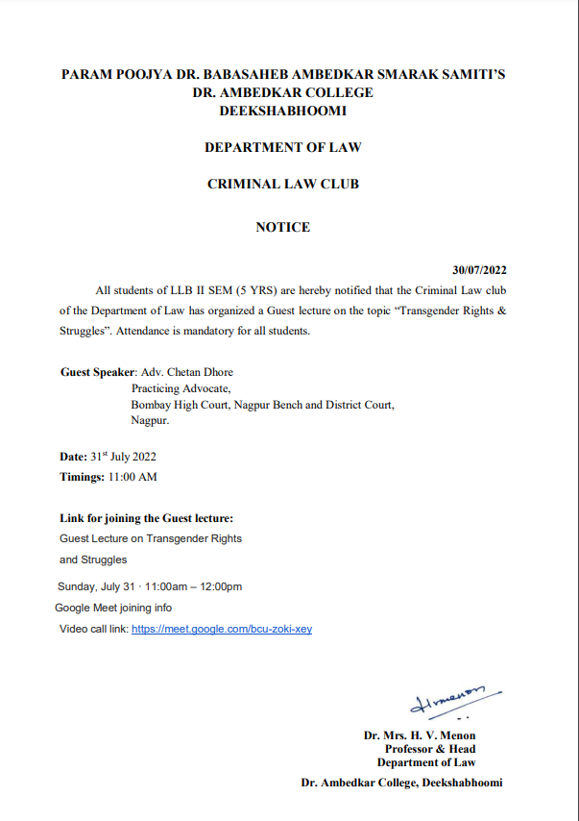

NAME OF THE PROGRAMME | Sensitization Workshop on the topic “Transgender rights and Struggles”
DATE AND DAY: | 31st July 2022
TIME: | 11.00 am to 12.30 pm
VENUE: | Virtual
ZOOM MEETING LINK: | https://meet.google.com/bcu-zoki-xey
PROGRAMME SUPERVISOR: | Dr. Sandhya P. Kalamdhad

On 31st July 2022, Department of Law through its Criminal Law Club organized a Sensitization Workshop on the topic “Transgender Rights & Struggles”. Approximately, 51 students of LLB ( 5 years course) joined the Workshop. Prof. Dr. H.V.Menon, Head of the Department of Law, Dr. Sandhya Kalamdhad, Co-ordinator of Criminal Law club, other Faculties joined the online Program through Zoom Meeting.
The Welcome address was given by Prof. Dr. H.V. Menon, Head of the Department of Law where she expressed the gratitude to the Resource person for sharing his knowledge and also emphasised the Importance of organizing such kind of sensitization programs by Criminal law Club for the Law students.
After the welcome address, Ms. Sarika Kamdi introduced the Resourse person. Adv. Chetan Dhore sensitized the students on a very important and contemporary issue of Transgender. By explaining the recent law on the subject, he elaborated some lacunas in the existing law. He cited important judgments of the Hon’ble Supreme Court to sensitize the students towards third gender. He emphasised upon that why and how law students should bear the responsibility to create awareness amongst the masses in regard to issues like this. It was indeed worth listening programme. Students were not only enlightened but they were greatly influenced by the speaker because of his unique style of dealing with this very sensitive issue. Coordinator of the club, Dr. Sandhya Kalamdhad proposed the vote of the thanks.

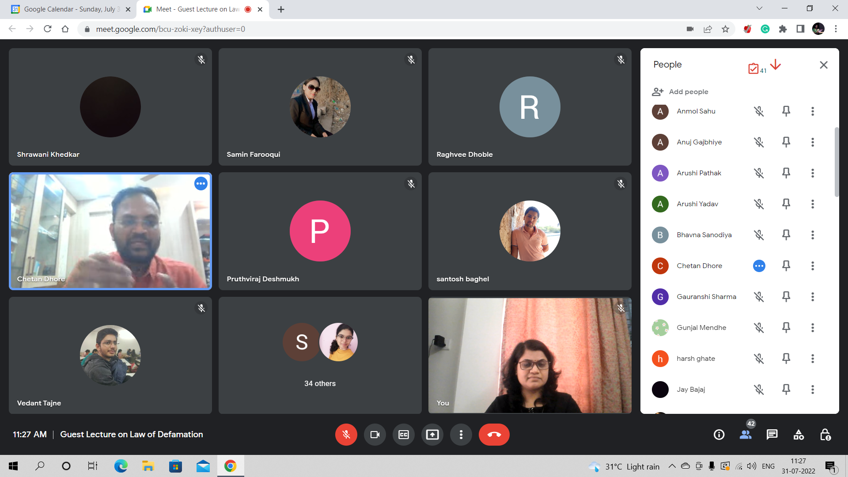

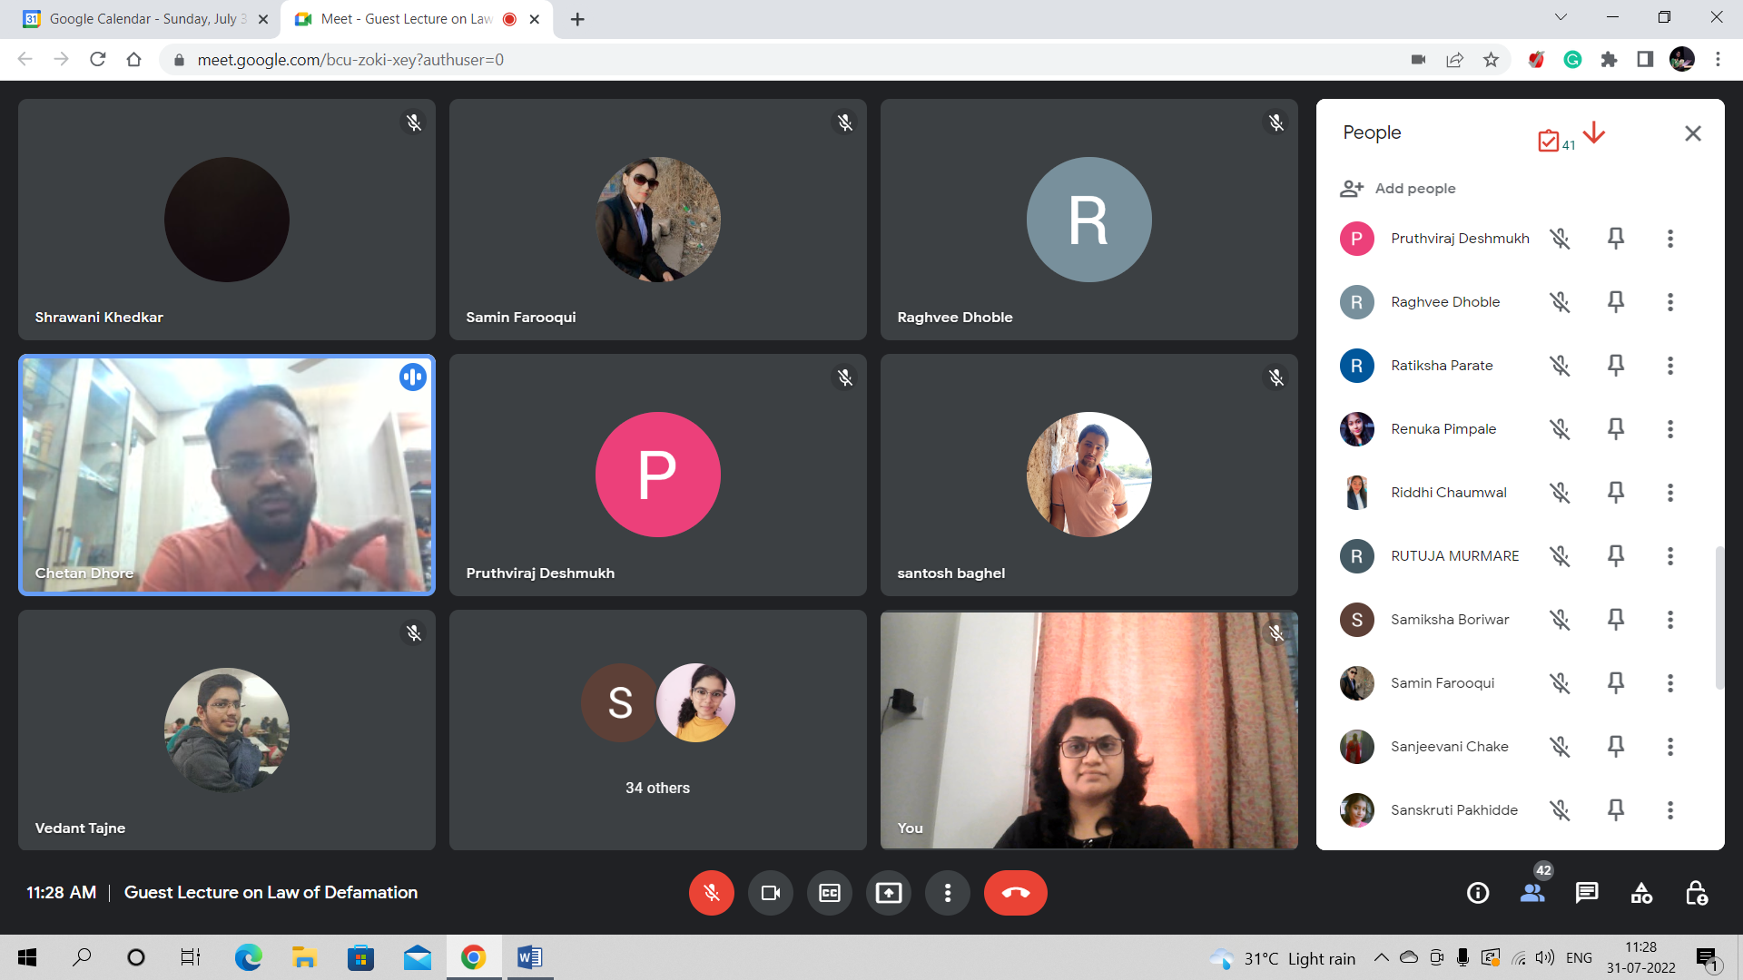
ADV. CHETAN DHORE ADDRESSING THE STUDENTS OF LAW
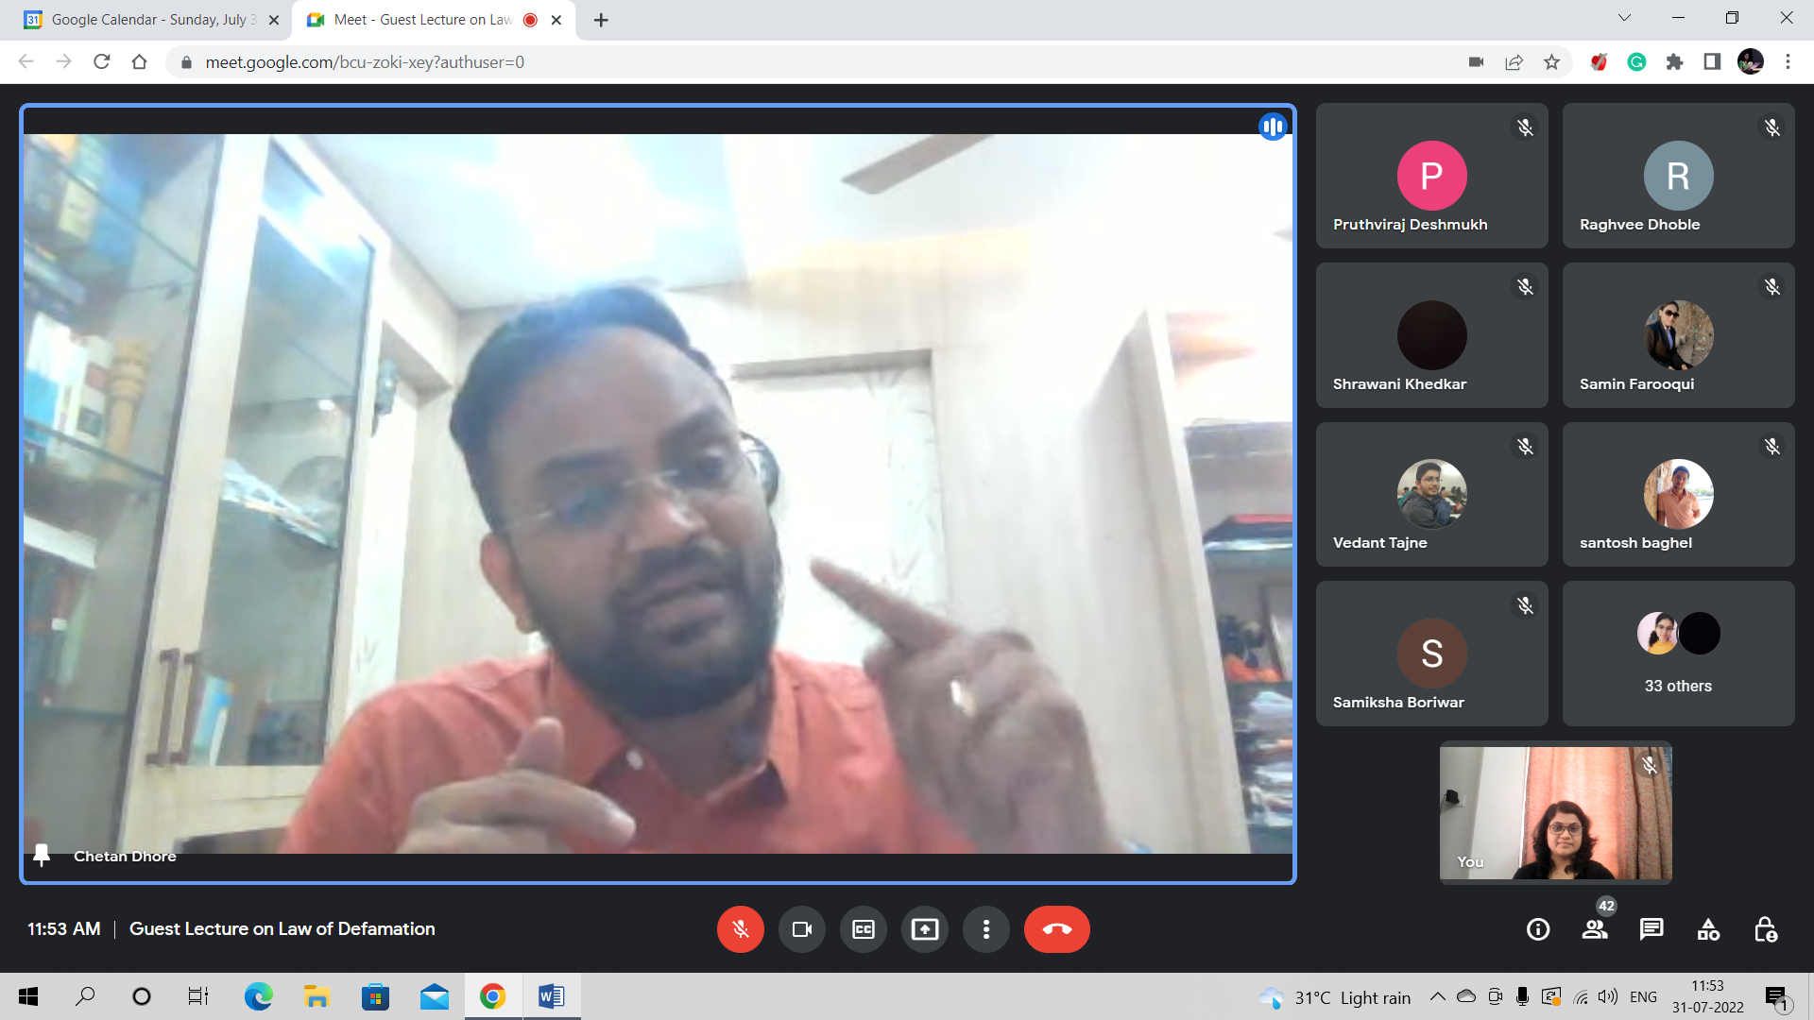

- GUEST LECTURE ON PUBLIC PEACE AND TRANQUILITY: 16-08-2022
Notice:
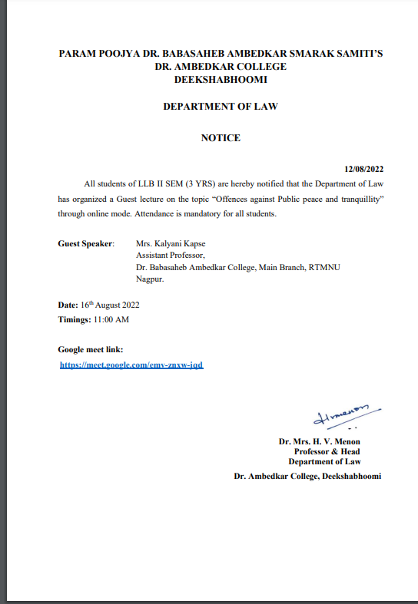

NAME OF THE PROGRAMME | Guest Lecture on the topic “Offences against Peace & Tranquillity”
DATE AND DAY: | 16th August 2022
TIME: | 11.00 am to 12.30 pm
VENUE: | Virtual
ZOOM MEETING LINK: | https://meet.google.com/emv-znxw-jqd
PROGRAMME SUPERVISOR: | Dr. Sandhya P. Kalamdhad

On 16th August 2022, Department of Law organized a guest lecture on the topic “Offences against Peace and Public Tranquility”. Approximately 45 students of LLB ( 3 years course) joined the programme. Prof. Dr. H.V.Menon, Head of the Department of Law joined the online Program through Zoom Meeting. The Welcome address was given by Prof. Dr. H.V. Menon, Head of the Department of Law where she expressed the gratitude to the Resource person for sharing his knowledge and also emphasised the Importance of organizing such programs.
The speaker Adv. Kalyani Kapse started her topic by stating the importance of the topic. She elaborated all the provisions under Indian Penal Code. Then she went through some important incidences and case laws on the topic. Students are greatly benefited out of this. Dr. Sandhya Kalamdhad proposed the vote of thanks.

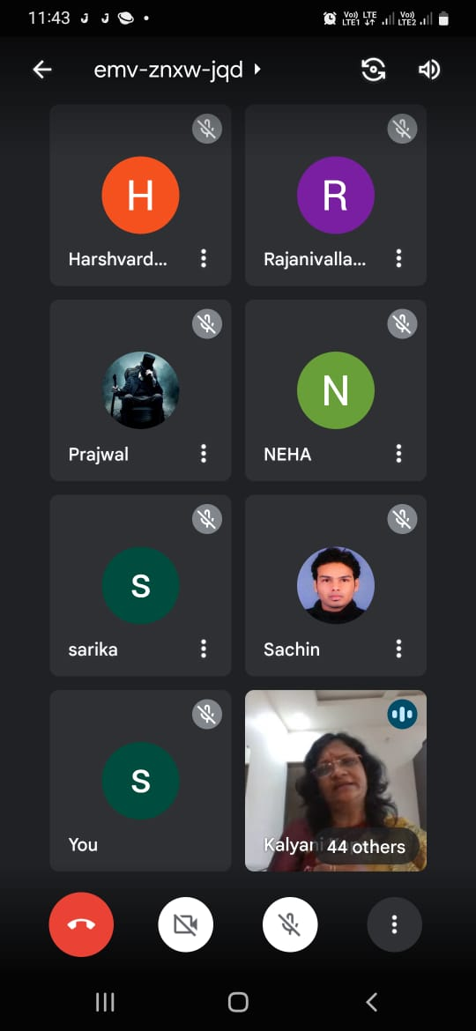
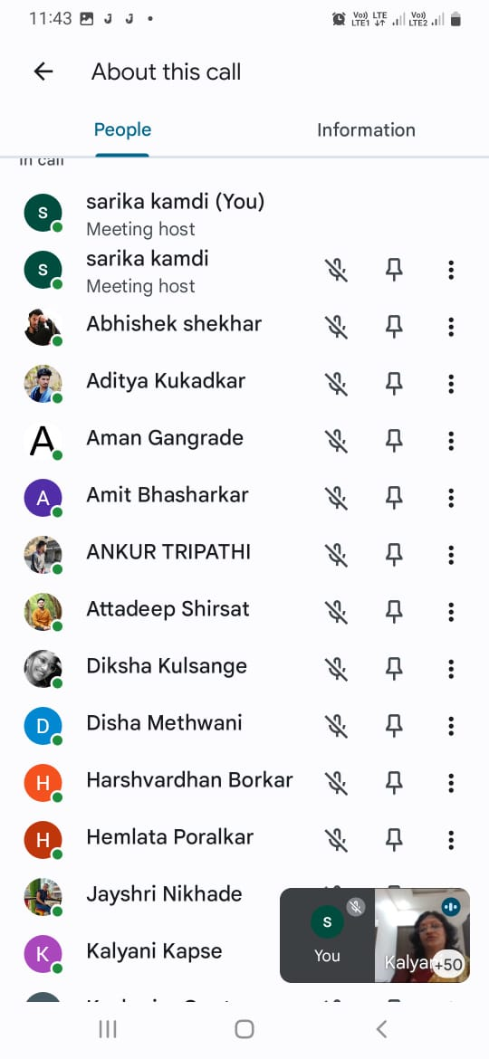

- GUEST LECTURE ON OFFENCES AGAINST STATE: 9-08-2022
Notice:
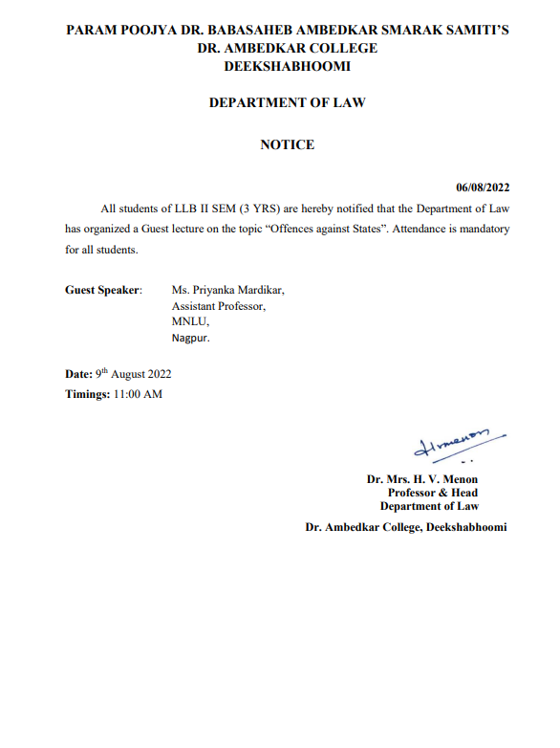

NAME OF THE PROGRAMME | Guest Lecture on the topic “Offences against State”
DATE AND DAY: | 9th August 2022
TIME: | 11.00 am to 12.30 pm
VENUE: | Virtual
ZOOM MEETING LINK: | https://meet.google.com/emv-znxw-jqd
PROGRAMME SUPERVISOR: | Dr. Sandhya P. Kalamdhad

On 9th August 2022, Department of Law organized a guest lecture on the topic “Offences againstt State”. Approximately 45 students of LLB ( 3 years course) joined the programme. Prof. Dr. H.V.Menon, Head of the Department of Law joined the online Program through Zoom Meeting. The Welcome address was given by Prof. Dr. H.V. Menon, Head of the Department of Law where she expressed the gratitude to the Resource person for sharing his knowledge and also emphasised the Importance of organizing such programs.
The speaker Adv. Priyanka Mardikar started her topic by stating the importance of the topic. She elaborated all the provisions under Indian Penal Code. Then she went through some important incidences and case laws on the topic. Students are greatly benefited out of this. Dr. Sandhya Kalamdhad proposed the vote of thanks.

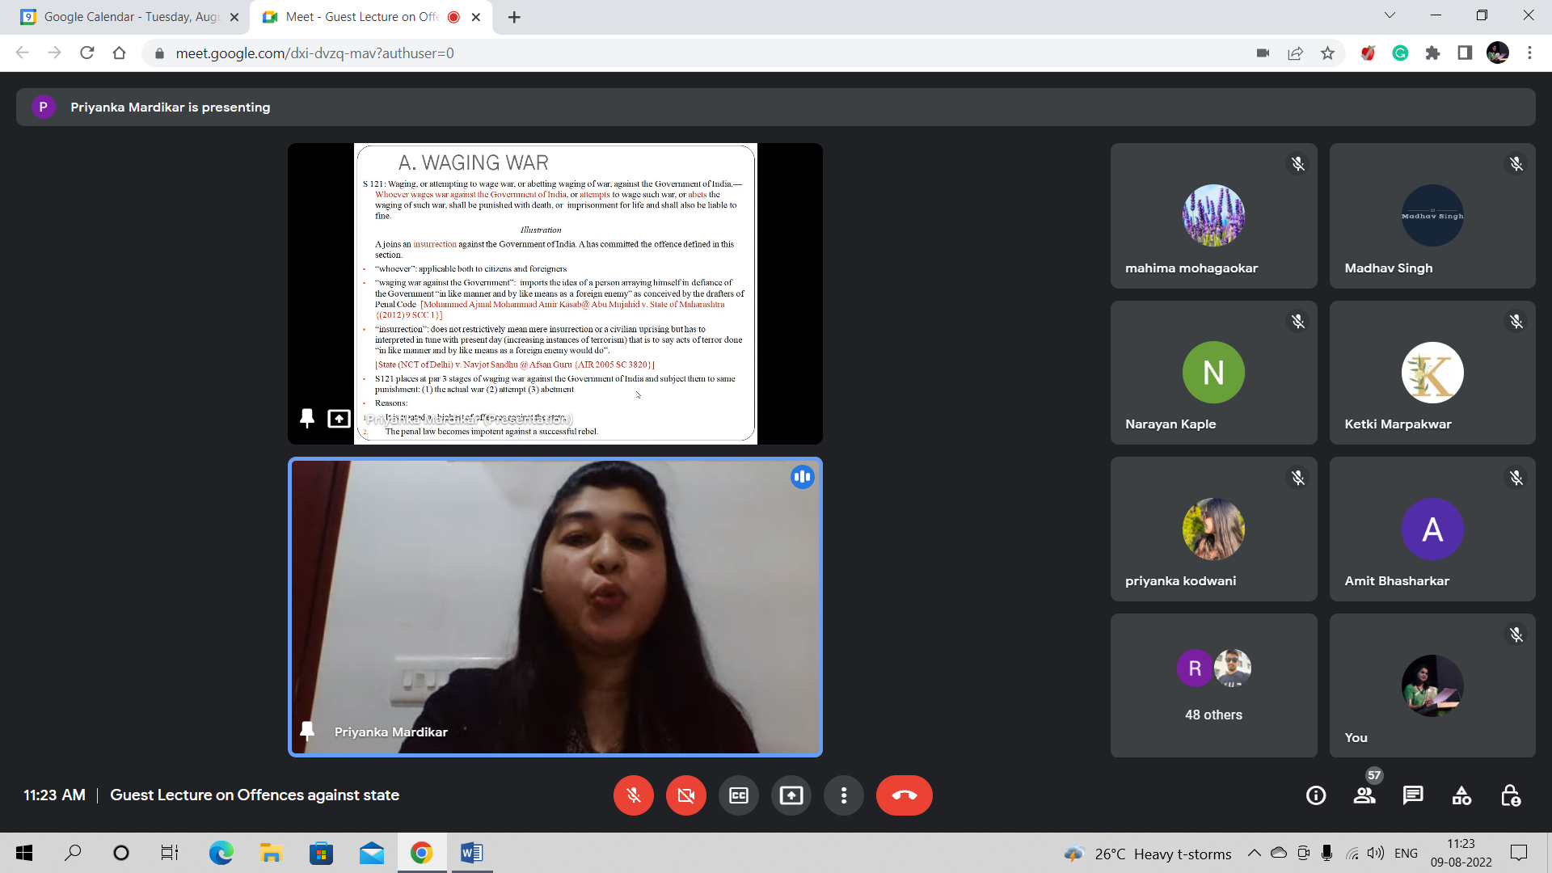
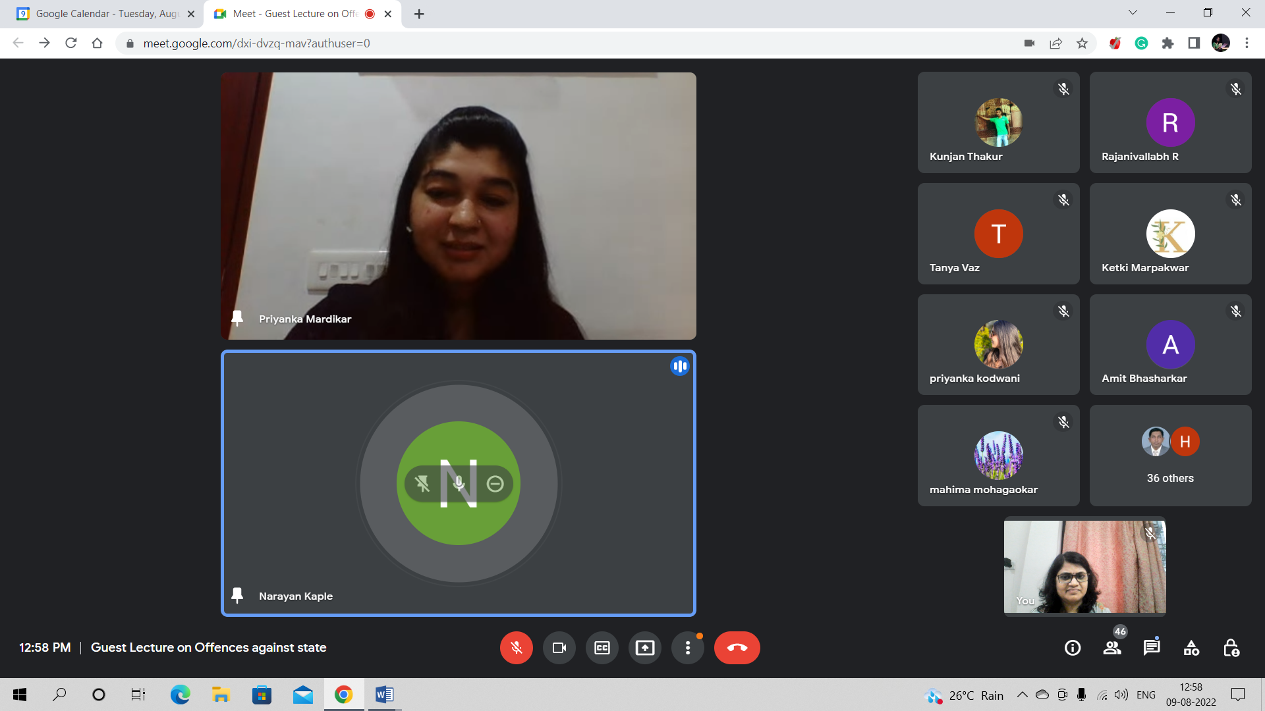
- GUEST LECTURE ON OFFENCES AGAINST WOMEN: 3-08-2022
Notice:
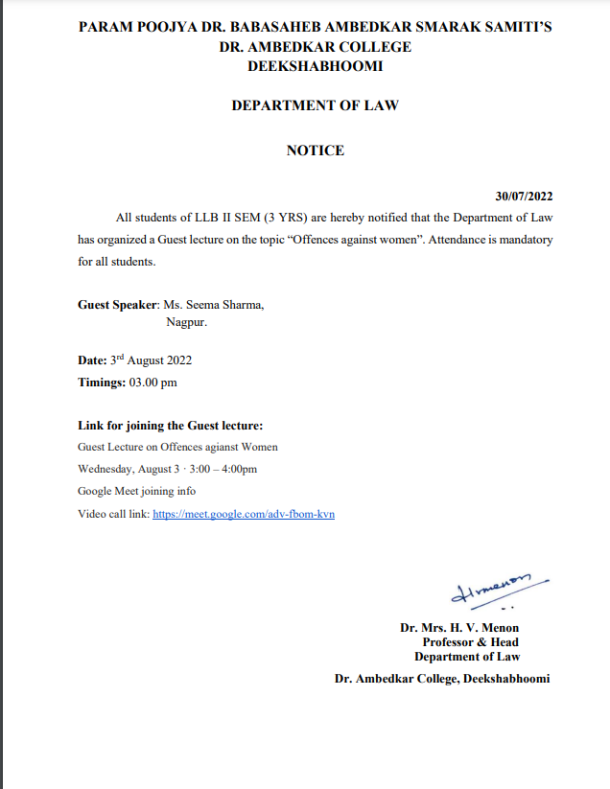

NAME OF THE PROGRAMME | Guest Lecture on the topic “Offences against Women”
DATE AND DAY: | 3rd August 2022
TIME: | 11.00 am to 12.30 pm
VENUE: | Virtual
ZOOM MEETING LINK: | https://meet.google.com/emv-znxw-jqd
PROGRAMME SUPERVISOR: | Dr. Sandhya P. Kalamdhad

On 3rd August 2022, Department of Law organized a guest lecture on the topic “Offences against Women”. Approximately 45 students of LLB II nd Sem. 3 years course joined the programme. Prof. Dr. H.V.Menon, Head of the Department of Law also joined the Program. The Welcome address was given by Prof. Dr. H.V. Menon, Head of the Department of Law where she expressed the gratitude to the Resource person for sharing his knowledge and also emphasised the Importance of organizing such programs.
The speaker Mrs. Seema Sharma, started her topic by stating the importance of the topic. She elaborated all the provisions under Indian Penal Code. Then she went through some important incidences and case laws on the topic. She also covered the recent Amendments in this area very precisely. Students are greatly benefited out of this. Dr. Sandhya Kalamdhad proposed the vote of thanks.

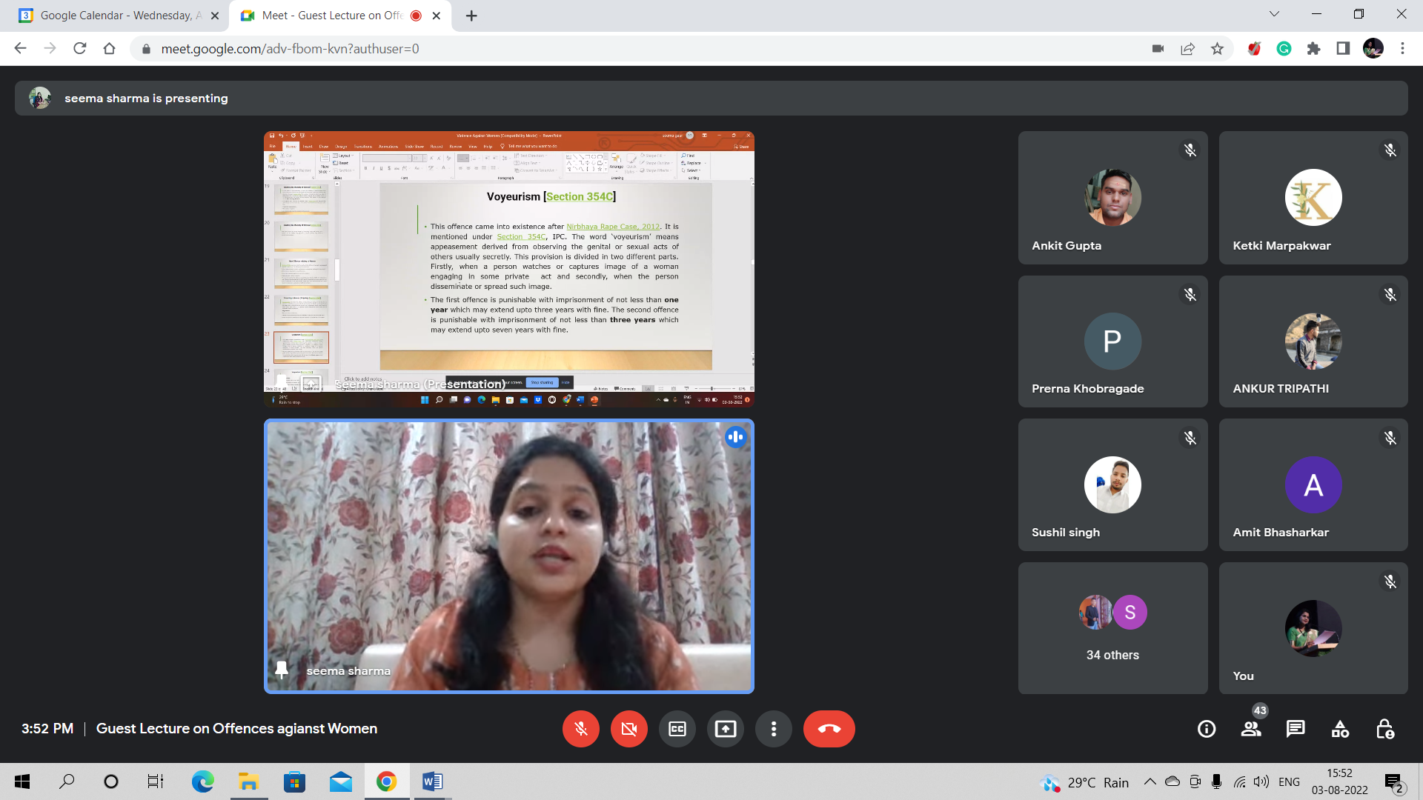
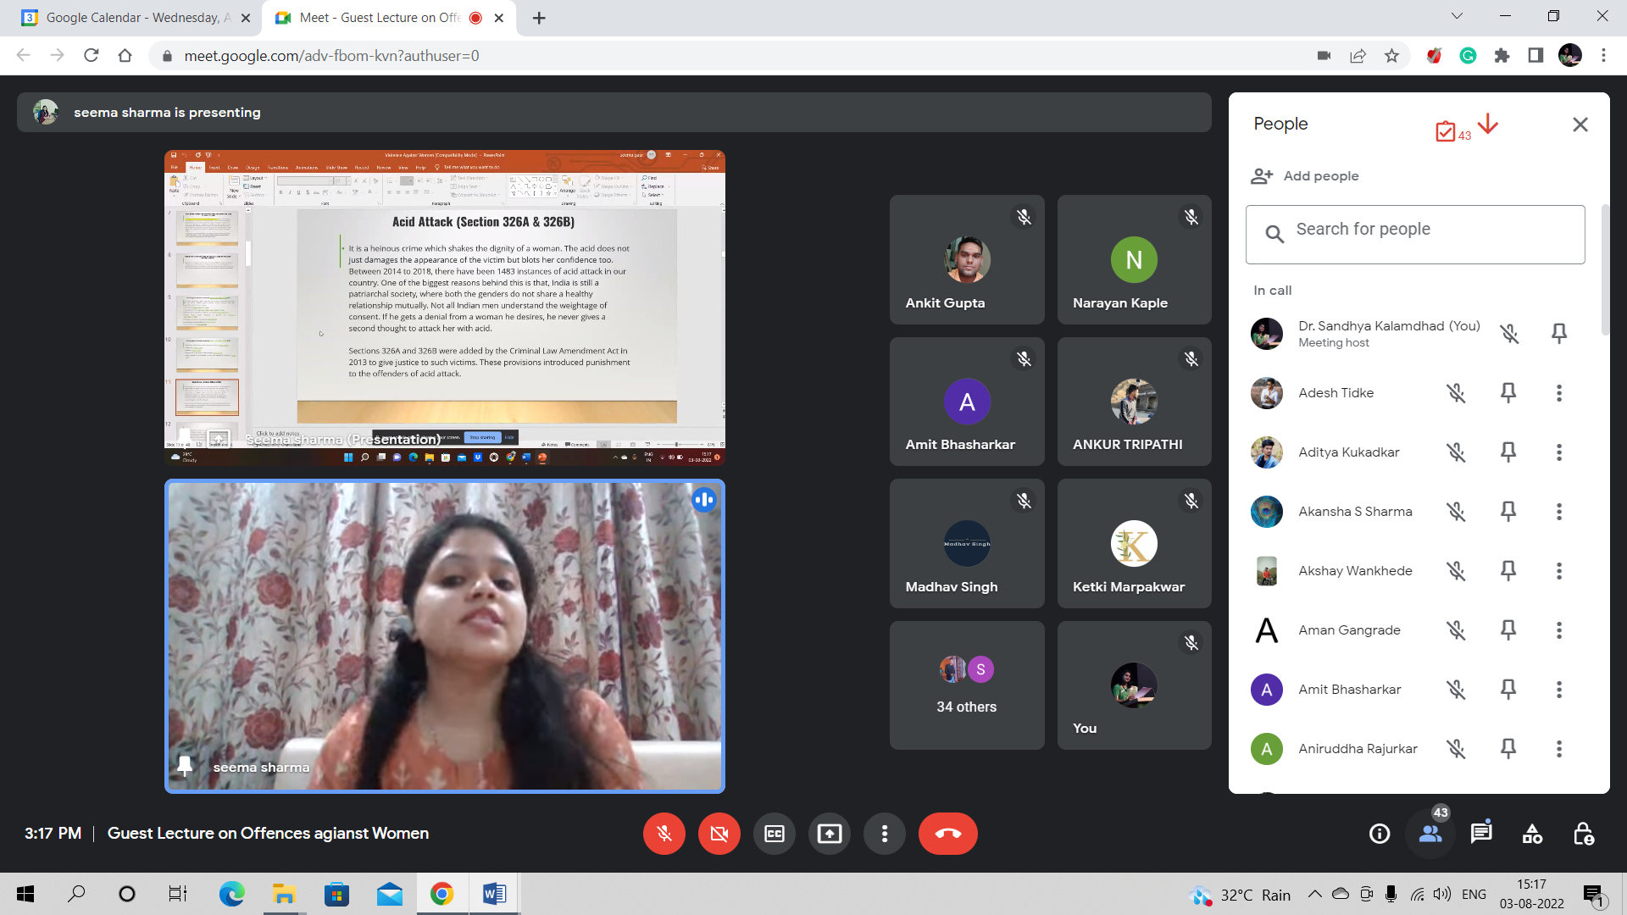
Mrs. Seema Sharma Addressing the Students of Law

- GUEST LECTURE ON INFORMED CONSENT: 27-09-2022
Notice:
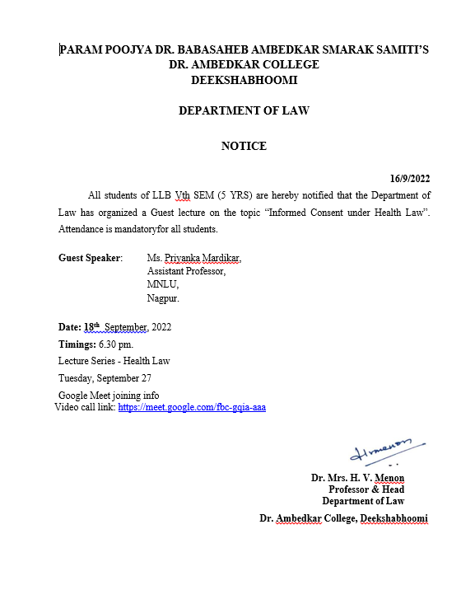

NAME OF THE PROGRAMME | Guest Lecture on the topic “Informed Consent under Health Law”
DATE AND DAY: | 27th September 2022
TIME: | 6.30 pm to 8.30 pm
VENUE: | Virtual
ZOOM MEETING LINK: | Tuesday, September 27  Google Meet joining info  Video call link: https://meet.google.com/fbc-gqia-aaa
PROGRAMME SUPERVISOR: | Dr. Sandhya P. Kalamdhad

On 27th September, 2022, Department of Law organized a guest lecture on the topic “Informed Consent under Health Law”. Approximately 51 students of LLB Vth Sem. ( 3 years course) joined the programme. Prof. Dr. H.V.Menon, Head of the Department of Law also joined the online Program. The Welcome address was given by Prof. Dr. H.V. Menon, Head of the Department of Law where she expressed the gratitude to the Resource person for sharing his knowledge and also emphasised the Importance of organizing such programs.
The speaker Ms. Priyanka Mardikar started her topic by stating the importance of the topic. She took the students through various national and international judgements to elaborate them the concept of Informed consent. Students are greatly benefited out of this. Dr. Sandhya Kalamdhad proposed the vote of thanks.

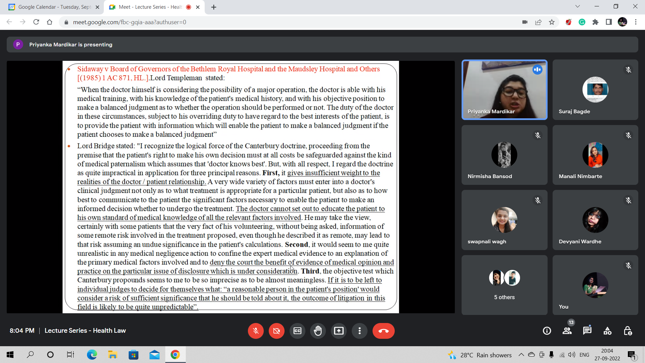
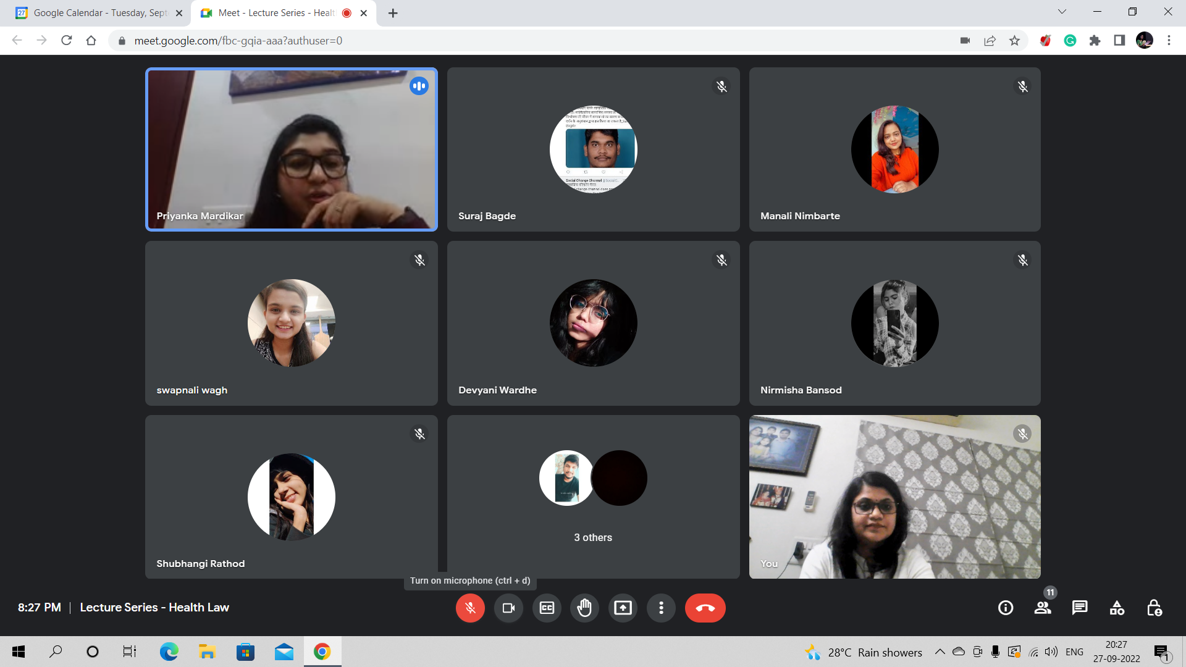
MS. PRIYANKA MARDIKAR ANSWERING THE QUESTIONS OF STUDETNS

- CONSUMER DAY- 24 DECEMBER 2022

NAME OF THE PROGRAMME: | CONSUMER DAY 2022 – CONSUMER RIGHTS AWARENESS PROGRAM
NAME OF THE PROGRAMME CO-ORDINATOR: | MRS. VAISHALI A. SUKHDEVE
DATE AND DAY: | 24TH DECEMBER, 2022 (SATURDAY)
TIME: | 11.30 AM – 1.30 PM
TOTAL NUMBER OF PARTICIPANTS FOR SPREADING AWARENESS: | 12 STUDENTS: 8 GIRLS; 4 BOYS
VENUE: | DEPARTMENT OF LAW AND  VNIT SQARE, BAJAJ NAGAR, NAGPUR.

Consumer day was celebrated in Dr. Ambedkar College, Deekshabhoomi, Department of Law on 24th December 2022. Students of Law department performed the skit on Consumer rights awareness in Department of Law and in VNIT Square Street to aware the common public on the recent issues covered under the new Consumer Protection Act of 2019, where emphasis was given on Unfair trade practices performed, misleading advertisements, E commerce and Mediation procedures.
Skit was divided into 4 parts covering 4 above-mentioned different issues. After each part, the legal provisions dealing with particular incident was explained in Hindi, so that common people can understand and be aware of their rights. Students of LLB 3rd semester 5 years performed the skit which was directed by Nishta Singh and Unnati Bobde. The performers were Harsh Guhe, Pruthviraj Deshmukh, Vedant Tajne, Khushi Chauhan, Renuka Pimple, Shraddha, Saniya Sheikh, Saleha Sheikh.
The skit was witnessed by the students of LLB I and III SEM (3 Years and 5 Years Course) along with all the present teaching and non-teaching staff in the Department of Law and the common people and students of different faculties available at Bajaj Nagar, VNIT Square. The skit was performed under the guidance and instructions by Dr. Pratima Lokhande and Mrs. Vaishali A. Sukhdeve.

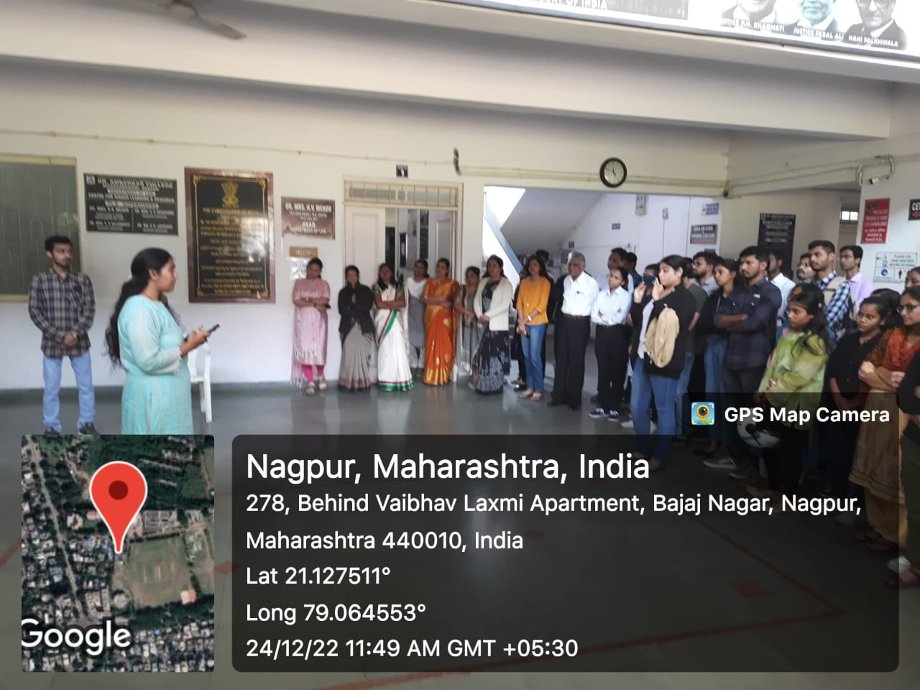

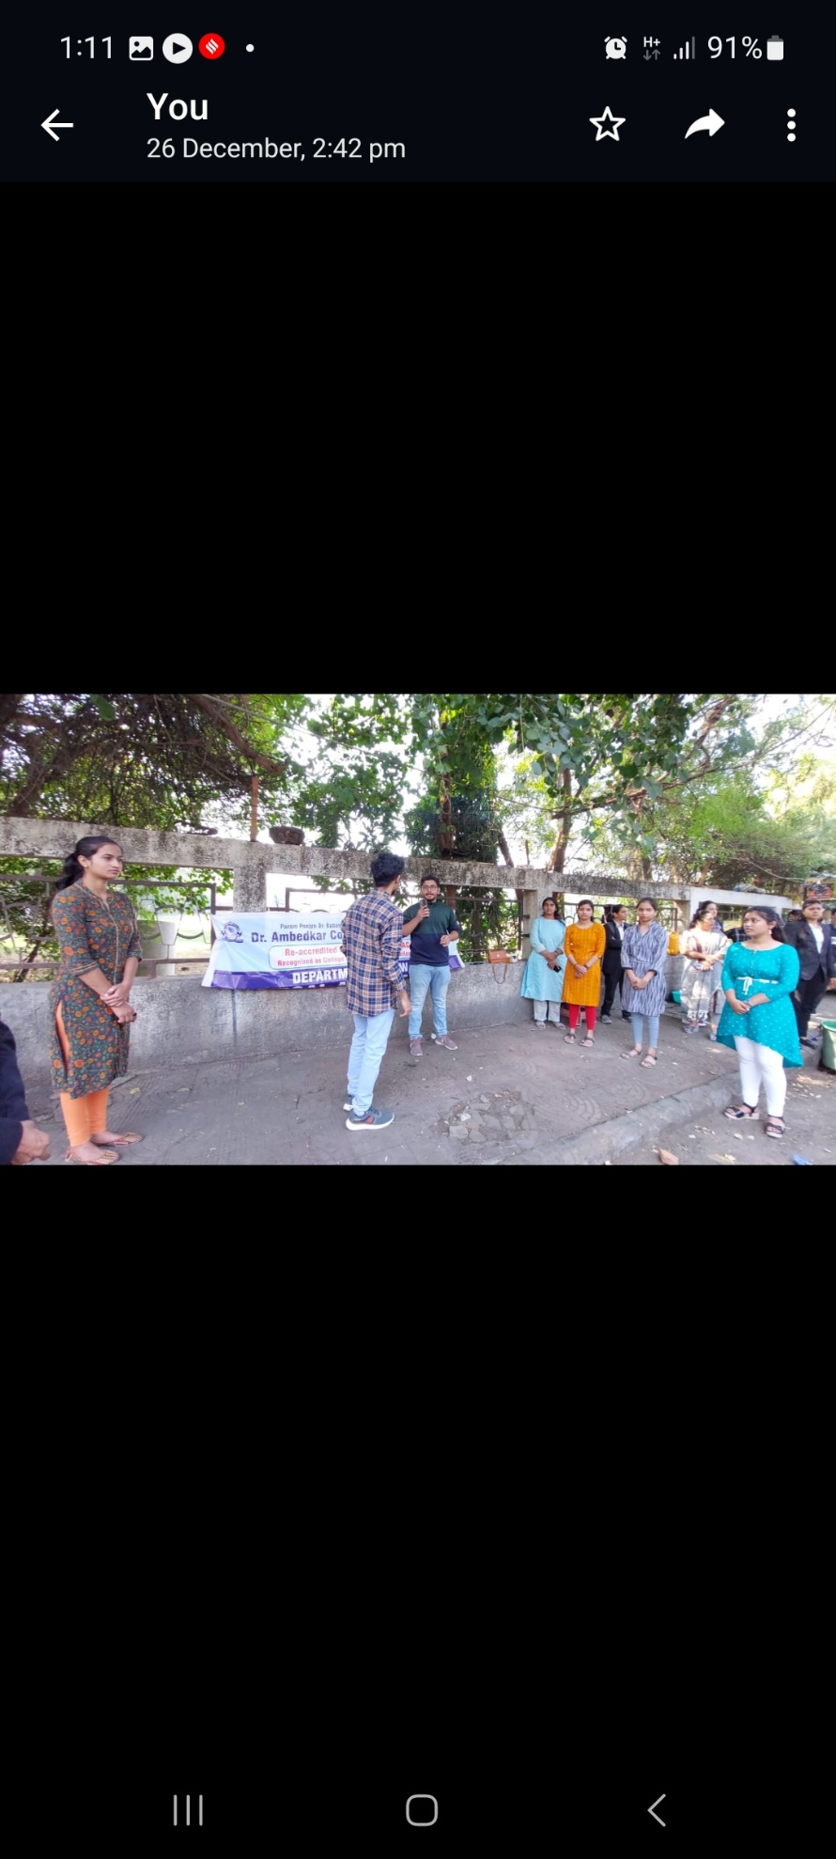
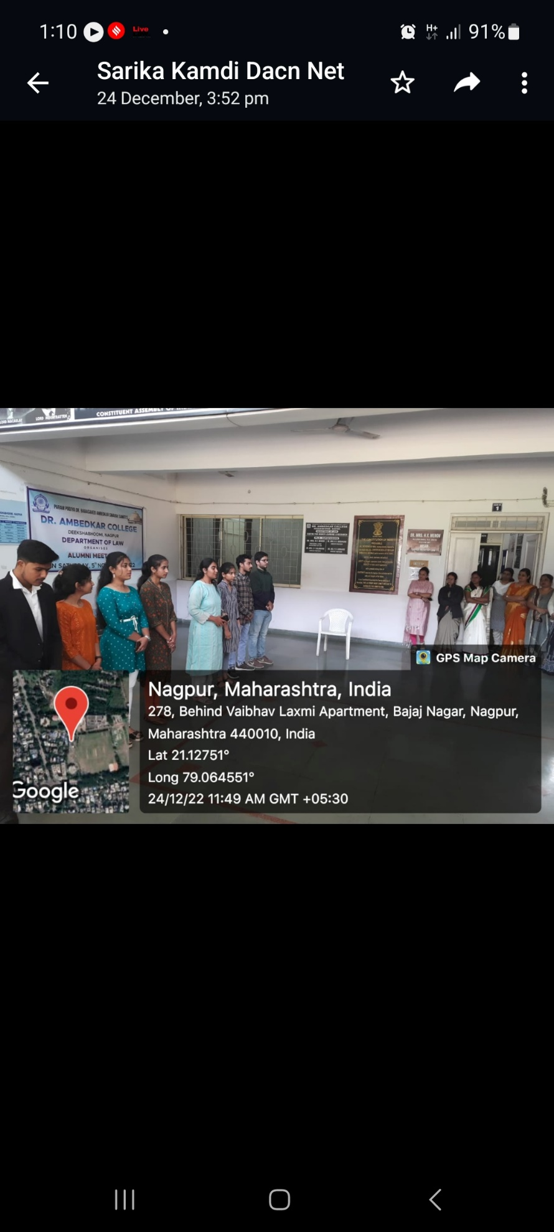
STUDENTS PERFORMING SKIT AT DEPARTMENT OF LAW AND VNIT SQUARE, BAJAJ NAGPUR

- E Commerce and Product Liability- Consumer Protection- 3rd November 2022

NAME OF PROGRAMME: | Guest lecture on the topic “E Commerce and Product liability- Consumer protection”.
DATE AND DAY: | 3rd November 2022
TIME: | 04:00 PM
VENUE: | Virtual
GOOGLE MEETING LINKS: | https://meet.google.com/yog-hwps-vmj
PROGRAMME SUPERVISOR: | Mrs. Vaishali A. Sukhdeve

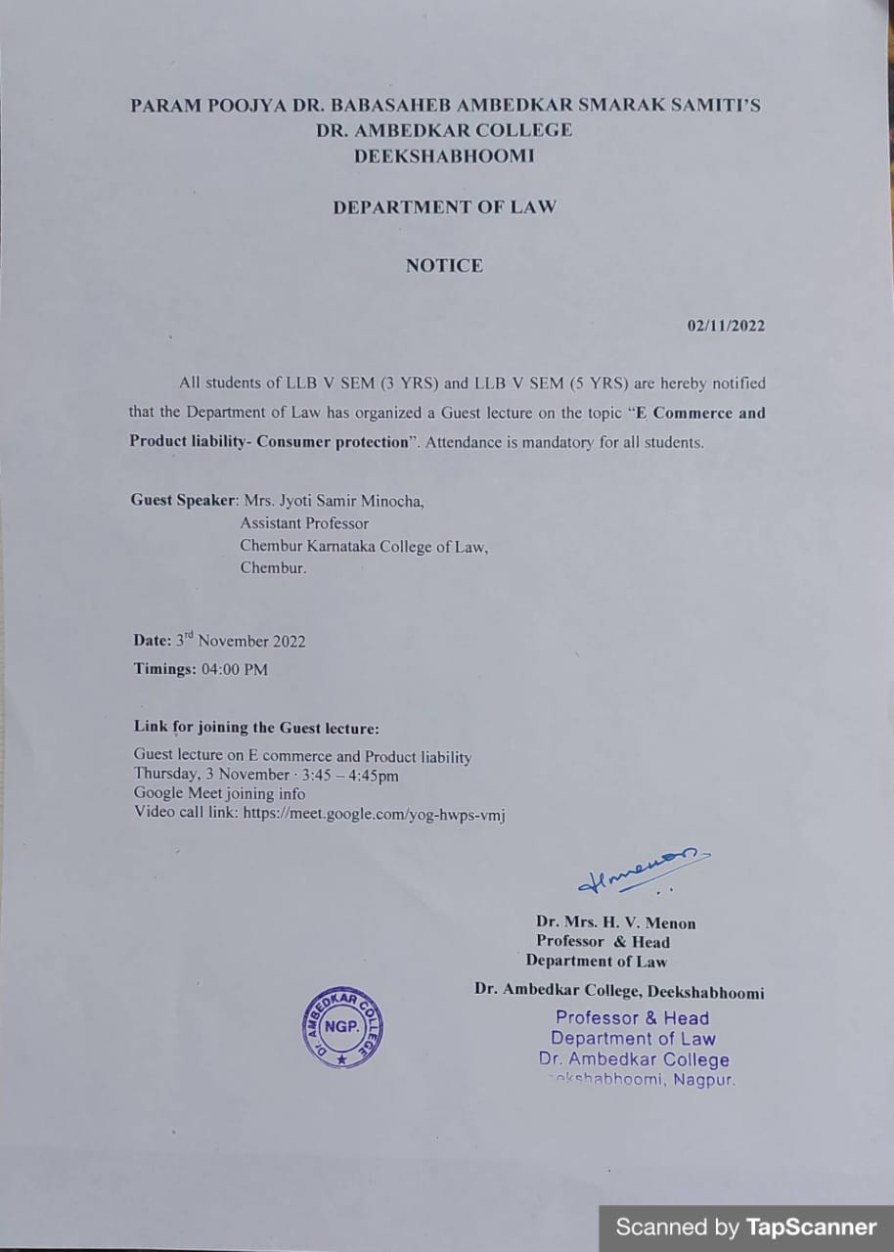

Department of Law of Dr. Ambedkar College, Deekshabhoomi, Nagpur conducted a Guest lecture on the topic “E Commerce and Product liability- Consumer protection” for the students of V Semester BA. LLB 5 Years and LLB 3 Years course. Total 60 students attended the guest lecture through Google meet link at 04:00 PM.
Mrs. Jyoti Samir Minocha, Assistant Professor in Chembur, Karnataka College of Law, Mumbai was invited as a guest speaker to deliver lecture on the topic “E Commerce and Product liability- Consumer protection”. Mrs. Minocha started the session with the historical background of Consumer movement in India. She further highlighted how the definition of consumer is applicable to the concept of E-commerce in contemporary times. She gave a comparative analysis of the provisions of Consumer Protection Act of 1986 and 2019. She discussed all the new provisions inserted in the new Act of 2019 laying emphasis on Mediation technique as one of the effective modes of Consumer dispute resolution. Use of E- commerce by the consumers by shopping from different online websites led to the issues involved with respect to the rights of the buyers on one hand and the responsibilities of the consumers as well as the sellers on other hand. She also focused on how the online sellers and to what extent the Online service providers could be held responsible. This is an emerging problem which requires different approaches and some efficient regulating authorities. The new Act of 2019 dealt with this issue which was critically analysed and explained by the guest speaker.
Mrs. Jyoti Minocha further highlighted the procedures for making online complaints and in this she also discussed the jurisdictions of different forums starting from District Consumer Redressal forum now known as District Commission as per the New Act of 2019. The pecuniary and territorial jurisdictions of State Commission and National Commission has seen amendments in the New Act which was explained in detail.
This was followed by the question answer session. All the questions related to practical applicability of the Act and the problems involved in online shopping were answered in detail by the Guest Speaker, Mrs. Jyoti Minocha to the satisfaction of the students. The program was conducted and co-ordinated by Mrs. Vaishali A. Sukhdeve under the able guidance of Head of the Department, Prof. Dr. Mrs. H.V. Menon.

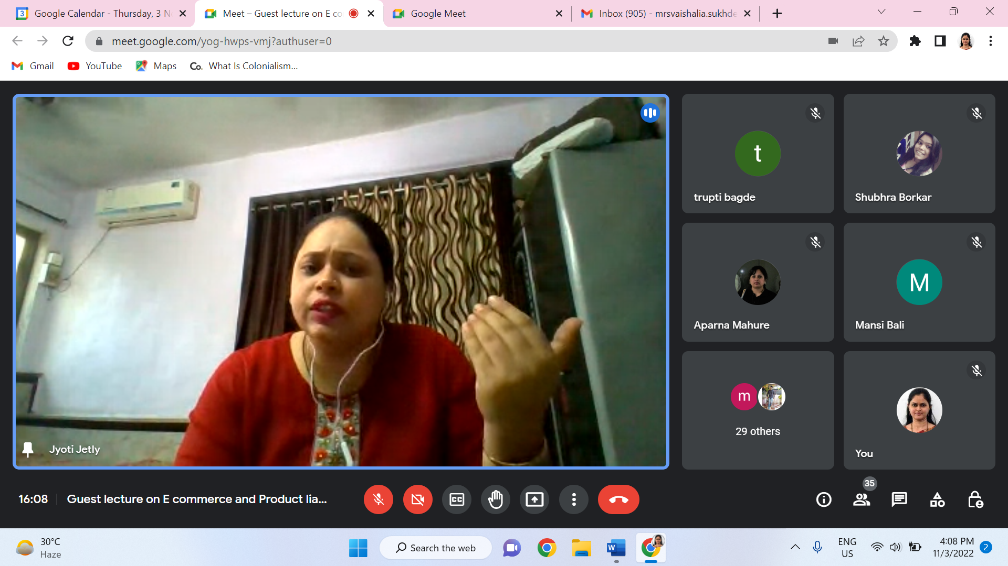
Mrs. Jyoti Minocha addressing the students

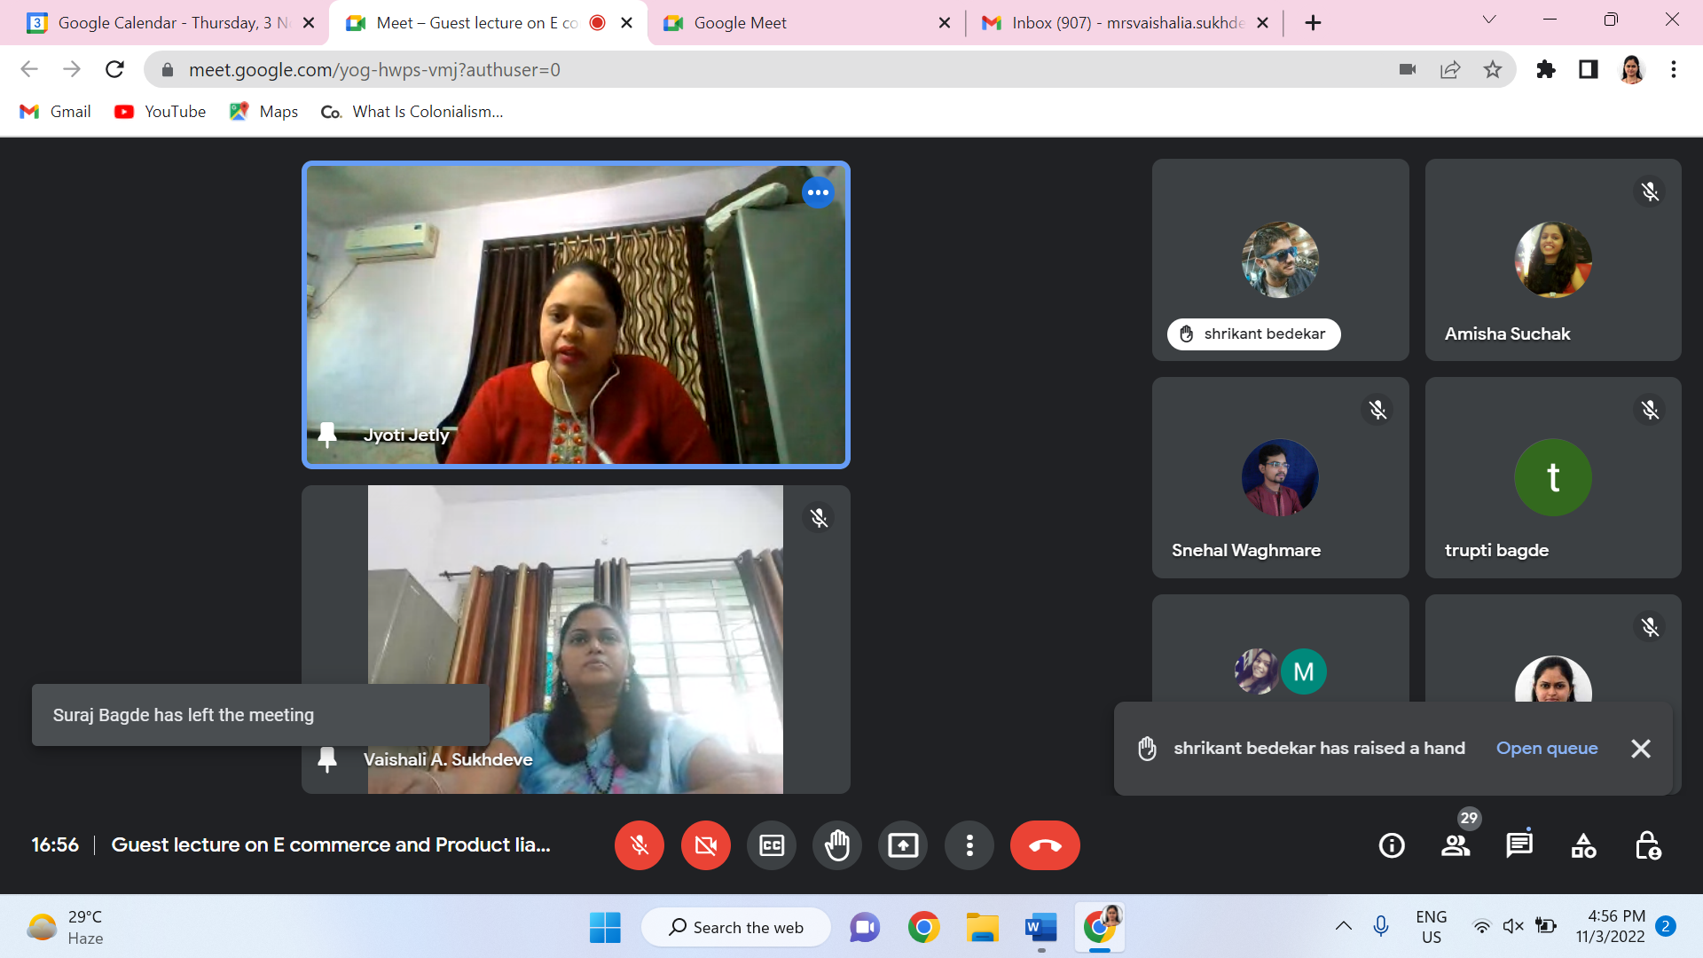
Mrs. Jyoti Minocha answering the question raised by one of the students.

- Moot Court Workshop- 26th December 2022
NAME OF THE PROGRAMME: | Moot Court Workshop 2022 by SMCA
NAME OF THE GUEST/ RESOURCE PERSONS: | 1. ADV. RAHUL DHANDE  2. ADV. WILSON MATHEW
NAME OF THE PROGRAMME SUPERVISOR | DR. VARSHA DESHPANDE
NAME OF THE PROGRAMME CO-ORDINATORS: | - Mrs. Vaishali A. Sukhdeve  - Ms. Sarika Kamdi
DATE AND DAY: | 26TH DECEMBER, 2022 (MONDAY)
TIME: | 11 AM – 1.30 PM
TOTAL NUMBER OF PARTICIPANTS: | 82 STUDENTS: 42 GIRLS; 40 BOYS
VENUE: | ROOM NUMBERS- 4 AND 6,  DEPARTMENT OF LAW, NAGPUR.

Moot Courts are the highlights of any law student’s life. After all, it is there that the student has the first taste of lawyering. It wouldn’t be wrong to say that mooting is the closest a law student can get to being an actual lawyer. Thus, it is extremely important that they receive proper and adequate guidance in the same. With this thought in mind, The Students’ Moot Court Association of the Department of Law, Dr. Ambedkar College, Nagpur organized a Workshop on Moot Court on the 26th of December 2022 for the students of LLB I Sem (3- and 5-Year’s course). Under the guidance of Adv Rahul Dhande and Adv Wilson Mathew both practising advocates from the Nagpur Bench of the Bombay High Court, the students were taught the basics of mooting- which start right from reading a proposition to drafting a memorial.
In order to make the whole learning process more effective, the students were circulated the moot proposition beforehand and were expected to be acquainted with it.
Adv. Rahul Dhande Sir went into great detail on the purpose of competing in moot court competitions as well as its significance. He clarified the proper format for writing a memorial and highlighted the value of conducting research before drafting it. While Adv. Wilson Mathew Sir enlightened the students upon the dos and don'ts which are to be taken care of while arguing a case in a Mock Court. He also shared his personal experience with Mooting in National and International Competitions and encouraged students to use their free time wisely beginning in the first semester.
The resource persons were kind enough to explain all the nitty-gritty of it. They also explained to the students how to look past the irrelevant facts, onto the relevant ones, to see the issues at hand. The resource persons also explained the method of researching for a moot. How one may browse through countless case laws and arrive at the most fitting one, is often a matter of stress for beginners. They were patient in explaining that as well, while also emphasising the significance of good research work. After this, the resource persons shifted the focus to the drafting of memorials. Certain cardinal rules of drafting were elucidated which gave the participants a very clear idea about how they may proceed with the drafting. The speakers also demonstrated how good drafting makes a difference in presenting the case before the court. Some apt examples were cited by the speakers to illustrate this point. The speakers left no stone unturned in enlightening the students and this could be best observed when they taught basic court mannerisms to the eager audience.
The students had a slew of questions for each speaker, which they answered to their satisfaction. After an interactive session, Ms. Anmol Sahu proposed a vote of thanks to Adv. Rahul Sir and Ms. Aditi Singh proposed a vote of thanks to Adv. Wilson Sir, and the workshop was concluded by presenting both of them a momento on behalf of the entire Students’ Moot Court Association. The participants as well as the organizers were indebted for the patient and kind demeanour and teaching style of the speakers. The audience left with a feeling of confidence and eagerness to learn more while the speakers parted with having taught probably the most enthusiastic participants ever!
Adv. Rahul Dhande guiding the students of LLB -I sem 3 Years and 5 years course
Adv. Wilson Mathew, adressing the students of LLB -I sem 3 Years and 5 years course

- Social Awareness Programme – 14th November 2022
Date: 14th NOV, 2022
Name of the Programme: Social Awareness Program on the Occasion of Children’s Day
Resource Person: 1. Dr. Kamayani Deshpande
2. Mr. Prince Singh
Organised by: Department of Law in collaboration with an NGO UPAY (Underprivilege’s Advancement by Youth) Nagpur
Name of Program Co-ordinators: 1. Dr. Hema Menon
2. Ms. Shilpa rathod
Number of Attendees: 53
Name of Venue: Seminar Hall, Department of Law, Dr. Ambedkar College Deeksha Bhoomi, Nagpur

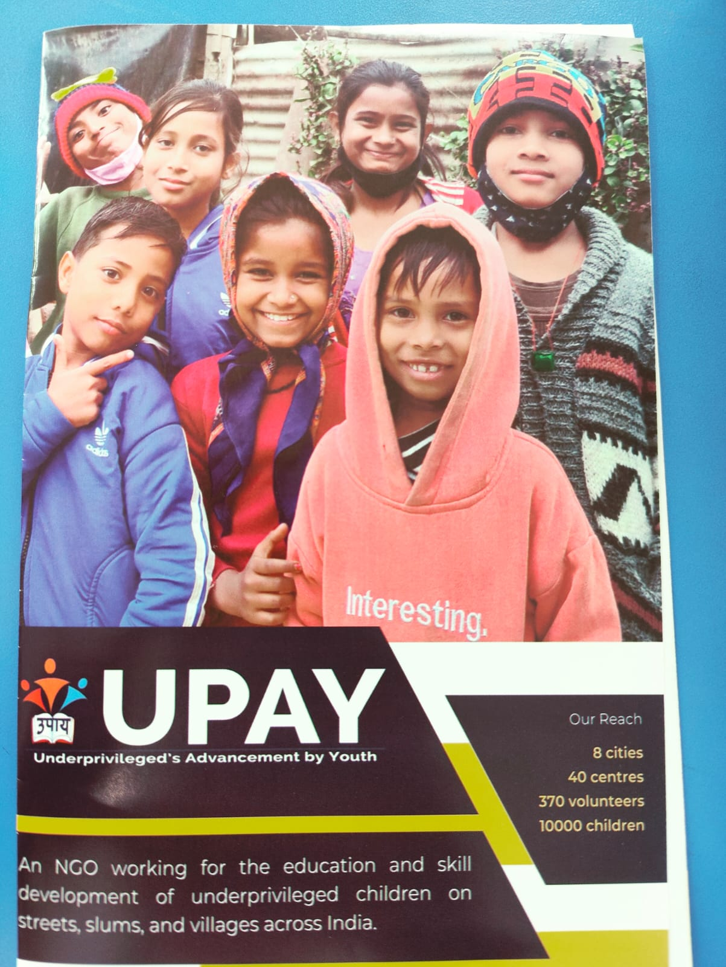
REPORT ON SOCIAL AWARNESS PROGRAM ON THE OCCASION OF CHILDREN’S DAY

The Department of Law of Dr. Ambedkar College, Deeksha bhoomi Nagpur, in collaboration with an NGO UPAY Underprivilege’s Advancement by Youth Nagpur has organised a social awareness Program on 14th November 2022 for the students of LLB 3 Years and LLB 5 Years Course.
Around 53 attendees were present in the program. Dr. Kamayani Deshpande, Co-Founder of UPAY NGO, Nagpur and Mr. Prince Singh Executive Member UPAY NGO, Nagpur were the resource persons who have sensitized the students about the problems of the children’s in Underprivilege section of the different area of Nagpur District on the occasion of Children’s Day.

Mr. Prince Singh enlightened the audience on the various targeted areas wherein they have launched their mission of teaching, sport training, and training the children according to their different skills and interests. He further highlighted their success stories through the PPT. Further he shared the live problems of the underprivilege children’s, their social and economic background and the present need to motivate and encourage them towards taking the education and make them eligible for further studies through Scheme sponsored by HDFC bank.

Dr. Kamayani Deshpande shared with the audience different challenges faced by the underprivilege children like absence of accommodation and acclimatization to the community by institutions, difficulty to access educational institutions, less focus on traditional methods of education, non-inclusion of certain communities, lack of minimum eligible proficiency and unavailability of proper learning resources. She further shared after their success work in elevating the Underprivilege children towards leaning, they still face the major challenge due to lack of volunteers to work with them. She has made appeal to all the students to contribute by working with them at least a day through various manner.

She overwhelmed with the positive response from the student’s end and the acknowledge the students for showing their interest by the way of variety of questions. They have shared the broachers and pamphlets with the students and faculties.

The Programme was conducted by Ms. Shilpa Rathod under the guidance & supervision of Head of the Department Dr. Hema Menon.

The event concluded with vote of thanks proposed by Ms. Shilpa Rathod to the guest speakers and also to everyone who was present to witness the event.

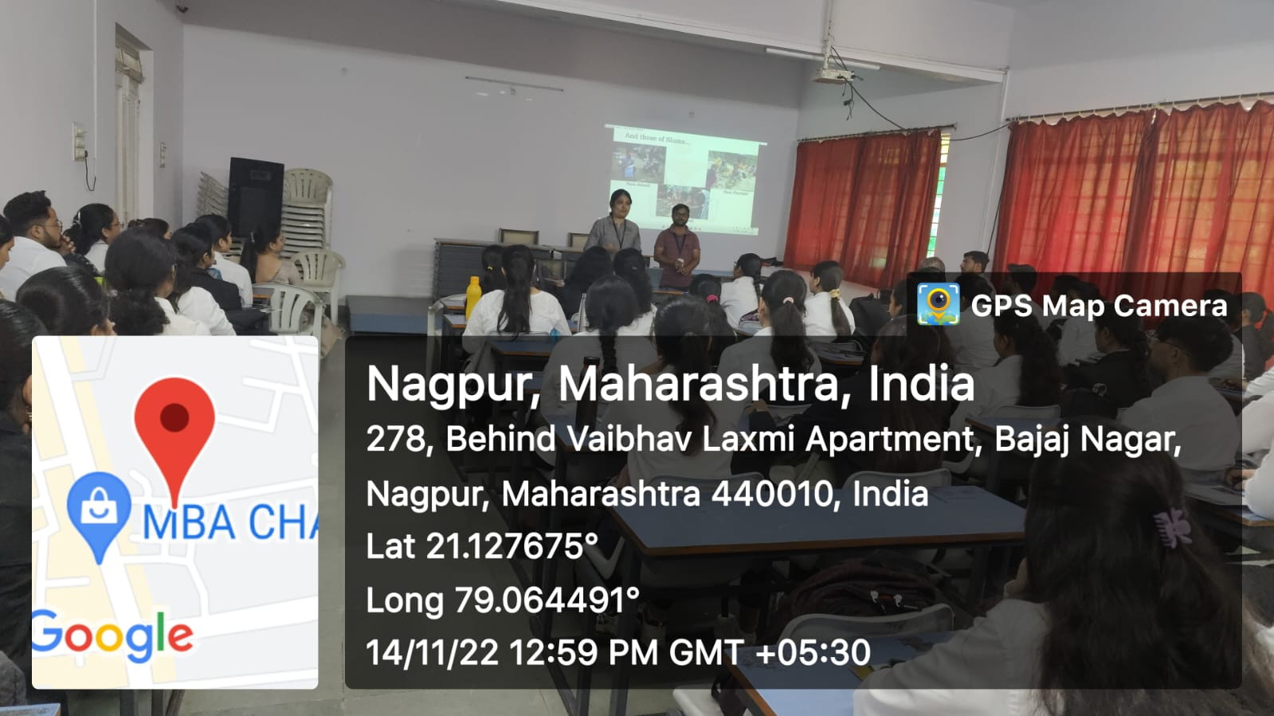

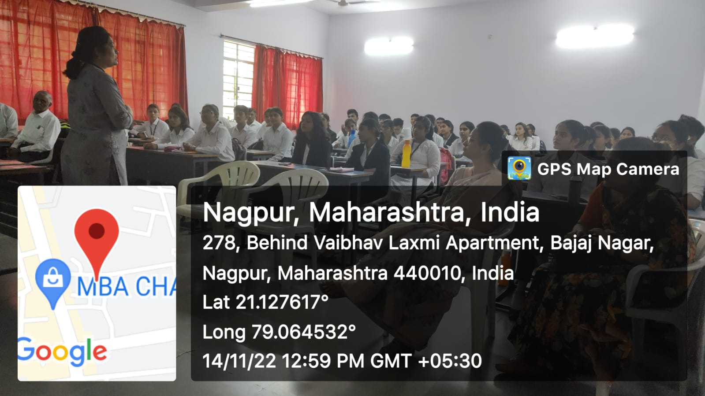

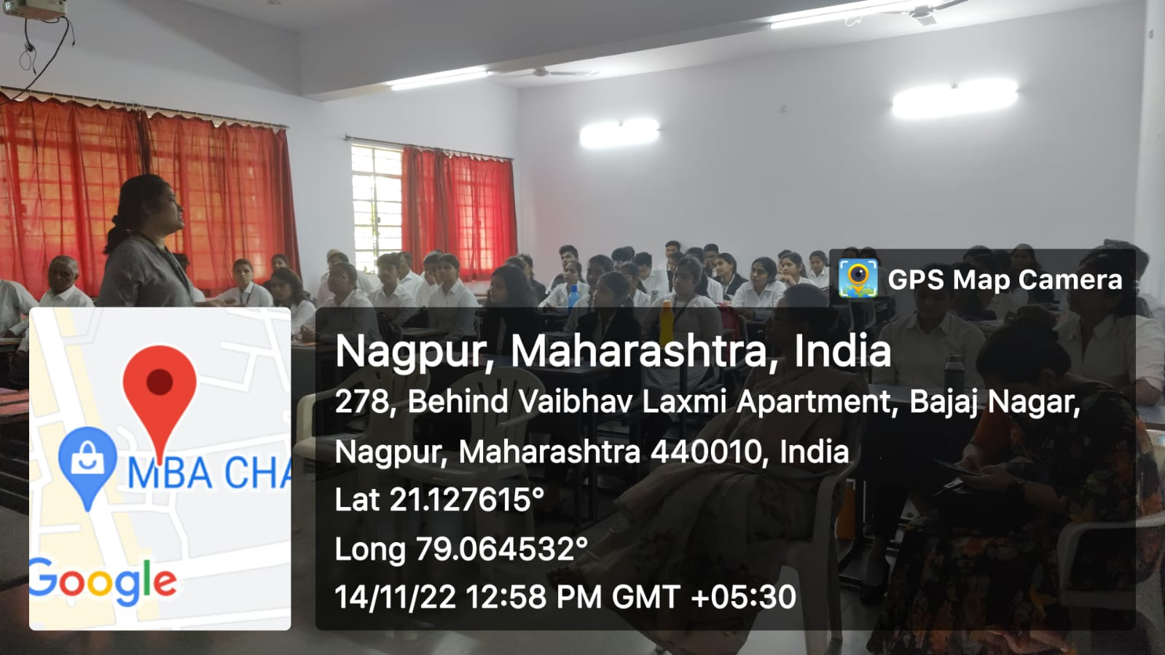

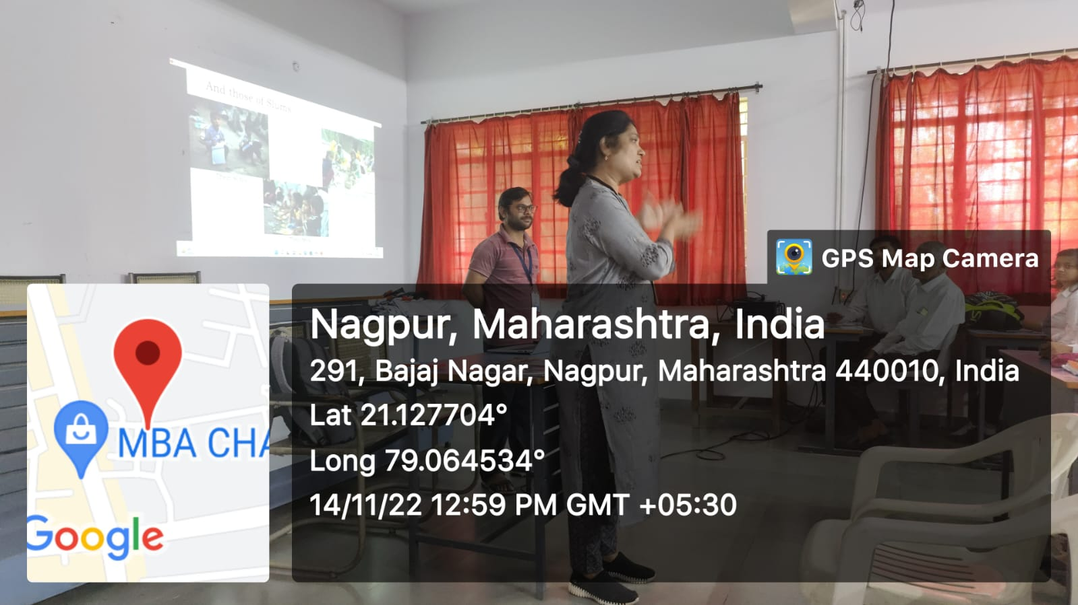

(STUDENTS ATTENDENCE)
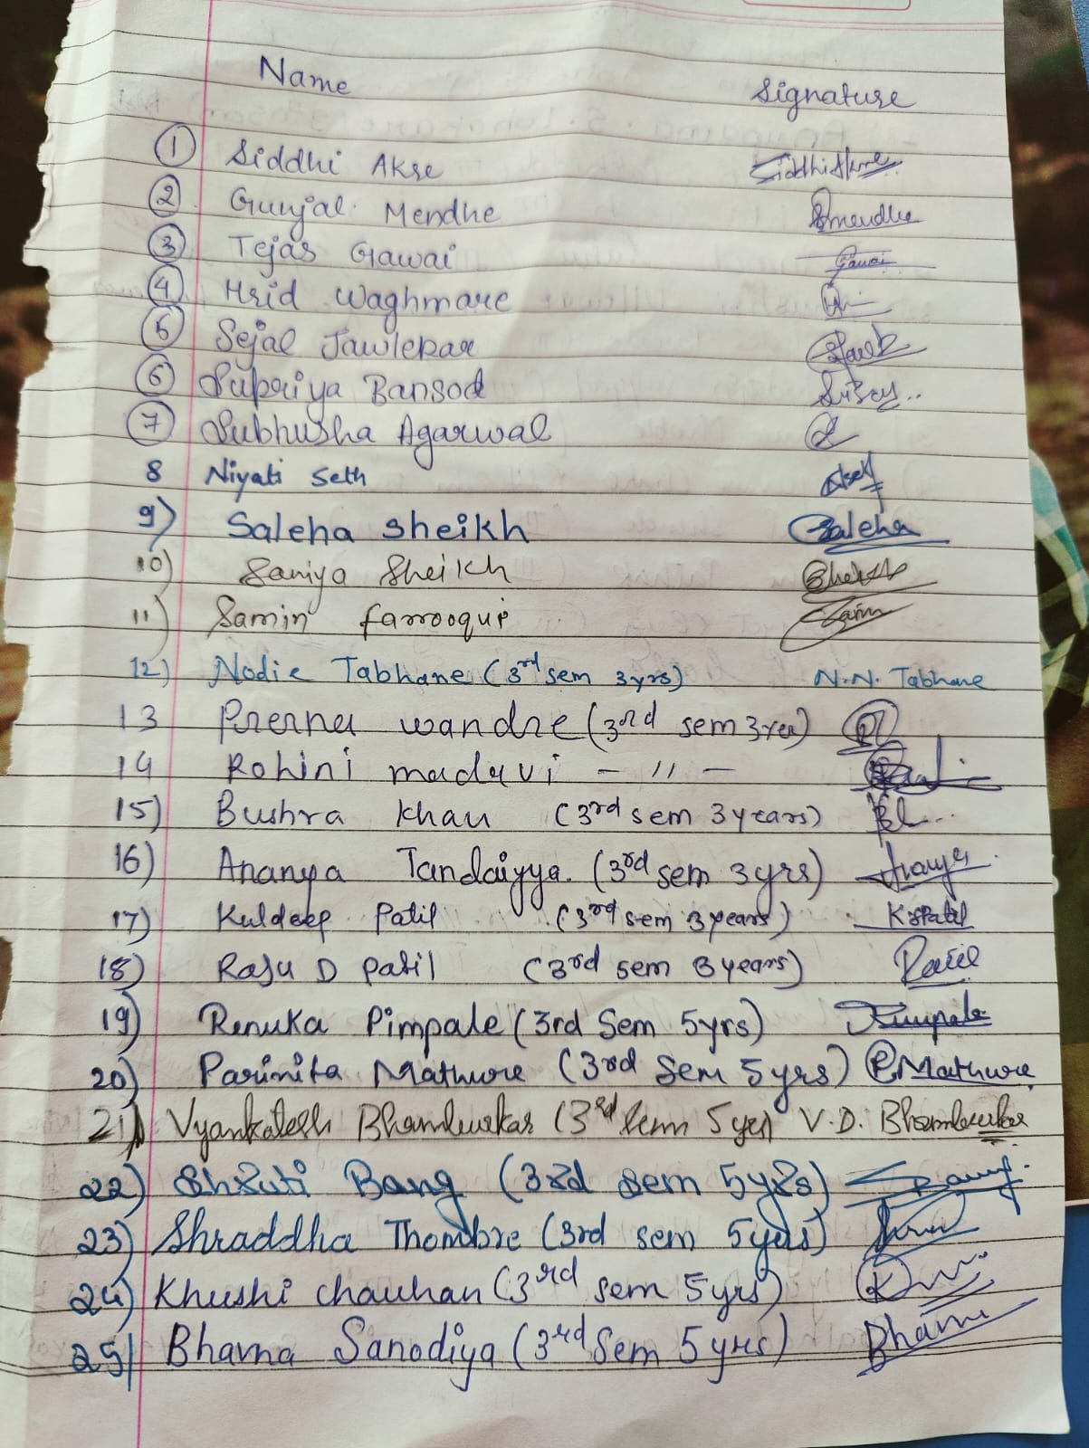

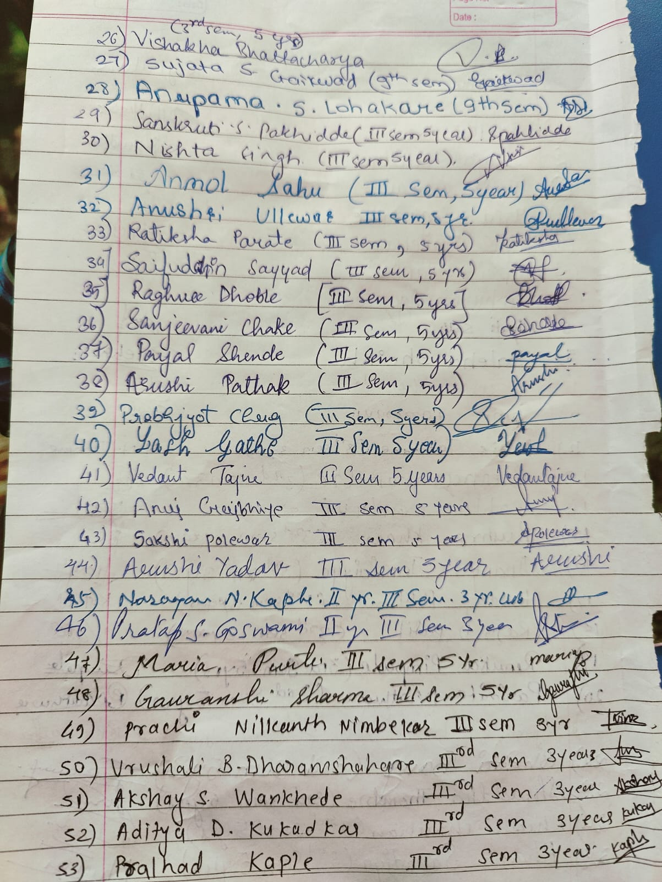

- Role of Family Court- 30th December 2023
Date: 30th December 2022
Name of the Programme: Lecture on “Role of Family Court”
Resource Persons: Adv. Padma Chandekar
Organised by: Department of Law
Name of Program Co-ordinator: Ms. Shilpa Rathod
Number of Attendees: Around 99
Mode: Offline
Name of Venue: Seminar Hall, Department of Law

NOTICE

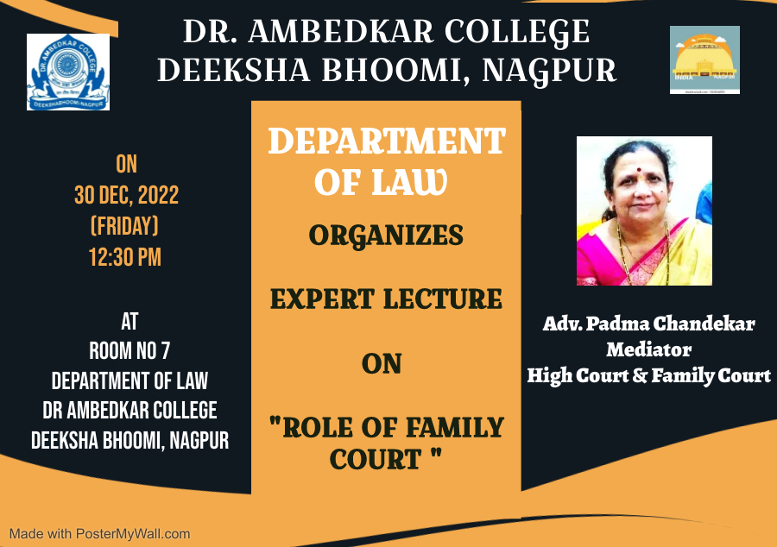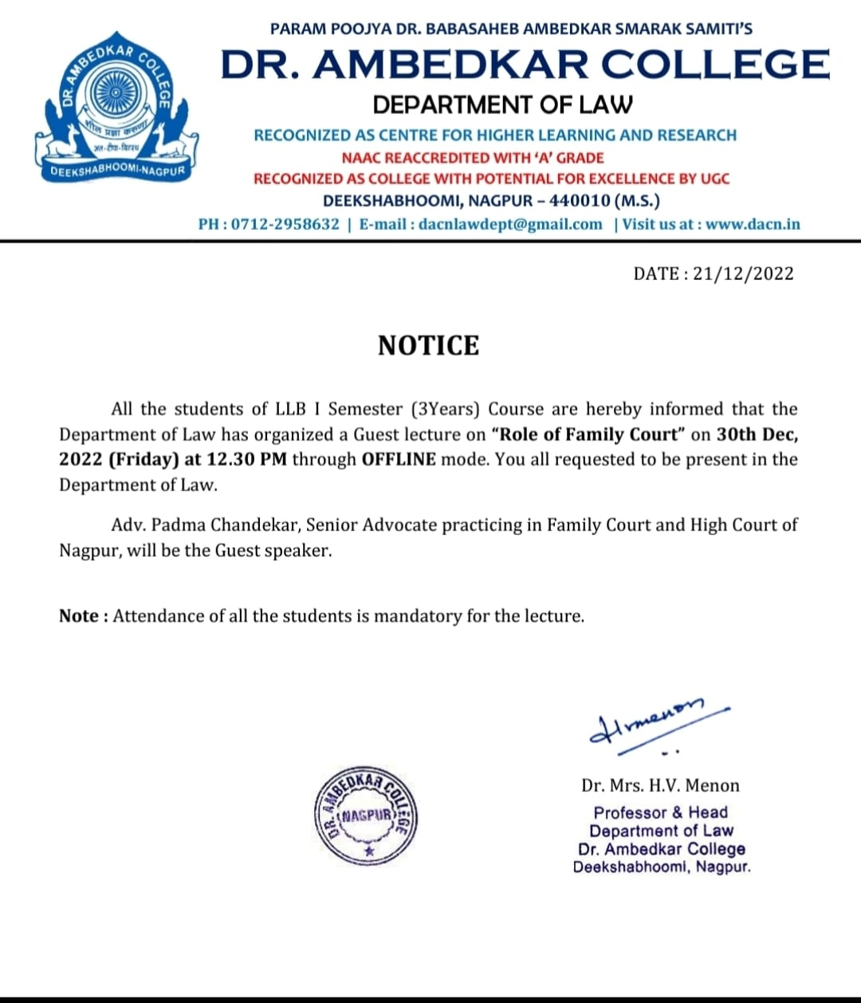
REPORT ON EXPERT LECTURE

The Department of Law, Dr. Ambedkar College, Deeksha Bhoomi Nagpur, has organised an expert Lecture on 30th Dec 2022 for the newly inducted Students of LLB 3 year and LLB 5 Year courses.
Around 99 attendees were present in the program through Offline Mode. Adv. Padma Chandekar, Mediator in High Court and Family Court Nagpur invited as an expert speaker in the program.
Adv. Padma Chandekar enlightened the audience on the topic of “Role of Family Court”. She commenced her talk by asking the question to the audience what is marriage? She has appreciated the audience for their active contribution in defining the term marriage according to their common understanding. She empathetically mentioned that through the marriage institution we can build the family. She gave the live examples and explained the reason for the break down of the marriage not only pre 2000 period but also the comparative position post 2000 period.

She has further explained how the Family Court provided the forum of Mediation and the Conciliation which plays a crucial role in dealing with the family dispute between the parties. It has mentioned by her that the conciliation is needful not only to the spouse but also to the entire family of the spouse to avoid the misunderstanding and issues between the family.

She advised the present audience that the pre marriage counselling is the important need of the present time. And it is very important for the parties wishing to marry should take the Pre-Counselling session. She has sensitized the audience by sharing the personal experience of practicing in family courts by presenting the issues of the live cases she has been handling for her client. She enlightened the students with the famous and recent judgement of the Courts dealt with the family issues between the parties.

The lecture is followed by the question-and-answer session wherein the different students asked the variety of questions which has been nicely answered by the guest speaker with full satisfaction of the students.

The hon’ble guests overwhelmed with the interest, participate on the part of audience and the interaction from the students, and for that she has congratulated the college.

The Programme was conducted and concluded with vote of thanks proposed by Ms. Shilpa Rathod. 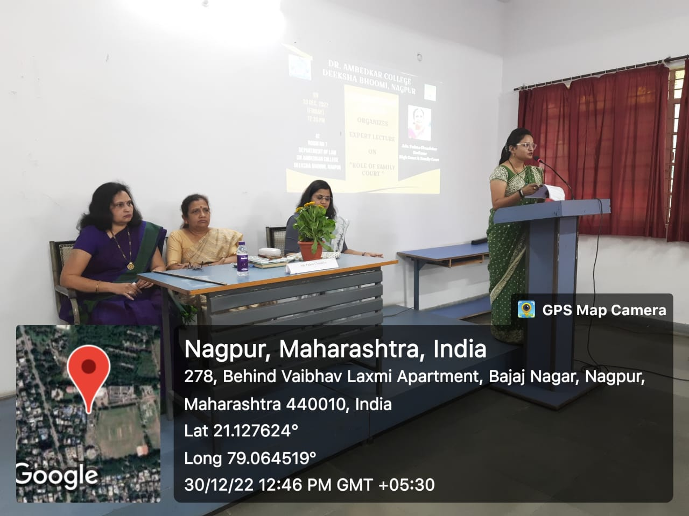
(Dr. V.V. Deshpande and Dr. S.P. Kalamdhad and Guest speaker shared the chair on Dais for the program)
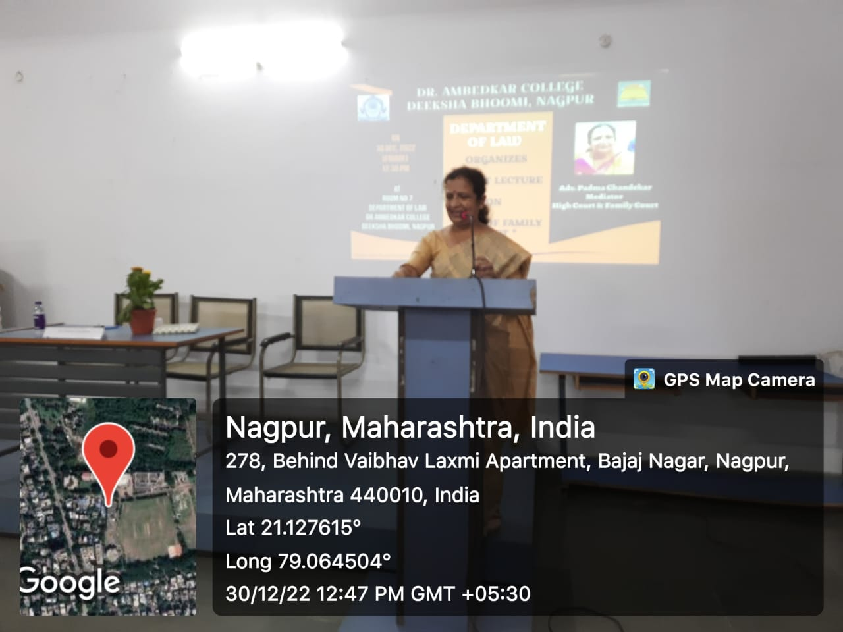
(Adv. Padma Chandekar delivering the lecture)

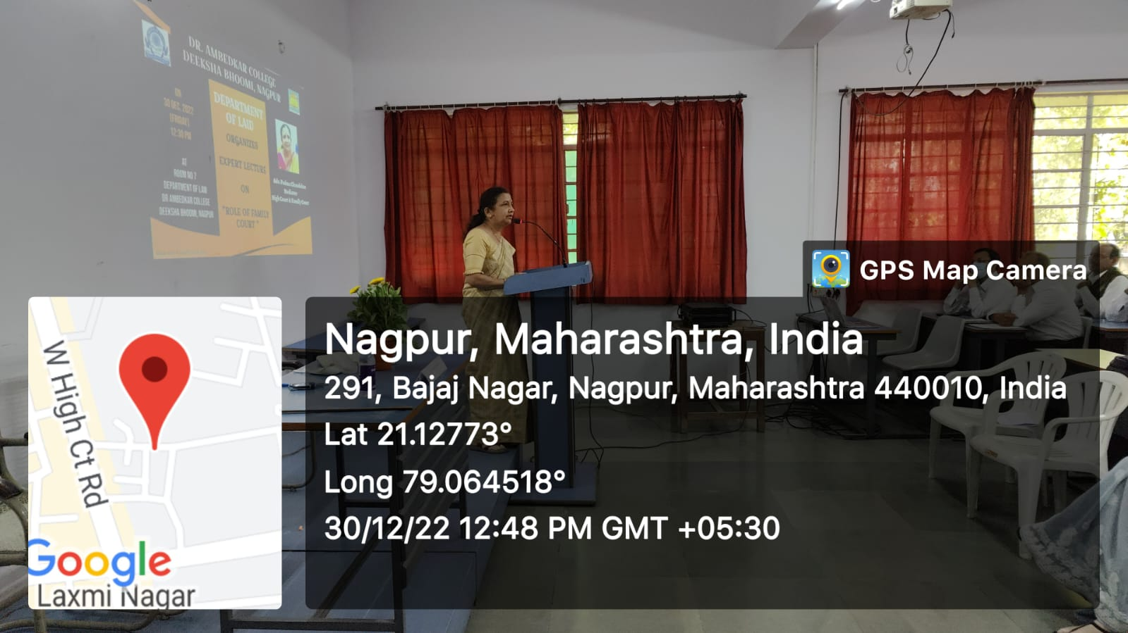
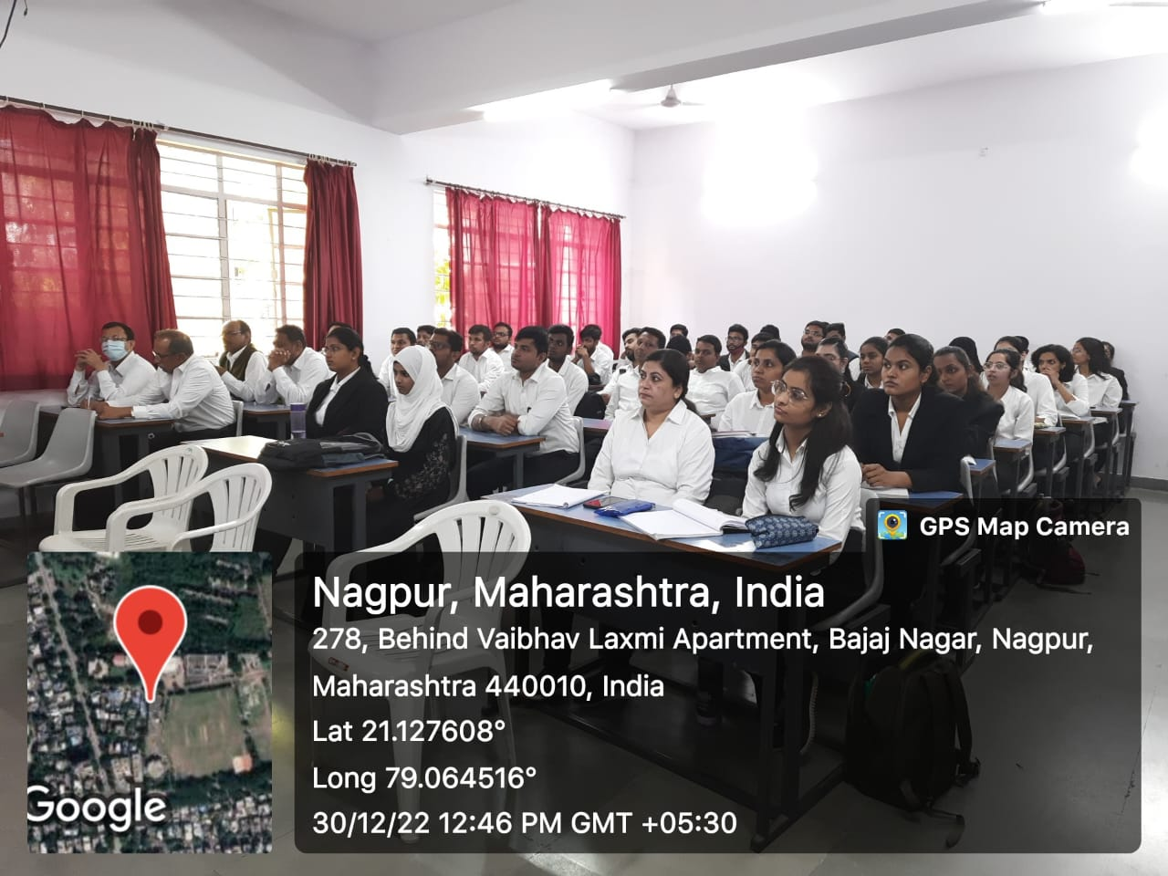
(Audience Present at the Awareness Programme through Offline mode)

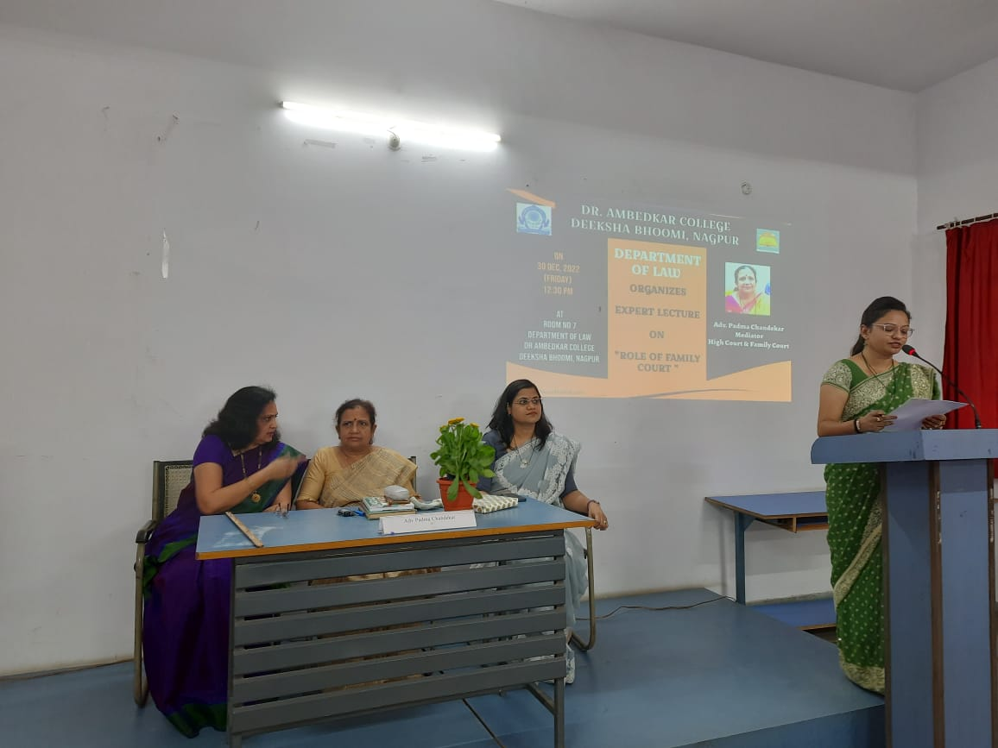
(Vote of Thanks delivered by Program co-ordinator Ms. Shilpa Rathod)

Induction programme for Fresher Students:

